COLLEGE OF COMPUTING & INFORMATICS

UNIVERSITI TENAGA NASIONAL

UNITEN EXECUTIVE EDUCATION PROGRAMME MANAGEMENT SYSTEM

NISHANTHINI A/P JEGABADUR

IS0103749

BACHELOR OF INFORMATION TECHNOLOGY (HONS)

INFORMATION SYSTEMS

SPECIAL SEMESTER 2019/2020

UNITEN Executive Education Programme Management System

by

NISHANTHINI A/P JEGABADUR

Project Supervisor: MDM RINA BTE. MD. ANWAR, TS.

A REPORT SUBMITTED IN PARTIAL FULFILLMENT OF THE REQUIREMENTS FOR THE BACHELOR OF INFROMATION TECHNOLOGY (INFORMATION SYSTEMS), COLLEGE OF COMPUTING & INFORMATICS

UNIVERSITI TENAGA NASIONAL

2020

**DECLARATION**

I hereby declare that this report, submitted to Universiti Tenaga Nasional as a partial fulfillment of the requirements for the Bachelor of Information Technology (Information Systems) has not been submitted as an exercise for a degree at any other university. I also certify that the work described here is entirely my own except for excerpts and summaries whose sources are appropriately cited in the references.

This report may be made available within the university library and may be photocopied or loaned to other libraries for the purpose of consultation.

24 July 2020 …………………………………...

NISHANTHINI A/P JEGABADUR

IS0103749

**APPROVAL SHEET**

The thesis entitled:

“Executive Education Programme Management System”

Submitted by:

NISHANTHINI A/P JEGABADUR (IS0103749)

I requirement for the degree of Bachelor of Information Technology (Information Systems), College of Computing & Informatics has been accepted.

Supervisor: MDM RINA BTE. MD. ANWAR, TS.

Signature: ……………………………

Date: 24th June 2020

**ACKNOWLEDGEMENT**

Primarily, I wish to express my sincere gratitude to my advisor Mdm Rina Bte. Md. Anwar, Ts. for continuously supporting and guiding me in completing my final year project successfully. In spite of being in MCO, she was there to constantly guide as well as help me in every way possible throughout my Project 1. In addition, I would like to thank my examiner, Dr Rosnafisah Bte. Sulaiman who believed in me by letting me to do this project and helped me to improvise my project. Without both of their advice and encouragement it would have been harder for me to complete this project.

Besides, a special thanks is a must for my family members for supporting me emotionally and spiritually which encouraged to not giving up on anything easily. Not forgetting my friends who constantly encouraged me to do better and guided me in this journey.

Last but not the least, I would like to take this opportunity to thank those who was there for me either directly or indirectly in completing my final year project entitled ‘Executive Education Programme Management System’.

**EXECUTIVE SUMMARY**

UNITEN Executive Education Programme Management System is a web-based application system which is specially designed for the Business Development Department (BDD) of UNITEN who is currently using manual method for the registration of users into short courses. This application is mainly for the users who are interested in short or special courses and to make the whole process efficient for the staffs.

Managing executive education programmes without the aid of an automation system will take a longer time because there are so many tasks involved in it which may slower the process. This manual method can cause problem to the management and also to the users because managing too many documents manually is difficult. Even though there is a website to provide details of the programs, they do not have a complete system where all the works can be done in a platform.

Therefore, a complete system is need to be developed to manage the programmes easily and efficiently. The objectives to develop this system is to allow users to register themselves for the courses, allow the users to make payment through online, generate receipt and sales report and send e-certificate to the users after the program completion. The proposed system will surely save staffs’ time and also shorten the waiting time of customers.

The software development methodology that have been used to develop the system is waterfall model. Waterfall model is chosen because it is a straightforward process and a phase will begin only after the phase before that is completed. Therefore the phases cannot be overlapped. Every phase of Waterfall model will be able to start and finish within the fixed deadline because they follow a timeline. At the end of each phase, a review takes place to determine if the project is on the right path and whether or not to continue or discard the project. [1]

In conclusion, the proposed system will be a complete system to manage the courses and users effectively and efficiently. Even there are similar systems like this it will be undoubtedly a new experience for BDD as they get to do their work differently and the users will get an opportunity to explore new system. This is because the system is new for the department and its current users.

**TABLE OF CONTENT**

**DECLARATION i**

**APPROVAL SHEET ii**

**ACKNOWLEDGEMENT iii**

**EXECUTIVE SUMMARY iv**

**TABLE OF CONTENT v**

**LIST OF TABLES viii**

**LIST OF FIGURES ix**

CHAPTER 1 INTRODUCTION

1.0 Overview 1

1.1 Background 2

1.2 Problem Statement 3

1.3 Objectives 4

1.4 Scope 5

1.5 Project Timeline 6

1.6 Conclusion 7

CHAPTER 2 ANALYSIS & SYSTEM REQUIREMENTS

2.0 Overview 8

2.1 What is Executive Education Programme Management System? 9

2.2 Review of System 10

2.2.1 Review of Current System 10

2.2.2 Review of Similar Systems 11

2.3 Comparison between Similar Systems 15

2.4 Software Development Methodology 16

2.5 Requirement Gathering Techniques 19

2.5.1 Interview 19

2.6 Tools and Technology 23

2.7 Conclusion 24

CHAPTER 3 ANALYSIS AND SYSTEM REQUIRMENTS

3.0 Overview 25

3.1 Context Diagram 26

3.2 Data Flow Diagram (DFD) Level 0 27

3.3 Entity Relationship Diagram (ERD) 28

3.4 Use Case Diagram 29

3.5 Data Dictionary 30

3.6 Navigation Diagram 34

3.7 System Interface Layout 36

3.7.1 User’s Interface 36

3.7.2 Admin’s Interface 41

3.7.3 Instructor’s Interface 45

3.8 Conclusion 52

CHAPTER 4 IMPLEMENTATION

4.0 Overview 53

4.1 Development Environment 54

4.1.1 Hardware Requirements 54

4.1.2 Software Requirements 55

4.2 Implementation of UNITEN EEProMS 55

4.2.1 Description of Developed System 55

4.3 Technical Detail of Implementation 56

4.3.1 Notepad++ 56

4.3.2 PhpMyAdmin 57

4.3.3 GitHub 57

4.4 Database Implementation 58

4.5 User Manual 63

4.5.1 Instructor Interface and Functionalities 63

4.5.2 Admin Interface and Functionalities 68

4.5.3 User Interface and Functionalities 77

4.6 Conclusion 85

CHAPTER 5 TESTING

5.0 Overview 86

5.1 User Acceptance Test 87

5.1.1 Testing for Registration and Login Function 87

5.1.2 Testing for Functions in Admin side 90

5.1.3 Testing for Functions in Instructor side 92

5.1.4 Testing for Functions in Front-end User side 94

5.2 Conclusion 96

CHAPTER 6 CONCLUSION

6.1 Project Outcome 97

6.2 Experience Gained 98

6.3 Problems Encountered 98

6.4 Limitations/ Excluded Functions 99

6.5 Future Recommendations 99

References 100

**LIST OF TABLES**

Table No. Page

Table 1.1 Gantt Chart 6

Table 2.1 Similar System Comparison Table 15

Table 2.2 List of Hardware and Software Requirements 23

Table 3.1 User’s Table 30

Table 3.2 Admin Table 30

Table 3.3 Instructor’s Table 31

Table 3.4 Course Table 32

Table 3.5 Enquiry Table 33

Table 3.6 Categories Table 33

Table 3.7 Certificate Table 34

Table 3.8 Order Status Table 34

Table 3.9 Order Table 35

Table 3.10 Order Detail Table 36

Table 4.1 Hardware Requirements 54

Table 4.2 Software Requirements 55

Table 5.1 User Acceptance of Admin Login 87

Table 5.2 User Acceptance for Instructor and User Registration 88

Table 5.1 User Acceptance for Instructor and User Login 89

Table 5.1 User Acceptance for Functions in Admin pages 90

Table 5.1 User Acceptance for Course Insertion Function 92

Table 5.1 User Acceptance for Functions in Instructor pages 93

Table 5.1 User Acceptance for Front-end User 94

Table 5.1 User Acceptance for Enquiry feature 96

**LIST OF FIGURES**

Figure No. Page

Figure 2.1: Online enquiry form of special programmes 10

Figure 2.2 Homepage of Iverson 11

Figure 2.3 Program added to cart in Iverson 12

Figure 2.4 Homepage of Coursera 12

Figure 2.5 Registration page of Coursera 13

Figure 2.6 Homepage of MIM system 13

Figure 2.7 Course details interface 14

Figure 2.8 Waterfall Model 16

Figure 3.1 Context Diagram 26

Figure 3.2 Data Flow Diagram (DFD) Level 0 27

Figure 3.3 Entity Relationship Diagram (ERD) 28

Figure 3.4 Use Case Diagram 29

Figure 3.5 Navigation Diagram of User 34

Figure 3.6 Navigation Diagram of Admin 35

Figure 3.7 Navigation Diagram of Instructor 35

Figure 3.8: Homepage 39

Figure 3.9: Enquiry form 39

Figure 3.10: Course List Page 40

Figure 3.11: Course Details Page 40

Figure 3.12: Shopping Cart Page 41

Figure 3.13: User Register Page 41

Figure 3.14 User Signin Page 42

Figure 3.15 Checkout Page 42

Figure 3.16 Payment Successful Page 43

Figure 3.17 Admin Login Page 44

Figure 3.18 Admin Dashboard 44

Figure 3.19 Enquiry Management Page of Admin 45

Figure 3.20 Course Approval Page 45

Figure 3.21 Invoice Approval Page 46

Figure 3.22 Instructors’ List Page 46

Figure 3.23 Form to add instructors 47

Figure 3.24 Logout Prompt of Admin Page 47

Figure 3.25 Instructor Login Page 48

Figure 3.26 Instructor Dashboard 48

Figure 3.27 Approved Course List Page 49

Figure 3.28 Update Course Form 49

Figure 3.29 Add Course Form 50

Figure 3.30 Enquiry Management Page of Instructor 50

Figure 3.31 Users’ Information Page 51

Figure 3.32 Logout Prompt of Instructor Page 51

Figure 4.1: Code in Notepad++ 56

Figure 4.2: phpMyAdmin 57

Figure 4.3: GitHub 57

Figure 4.4: Admin login table 58

Figure 4.5: Categories table 58

Figure 4.6: Certificate table 59

Figure 4.7: Courses table 59

Figure 4.8: Enquiry table 60

Figure 4.9: Instructor table 60

Figure 4.10: Order table 61

Figure 4.11: Order detail table 61

Figure 4.12: Order status table 62

Figure 4.13: User table 62

Figure 4.14: Instructor Register Page 63

Figure 4.15: Account verification link 63

Figure 4.16: Instructor Login Page 64

Figure 4.17: Instructor dashboard 64

Figure 4.18: Add Course Page 65

Figure 4.19: Pending Courses Page 65

Figure 4.20: Approved Courses Page 66

Figure 4.21: Edit and Update Course Page 66

Figure 4.22: Rejected Course Page 67

Figure 4.23: Logout 67

Figure 4.24: Admin Login Page 68

Figure 4.25: Dashboard Page 68

Figure 4.26: Categories Page 69

Figure 4.27: Add Categories Page 69

Figure 4.28: Edit and Update Categories Page 70

Figure 4.29: Delete Categories 70

Figure 4.30: Course Approval Page 71

Figure 4.31: Course Approve Page 71

Figure 4.32: Course Reject Page 72

Figure 4.33: Able/Disable Instructor Page 72

Figure 4.34: Approved Courses Page 73

Figure 4.35: Edit and Update Course Page 73

Figure 4.36: Registered User List Page 74

Figure 4.37: Registration Page 74

Figure 4.38: Registration Detail Page 75

Figure 4.39: e-Certification Page 75

Figure 4.40: Sales Report Page 76

Figure 4.41: Homepage 77

Figure 4.42: Enquiry Form 77

Figure 4.43: Register/Login Page 78

Figure 4.44: Forgot Password Page 78

Figure 4.45: Course Page 79

Figure 4.46: Course Details Page 80

Figure 4.47: Cart Page 80

Figure 4.48: Registration/Login (Checkout Page) 81

Figure 4.49: Billing Address (Checkout Page) 81

Figure 4.50: Pay With Card 82

Figure 4.51: Stripe Payment Gateway 82

Figure 4.52: Thank You page 83

Figure 4.53: My Registration Page 83

Figure 4.54: My Courses page 84

Figure 4.55: -e-Certificate Form 84

Figure 4.56: My Profile Page 85

**CHAPTER 1**

**INTRODUCTION**

**1.0 OVERVIEW**

Chapter 1 consists of background of the problem, problem statement, objective, scope and project timeline. This chapter describes the project details thoroughly.

**1.1 BACKGROUND**

Universiti Tenaga Nasional (UNITEN) was established in 1999 and is one of the first private universities in Malaysia. It is wholly owned by the public listed Tenaga Nasional Berhad (TNB) UNITEN has various departments functioning under it, contributing towards the success of the university in every aspects and Business Development Department (BDD) is one of them. BDD offer and manage professional services to create long-term value for the university from its customers, markets, and relationships with the local and global community. [2] It also provides consultative help in the products, services and operation of UNITEN. This department is handling the rental facilities, professional services and special programs held by UNITEN. Under the special programs, executive education programs are designed to enhance technical skills in engineering, management and computing, leadership skills, and build foundation in general management. Example of programs they are offering is energy management, big data & analytics, computing & IT solutions and more. These programs are considered as special programs because these programs are offered to public and corporate clients to enhance their knowledge and skills in a specific or new field.

With the current website, the short courses are listed in the website which can be viewed by the users. The users can see the details and inquire about the courses. The staffs have to call back or e-mail the users who have inquired about the courses to give further details on it and will manually register the users into the courses. Hence, a web-based UNITEN Executive Education Programme Management system should be developed to ease the whole process and making it beneficial for all three parties which are the users, staffs and also the university. This automated system can perform several activities such as register for the courses, pay for the courses through online, provide e-certificate for the users after their course completion and allow users to view course details and enquire about that. Moreover, keying-in the participant names manually into a course may cause human error anytime so, the development of the system can help to overcome that too. In a nutshell, this system will improve the quality of the process of managing executive programmes of UNITEN in a more systematic and functional way.

**1.2 PROBLEM STATEMENT**

The BDD do have a website where people can view the programs or short courses offered by UNITEN and enquire about the programs but the users cannot register themselves into the programs or buy the modules online. After receiving the inquiry, the department staffs have to call back the users one by one to note down their information and manually register them in the programs. Sometimes, the customers directly call the in-charge person to get themselves registered in course. Therefore, they have to manage too many documents at a time manually. Due to this they may face problems caused by human errors such as registering an user in a program that already have enough number of participants, users who have not paid can be marked as already paid, keying-in the users name in a wrong program and more. This can be problematic to the users as well as the management.

Other than that, people nowadays prefer online payment than manual payment because it is considered to be not safe keeping large amount of money with them. But this existing system do not have the advanced technique in it and user have pay by cash or cheque at the UCC payment counter or instructed to transfer the money to a particular account which is not safe. If there is any error in recording the transactions, this may cause trust issues between the users and management in future if any problem occurs.

Most importantly, they do not have a complete system where all the activities can be done in a platform. Their current system is incomplete because users can only view the course details and inquire about it. The staffs have to check all the inquiries and get back to the users one by one which can take longer time. The users also have to wait for the staffs to call them back which may take longer period than expected by them. Sometimes, the users do not even use that online enquiry form instead, they directly call person in-charge to get details of the courses. This makes the whole current process inefficient.

**1.3 OBJECTIVES**

The main objective of developing UNITEN Executive Education Programme Management system is to benefit the users by designing a system which can help them to enrol in the short courses provided by UNITEN easily and efficiently. This system will definitely ease the work of users and staffs. Besides that, to save the staffs’ time and also shorten the waiting time of the users who in previous should wait for the staffs’ call to enrol in courses. The system developed will be a complete web based system with the following functions to manage executive programmes organised by UNITEN. Other than this, the functionalities of the system are to:

1. provide course details
2. allow users to register for the courses
3. allow online payment
4. produce receipt and generate sales report
5. prepare and send e-certificate once after the course completion

**1.4 SCOPE**

The project scope can be categorized into two that are user scope and system scope. User’s scope is to determine the users who have the access to use the system and their level of authorization. While, system scope is to specify the function of the system.

**1.4.1 User Scope**

There will be three types of users who can access the system:

1. Admin

The system admins are allowed to access to manage all the information. Admin can approve the programs, reply the enquiries, view user information, add instructors and update the users’ payment status and approve invoice.

1. Individuals, students and corporate customers from other companies

Users can view program details and enquire about it. They also can register themselves in the program they like and make payment through online.

1. Instructors

Instructors are the people who is going to educate the courses to users. They are in charge of the programs therefore, they can add programs and edit and update the existing programs. They also have access to the users’ information who registers.

**1.4.2 System Scope**

This system will be equipped with the following function:

a) The system will allow users to view course details and enquire about the program

b) The system will allow users to register themselves in the courses

1. The system will allow users to make payment through online
2. The system will be able to send e-certificate to the users after their completion
3. The system will be able to produce receipt or invoice for the users

**1.5 PROJECT TIMELINE**

The project timeline for this is project is explained in the form of Gantt chart and shown in Table 1.1

**Table 1.1 Project Management Gantt Chart**

|  |  |  |  |  |  |  |  |  |  |  |  |  |  |  |  |  |
| --- | --- | --- | --- | --- | --- | --- | --- | --- | --- | --- | --- | --- | --- | --- | --- | --- |
| **Task** | **Week** | | | | | | | | | | | | | | | |
| **1** | **2** | **3** | **4** | **5** | **6** | **7** | **8** | **9** | **10** | **11** | **12** | **13** | **14** | **15** | **16** |
| Project Supervisor and Title |  |  |  |  |  |  |  |  |  |  |  |  |  |  |  |  |
| Project Proposal Submission |  |  |  |  |  |  |  |  |  |  |  |  |  |  |  |  |
| Study System Requirements |  |  |  |  |  |  |  |  |  |  |  |  |  |  |  |  |
| Executive Summary  Draft |  |  |  |  |  |  |  |  |  |  |  |  |  |  |  |  |
| Chapter 1 – Introduction  Draft |  |  |  |  |  |  |  |  |  |  |  |  |  |  |  |  |
| Chapter 2 – Analysis & System Requirement  Draft |  |  |  |  |  |  |  |  |  |  |  |  |  |  |  |  |
| Executive Summary, Chapter 1 and Chapter 2 Draft Submission |  |  |  |  |  |  |  |  |  |  |  |  |  |  |  |  |
| Milestone 1 & 2 Submission |  |  |  |  |  |  |  |  |  |  |  |  |  |  |  |  |
| Chapter 3 – Design  Draft |  |  |  |  |  |  |  |  |  |  |  |  |  |  |  |  |
| Chapter 3 Draft  Submission |  |  |  |  |  |  |  |  |  |  |  |  |  |  |  |  |
| Poster Design |  |  |  |  |  |  |  |  |  |  |  |  |  |  |  |  |
| Poster Presentation |  |  |  |  |  |  |  |  |  |  |  |  |  |  |  |  |
| Milestone 3 – Final  Report Submission |  |  |  |  |  |  |  |  |  |  |  |  |  |  |  |  |
| Logbook Submission |  |  |  |  |  |  |  |  |  |  |  |  |  |  |  |  |

**1.6 CONCLUSION**

In conclusion, this chapter explains about the background of the project, the problems faced by the organization, the objectives of the proposed system, the project scope and the timeline to develop the whole system. We can hope that the executive education programs can be managed easily through the development of the proposed system.

**CHAPTER 2**

**ANALYSIS AND SYSTEM REQUIREMENTS**

**2.0 Overview**

Chapter 2 define the executive education programme management, review similar systems like proposed system and compare it. It will also discuss about the software development methodology, requirement gathering technique and the tools and technology used.

**2.1 What is Executive Education Programme Management?**

Executive Education Programme Management System is a computer-based system that manages the short courses organised by the university, improves the performance of the organization. There are some courses that could not be included in our study program due to limited credit hours or some courses we want to learn to gain extra knowledge about a specific field; these are the courses we can find in the executive programme management. In most of the universities they do not have a system for this particular program because they think they can handle in manually but UNITEN wants to develop a system for this because they want to attract more users towards them by offering more programmes and promoting it online. And they also consider that handling all this manually can burden the management and staffs more. So, this system will act as a mediator for the user and the staffs or management. They system will give better experience for the users by making it easier for them to register for the courses and pay through online directly without waiting for the staffs to call them back. And for the staffs, they do not have to get back to all the users one by one and they can focus on other things instead of that.

**2.2 REVIEW OF SYSTEM**

**2.2.1 Review of current system**

The current method that is being used by the UNITEN BDD to register for the special programmes is manual where the users will view the program details and inquire about it through the website they already have which attached to the UNITEN official website or UNITEN Student Hub. Afterwards, the processes will be done manually starting from the staff notice the inquiry and call back or e-mail each one of them to give further explanations about the programs and register their names in the programs they wanted to participate in. If users want to buy the online module and do not want to attend the program they have to transfer the required money to UNITEN account and get the module through e-mail. After the program completion, the participants will receive their certificates by hand or mail. In overall, this method is an inconvenient and inefficient method because it takes longer time to call back each one of them and the users have to wait for the call from the staff or they have to call the management if it takes longer time than expected by them. By registering manually, the data could get lost, destroyed or ripped easily if it is not protected well. This can cause problems not only for the users but also for the management. As we all know, user information is vital and it is hard to be maintained nowadays because it is large. And also with the payment, paying through cash, cheque or fund transfer is not preferable nowadays.

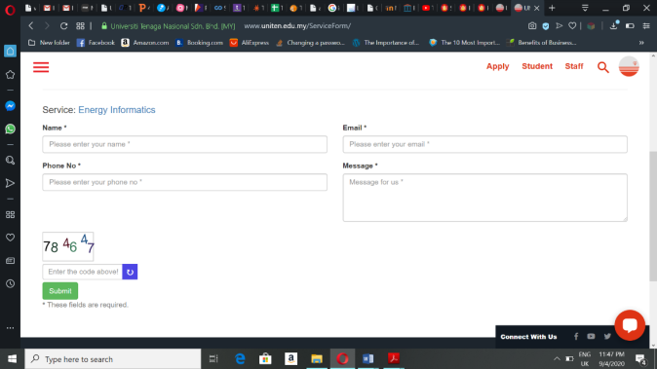

**Figure 2.1: Online enquiry form of special programmes**

**2.2.2 Review of Similar System**

There are some systems which has been developed to ease the process of managing executive education programmes (short courses). These systems are mainly found in websites. Each organisation has been very particular about the systems’ functions and has its own unique feature. The comparison is made based on overall features of each system.

1. Iverson (URL: https://www.iverson.com.my)

Iverson is an organisation that provides high-quality IT training solutions to corporate customers, meeting their learning needs and helping them achieve their training objectives. Their training courses are created to meet the needs of corporate customers ranging from small, medium to large organisations. Iverson promote their shout courses through their website. This website allows their customer to view their program details and enquire about them. After choosing the program they want register for the customers have to fill in their details and card information or online banking information to pay for the courses through online. It also provides e-certificate for users after the program completion. Not just that, Iverson also provides online modules for those who do not want to attend the live program.

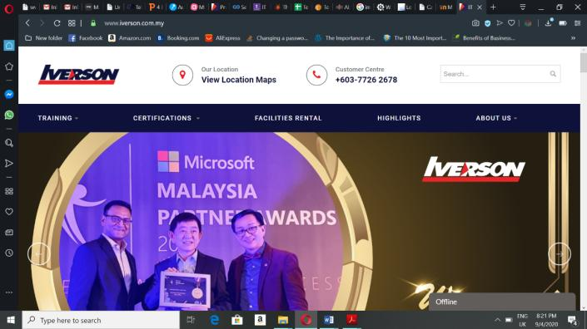

**Figure 2.2 Homepage of Iverson**

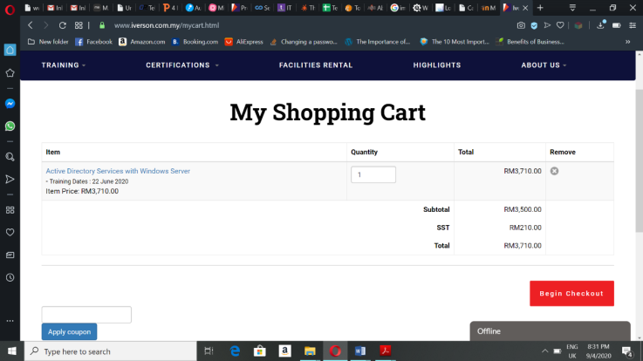

**Figure 2.3 Program added to cart in Iverson**

2. Coursera (URL: https://www.coursera.org)

Coursera is an American online learning platform that offers massive open online courses, specializations and degrees. It allows its users to view courses from various universities and organizations in a variety of subjects. The users can register themselves, enrol in courses and pay for the courses through online payment. It also provide online certificate after completion of the program.



**Figure 2.4 Homepage of Coursera**

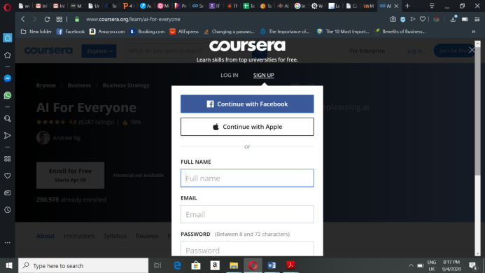

**Figure 2.5 Registration page of Coursera**

3. Malaysian Institute of Management (MIM) (URL: https://www.mim.org.my)

MIM is a leading membership-based organisation which, for over half a century, has served as the definitive voice of leadership and management across the country. This organisation offers several short courses which provide professional certification to help people achieve professional career in future. This system let users to view the course details and enquiry about the courses. Users can add the courses to the cart after registering themselves and pay through online. The system also indicates the time left for the course begin and if the course has passed.



**Figure 2.6 Homepage of MIM system**

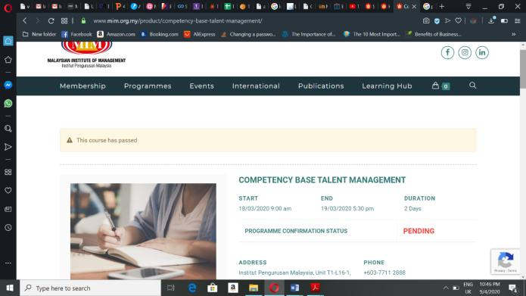

**Figure 2.7 Course details interface**

**2.3 COMPARISON BETWEEN SIMILAR SYSTEMS**

The table below shows comparison between the proposed systems, UNITEN Executive Programme Management System with other 2 similar system.

|  |  |  |  |  |  |
| --- | --- | --- | --- | --- | --- |
| No. | Similar  Systems    Features | Iverson | Coursera | MIM system | Proposed System |
| 1. | Choose a course and view course details |  |  |  |  |
| 2. | Enquire about the courses |  |  |  |  |
| 3. | Registration |  |  |  |  |
| 4. | Search and filter courses |  |  |  |  |
| 5. | Payment through online |  |  |  |  |
| 6. | Provide e-certificate |  |  |  |  |
| 7. | Provide face-to-face programs |  |  |  |  |
| 8. | Provide online programs |  |  |  |  |

**Table 2.1 Similar System Comparison Table**

**2.4 SOFTWARE DEVELOPMENT METHODOLOGY**

Software Development Methodology is a framework that is used to structure, plan and control the process of developing an information system.[3] The methodology plays an important role in the developing a system or project since it determines the success or failure of a software project. The methodology used for this project development is Waterfall model. The waterfall model is a breakdown of project activities into linear [sequential](https://en.wikipedia.org/wiki/Sequence) phases, where each phase depends on the deliverables of the previous one and corresponds to a specialisation of tasks.[4] The waterfall model has been chosen because it goes well with almost all the systems.

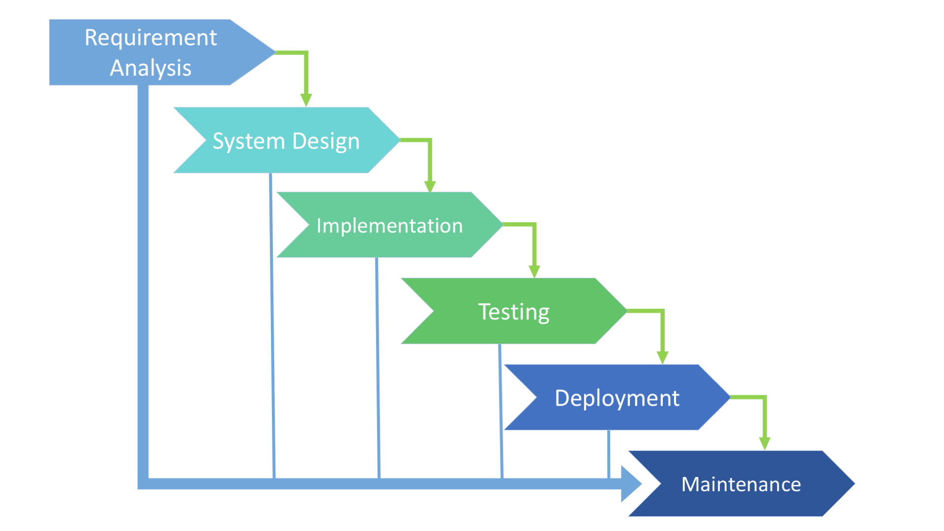

**Figure 2.8 Waterfall Model**

There are 6 phases involved in the waterfall model which are requirement analysis, system design, implementation, testing, deployment and maintenance. How each of these phases are implemented for the proposed system is explained further below:

* Requirement Analysis

This is the first phase of waterfall model. In this phase, activities such as project initiation and requirement gathering will take place. During project initiation, the problem statement and objectives of the project are identified which can show what is the main purpose for the development of the proposed system. After that, all the relevant requirements of the project are collected and analysed to make sure it can be used to satisfy the end-user requirements. Analysed requirements then documented in a specification document and a feasibility analysis is done to check if these requirements are valid. Limitations and restrictions such as time and budget are also examined so that it does not affect the development process of the project in the future.

* System Design

The second phase of this methodology is system design. For the proposed system, the system design phase will take place in Chapter 3. Upon identifying and understanding the requirements that has been gathered from the first phase, the developer will use the ideas to come up with the system design and design the interface of the proposed system. The deliverable for Chapter 3 will be Class Diagrams, Data Dictionary, Navigation Diagram and System Interface Layout.

* Implementation

The implementation stage is where the actual code is written by the programmers to turn the design phase into a workable system. Initially, the proposed system will be developed in many small modules, after which these modules are combined together to work as complete system. The development of UNITEN Executive Education Programme Management begins with the development of system interfaces and then connected to database and followed by the function of the system. This phase has been done in the Project 2.

* Testing

In testing phase, each developed system function in the earlier phase will be tested individually and the integration testing will begin once all functions of the system work as intended to ensure they are error-free and meet the user requirements in the first step. This project will be tested by the lecturers or staff of UNITEN where they will be provided with a checklist of requirements to make sure they meet with requirements that have been gathered in analysis phase.

* Deployment

The deployment phase will take place once the integration testing is successfully done. The system will be deployed into the user environment in order to the test its performance and report if there is any bugs or error occur in the system. The deployed system becomes available for the end-users after the BDD installed the system.

* Maintenance

The final phase of waterfall model is maintenance where the system is technically repaired and improved. Even though the system is fully tested and deployed, a new system often need ongoing maintenance because problems may still continue to arise. Therefore, the proposed system will undergo maintenance regularly. Maintenance is essential for a system as it will make sure that the system is up-to-date and operating efficiently without causing technical issues.

**2.5 REQUIREMENTS GATHERING TECHNIQUE**

Interviews considered as one of the primary sources of requirements. Therefore, one-to-one interview is used for gathering requirements to develop the system. There are 2 people who have been interviewed to gather information. One of them is the staff who is working in the business development department and the other one is a short interview with the user who wanted to participate in the courses but could not. Before interviewing these 2 person there was a meeting held with the Head of Business Development Department, Dr Rosnafisah who needed this system for the department. This meeting was held for clear understanding of what are the requirements of the head of department. The HOD stated the functions needed to be in the system, that are users able to enrol themselves in the courses, make payment through online, the system must be able provide e-certificate, more than one program can be added to cart and the system able to produce and send receipt for the users.

**2.5.1 Interview**

The first interviewee, Puan Harizatul Akma who has been working with UNITEN for almost 10 years and with BDD for 4 years now. She is the in-charge person of the all the special programmes which are held by Business Development Department. The questions asked in this interview are:

a) Can Puan brief about the whole of this short course registration process?

Yes, sure. Initially, users submit their enquiry about the course through provided online form in the website and the staffs will get back to them through email or phone call to provide them brochures or more details of the courses. But nowadays, mostly users directly call the in-charge person instead of using the online enquiry form because they think it takes longer time to get back reply. The payment is made with either cash or cheque at UCC payment counter or through electronic bank transfer if they could not make it to UNITEN. She further goes on explaining the process which is already stated in review of current system.

b) Which type of clients mostly participates in the programmes? Internal or external clients?

The main clients are mostly external, which consist of participants from other companies, students, individuals and more.

c) How these executive education programmes or short courses are being promoted?

We promote these courses through their social media such as Facebook, email and by brochures, banners, livewire TNB, etc.

d) How are the receipts and sales report produced?

It is based on invoice that BDD have issued to the clients or participants and the process quite long.

e) What are difficulties faced by the staffs and management during this courses registration process?

Now with the current practice, registration is done manually. Head of program have submit all the documents for program registration by using forms so they have to manage too many documents which slower the process. This method is also time consuming as almost everything is done manually even getting approval from the Dean or Director. And if the documents lost it can be problematic for the head of program as everything need to be done again. And with too many papers or forms it is difficult for the executive to manage all the documents in the file.

f) Do you think the current method for registration is satisfying and efficient enough?

No, because it takes a longer time and many problems occur in meanwhile. If the registration can be done in a system registration can be done easily and approval can be accessed from outside the office..

g) How the certificates are given out to the participants?

The certificates are prepared by the BDD staff, based on the name list given to them and later BDD will post the certificated to the participants.

h) If there is system developed for this, how it can solve the problem.

There will be no repetition of work as all the data or information can be extracted from the system. Other than that, there is no need to maintain the record manually, the data can be accessed anywhere and lots of time can saved with this system.

Through this interview, the main problems faced by the department are clearly stated by the Puan Harizatul and helped in identifying the requirements to complete the system. It is also known that a complete system for this process can make it a whole lot better for the department.

The second interviewee is Kumaran who is working in an IT company and former UNITEN student, who wanted to participate in one of the courses but could not make it due to some reasons.

a) Have you ever participated in any the executive education programmes?

No, I have never participated in any of the programmes or courses before but I was very keen on participating in a virtual reality course because I was interested in it.

b) How do you get to know about the course?

I got to know from Facebook while I was his scrolling I happen to know that UNITEN offering short courses and checked on their official website to get more details on it.

c) Then why did not you get yourself registered in the programme you were interested in?

Actually, after reading the course details I contacted the person in-charge because I felt it might take a long time to fill in the enquiry form and get back reply from them. They get my email id and send me brochures and information of the course. After I read it and get to know about the course in detail, I thought of contact back the staffs later but forgotten due to my work pressure. But, if there was a system for the registration I would have easily joined the course because registering manually takes a longer time and I felt it is a longer process.

d) What can be done by the management to make the process more efficient?

In my opinion, having a complete website or system can make it whole lot easier for everyone to register themselves without any difficulties.

Even if it is a short interview, it clearly showed the problems faced by an user from their perspective. Both the staff and user felt that having a complete system to manage the registration and approval process can make the whole process easier than expected. These two interviews helped in gathering the requirements and identifying the functions needed to build the complete system entitled ‘Executive Education Programme Management System’.

**2.6 TOOLS AND TECHNOLOGY**

Choosing the right tool and technology to be used in software development process is essential as it can literally make or break a project. Tools and technology includes all of the requirements needed to develop a system. The requirements can be divided into 2 main categories that are software and hardware. There are some hardware and software that has been used to develop the system. Wamp Server is used to create web application by connecting the database. Programming languages such as HTML, PHP, JavaScript, CSS and MySQL are used to create interface and functions of the system to be efficient.

**Table 2.2 List of Hardware and Software Requirements**

|  |  |
| --- | --- |
| Requirements | Tools |
| Software | 1. Xampp Server  2. Windows 8 and above  3. Programming Language:   * CSS * HTML * PHP * JavaScript * MySQL |
| Hardware | 1. Memory  2. Processor: Intel 3 and above  3. Other required devices |

**2.7 CONCLUSION**

This chapter is discussed about the analysis and requirement of the project which consist of the methodology, technology and tools that will be used to develop the system. Existing similar systems are identified and compared with the proposed system to obtain appropriate functionality in the development of the system. This chapter also discusses about the requirement gathering techniques which have been analysed to collect all the functional and non-functional requirements. The flow of the project is also discussed to ensure the project is on the right path.

**CHAPTER 3**

**DESIGN**

**3.0 Overview**

Chapter 3 focuses on the diagram developed to show the functionalities of the proposed system and its early designs of graphical user interface. This chapter also includes data dictionary and navigation page which navigates the structure of the proposed system.

**3.1 CONTEXT DIAGRAM**

**Figure 3.1** shows the context diagram of UNITEN Executive Education Programme Management System. This diagram revolves around data flow from the system to the entities. There are several input and output from three different entities that are user, admin and instructor to the system.

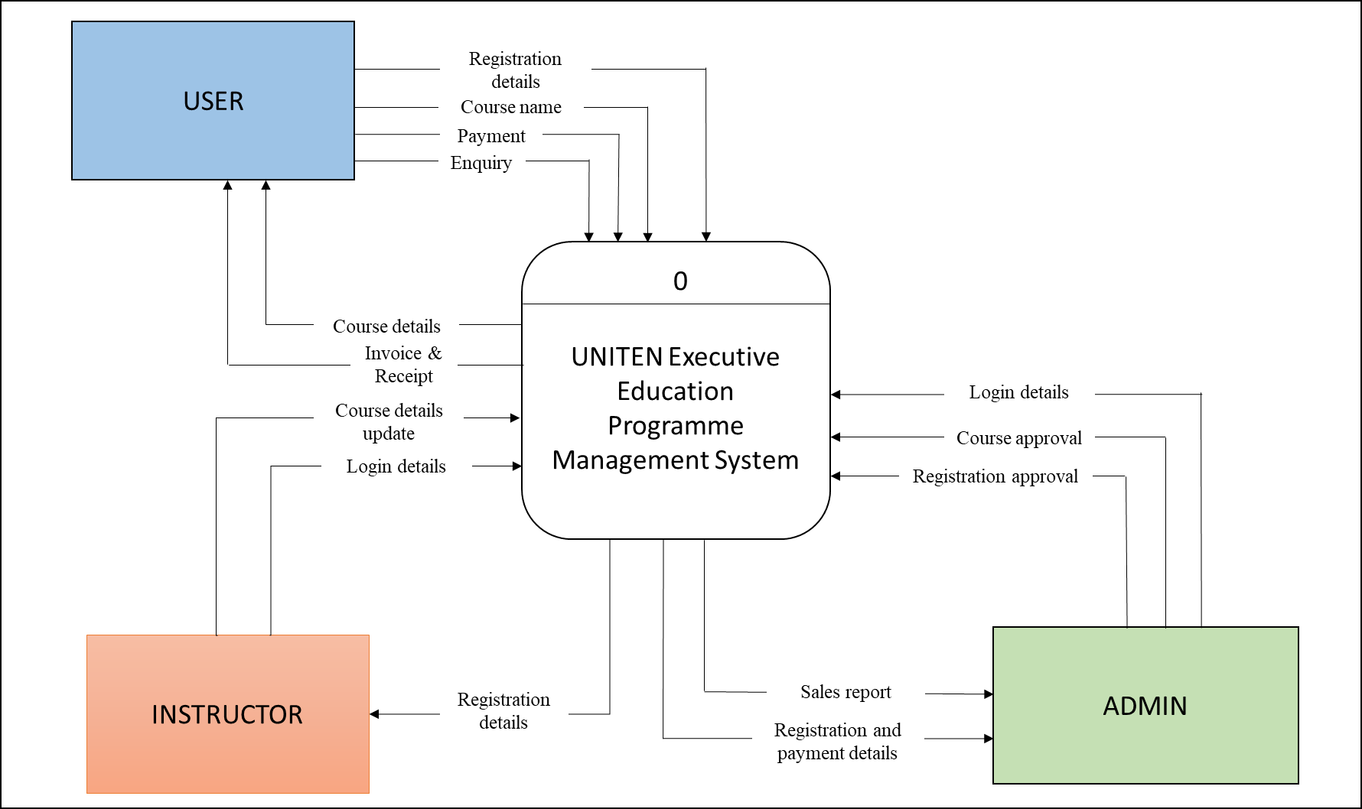

**Figure 3.1 Context Diagram**

**3.2 DATA FLOW DIAGRAM (DFD) LEVEL 0**

**Figure 3.2** shows the Data Flow Diagram of the UNITEN Executive Education Programme Management System. This diagram is an expansion of the context diagram which shows the data flow and process in the system in detail.

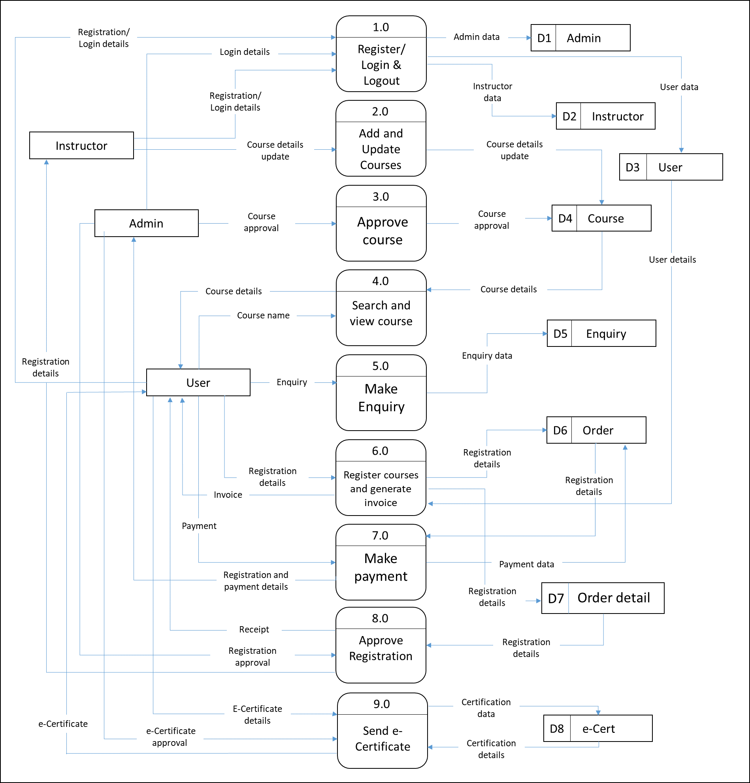

**Figure 3.2 Data Flow Diagram (DFD) Level 0**

**3.3 ENTITY RELATIONSHIP DIAGRAM (ERD)**

**Figure 3.3** shows the Entity Relationship Diagram of UNITEN Executive Education Management System. This diagram shows how the entities in the database are related to each other. There are 9 tables in this system which have their respective attributes.

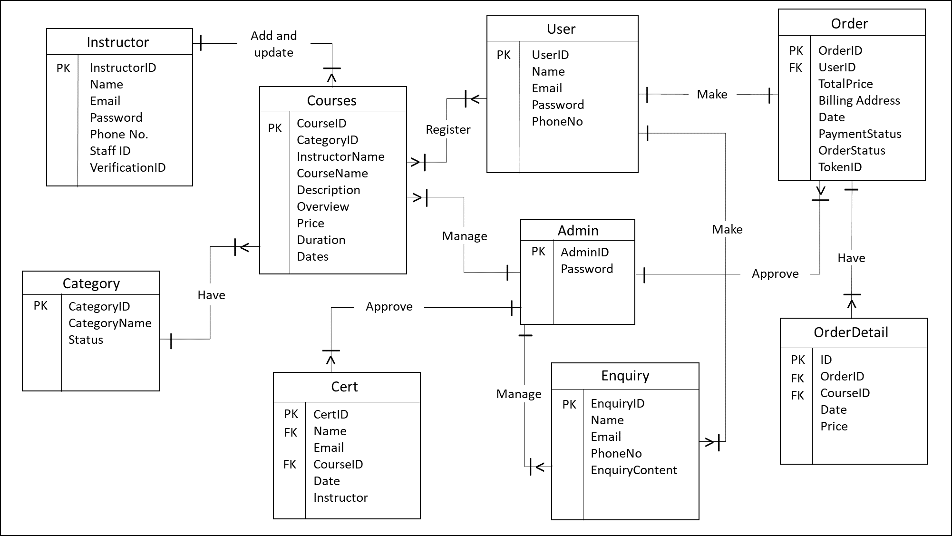

**Figure 3.3 Entity Relationship Diagram (ERD)**

**3.4 USE CASE DIAGRAM**

**Figure 3.4** shows the use case diagram of UNITEN Executive Education Management System. Three actors involved in this system that are the users, admin and instructors. The system have several functions that is also known as features of the system.

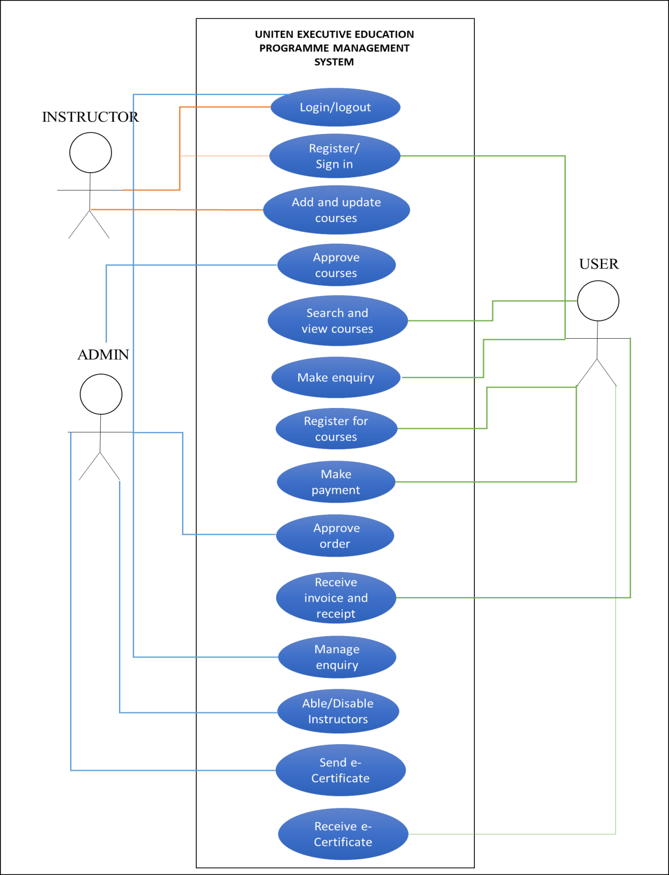**Figure 3.4 Use Case Diagram**

**3.5 DATA DICTIONARY**

Data dictionary contains information such as structure of the database and table contents such table name with its attributes, description, data type, constraints and data format that has been used for development of UNITEN Executive Programme Management System.

**Table 3.1** shows the user’s table that containing information of users such as user id, name, email, password, mobile number and user category.

**Table 3.1 User’s Table**

|  |  |  |  |  |
| --- | --- | --- | --- | --- |
| **User** | | | | |
| **Attributes** | **Description** | **Type** | **Required** | **PK/FK** |
| User_ID | User ID that uniquely identifies user | Integer(20) | Yes | Primary Key |
| Name | User’s name | Varchar(255) | Yes |  |
| Email | User’s email  address | Varchar(255) | Yes |  |
| Password | User’s password  used to login | Varchar(255) | Yes |  |
| PhoneNo | User’s phone  number | Integer(11) | Yes |  |

**Table 3.2** shows admin’s table that containing login details of admin such as admin id and password.

**Table 3.2 Admin Table**

|  |  |  |  |  |
| --- | --- | --- | --- | --- |
| **Admin** | | | | |
| **Attributes** | **Descriptions** | **Type** | **Required** | **PK/FK** |
| Username | Admin’s unique ID  that identifies admin | Varchar(50) | Yes | Primary  Key |
| Password | Admin’s password | Varchar(20) | Yes |  |

**Table 3.3** shows instructor’s table where it contains the instructor’s id, name, email, mobile number and more.

**Table 3.3 Instructor’s Table**

|  |  |  |  |  |
| --- | --- | --- | --- | --- |
| **Instructor** | | | | |
| **Attributes** | **Description** | **Type** | **Required** | **PK/FK** |
| Instructor_ID | Instructor ID that uniquely identifies user | Integer(10) | Yes | Primary Key |
| Name | Instructor’s name | Varchar(255) | Yes |  |
| Email | Instructor’s email  address | Varchar(255) | Yes |  |
| Password | Instructor’s password  used to login | Varchar(255) | Yes |  |
| Staff_num | Instructor’s staff number | Varchar (12) |  |  |
| PhoneNo | Instructor’s phone  number | Integer(13) | Yes |  |
| Verification_id | Unique verification used to verify instructor’s email | Integer(11) | Yes |  |
| Verification | Instructor’s email verification status | Integer (1) | Yes |  |
| Status | Instructor’s status of account availability | Varchar(45) | No |  |

**Table 3.4** shows course table that containing details of courses such as course id, name, description, course price and instructor name who conducts the course.

**Table 3.4 Course Table**

|  |  |  |  |  |
| --- | --- | --- | --- | --- |
| **Course** | | | | |
| **Attributes** | **Description** | **Type** | **Required** | **PK/FK** |
| Course_ID | Course ID that uniquely identifies course | Integer (11) | Yes | Primary Key |
| Categories_ID | Category that the course belongs to | Integer (11) |  |  |
| CourseName | Course’s name | Varchar(255) | Yes |  |
| Description | Course’s description that describes about the course | Longtext | Yes |  |
| Overview | Course’s overview | Longtext | Yes |  |
| TargetAudience | Course’s targeted audience | Varchar (250) | Yes |  |
| Duration | Number of days course held for | Integer(11) | Yes |  |
| Price | User’s password  used to login | Float | Yes |  |
| Dates | On the date course takes place | Date | Yes |  |
| Dates2 | On the date course takes place (can have more than one date) | Date | No |  |
| Instructor_name | Instructor’s name who is instructing the course | Varchar(60) | Yes |  |
| Status | Course’s status that is decided by the admin | Varchar(60) | Yes |  |
| Active | Course’s state of displaying in the front-end | Integer (11) | Yes |  |
| Filename | File uploaded for particular course | Varchar (45) | No |  |

**Table 3.5** shows enquiry table that containing details of enquiry such as enquiry id, name of user who enquired, their contact details and enquiry content.

**Table 3.5 Enquiry Table**

|  |  |  |  |  |
| --- | --- | --- | --- | --- |
| **Enquiry** | | | | |
| **Attributes** | **Description** | **Type** | **Required** | **PK/FK** |
| EnquiryID | Enquiry ID that uniquely identifies each enquiry | Integer(11) | Yes | Primary Key |
| Name | Name of user who enquired | Varchar(255) | Yes |  |
| Email | Email address of user who enquired | Varchar(255) | Yes |  |
| PhoneNo | Phone number of user who enquired | Integer(20) | Yes |  |
| Enquiry | Enquiry content filled by users | Varchar(200) | Yes |  |

**Table 3.6** shows categories table that contains data of categories such as its id, categories and status

**Table 3.6 Categories Table**

|  |  |  |  |  |
| --- | --- | --- | --- | --- |
| **Categories** | | | | |
| **Attributes** | **Description** | **Type** | **Required** | **PK/FK** |
| categoryID | Category id uniquely identifies the listed categories | Integer(11) | Yes | Primary  Key |
| Categories | Category’s name | Varchar (255) | Yes |  |
| Status | Category’s state of displaying in the front-end | Integer(11) | Yes |  |

**Table 3.7** shows invoice table that containing invoice details such as invoice id, payment id, course id that identifies the course, user id who made payment, date and time invoice issued.

**Table 3.7 Ceritificate Table**

|  |  |  |  |  |
| --- | --- | --- | --- | --- |
| **Certificate** | | | | |
| **Attributes** | **Description** | **Type** | **Required** | **PK/FK** |
| CertID | Certificate ID that uniquely identifies certificate | Integer(11) | Yes | Primary Key |
| Order_detail_id | Order detail id the certificate belongs to | Integer(11) | Yes | Foreign Key |
| Course | Course ID that identifies the course belong to the certificate | Integer(11) | Yes | Foreign Key |
| Name | Name of user who that certificate belongs to | Varchar(45) | Yes |  |
| Email | Email of user who that certificate belongs to | Varchar(45) | Yes |  |
| Date | Date of the registered course taking place | Date | Yes |  |
| Instructor | Instructor of the registered course | Varchar (45) | Yes |  |
| Status | Status of certificate being sent or not | Integer (11) | Yes |  |

**Table 3.8** shows order status table that contains id and order status name.

**Table 3.8 Order Status Table**

|  |  |  |  |  |
| --- | --- | --- | --- | --- |
| **Order_Status** | | | | |
| **Attributes** | **Description** | **Type** | **Required** | **PK/FK** |
| ID | Order status id uniquely identifies the order status name | Integer (11) | Yes | Primary  Key |
| Name | Order status name identifies the current status of the order | Varchar (40) | Yes |  |

**Table 3.9** shows order table that contains order made details such as id, user’s name, address, state, postcode, total price, payment status, payment token, order status and added on date.

**Table 3.9 Order Table**

|  |  |  |  |  |
| --- | --- | --- | --- | --- |
| **Order_Status** | | | | |
| **Attributes** | **Description** | **Type** | **Required** | **PK/FK** |
| ID | Order id uniquely identifies the order made | Integer (11) | Yes | Primary  Key |
| UserName | Name of user who made the order | Varchar (200) | Yes |  |
| Address | Address of user who made the order | Varchar (250) | Yes |  |
| State | State of address of user who made the order | Varchar (50) | Yes |  |
| Postcode | Postcode of address of user who made the order | Integer (11) | Yes |  |
| Total_price | Total price of purchase made | Float | Yes |  |
| Payment_status | Payment made status (success or fail) | Varchar (20) | Yes |  |
| Token | Token of payment | Varchar (200) | No |  |
| Order_status | Status of order made | Integer (11) | Yes |  |
| Added_on | Date of purchase made | Date | Yes |  |

**Table 3.10** shows order detail table that contains details of every order made such as id, order id, product id, date, quantity and price.

**Table 3.10 Order Detail Table**

|  |  |  |  |  |
| --- | --- | --- | --- | --- |
| **Order_Detail** | | | | |
| **Attributes** | **Description** | **Type** | **Required** | **PK/FK** |
| ID | Order detail id uniquely identifies the order detail data | Integer (11) | Yes | Primary  Key |
| Order_ID | ID of order the detail has been taken from | Integer (11) | Yes | Foreign Key |
| Product_ID | ID of products (courses) purchased | Integer (11) | Yes | Foreign Key |
| Date | Date of the registered course taking place | Date | Yes |  |
| Quantity | Quantity of the purchasing product | Integer (11) | Yes |  |
| Price | Price of the course registered | Float | Yes |  |

**3.6 NAVIGATION DIAGRAM**

Navigation diagram is to guide users through the website from homepage until logging out. **Figure 3.5** shows the user’s navigation diagram that begins with homepage and from there user get to choose their activity and can go with flow of the system.

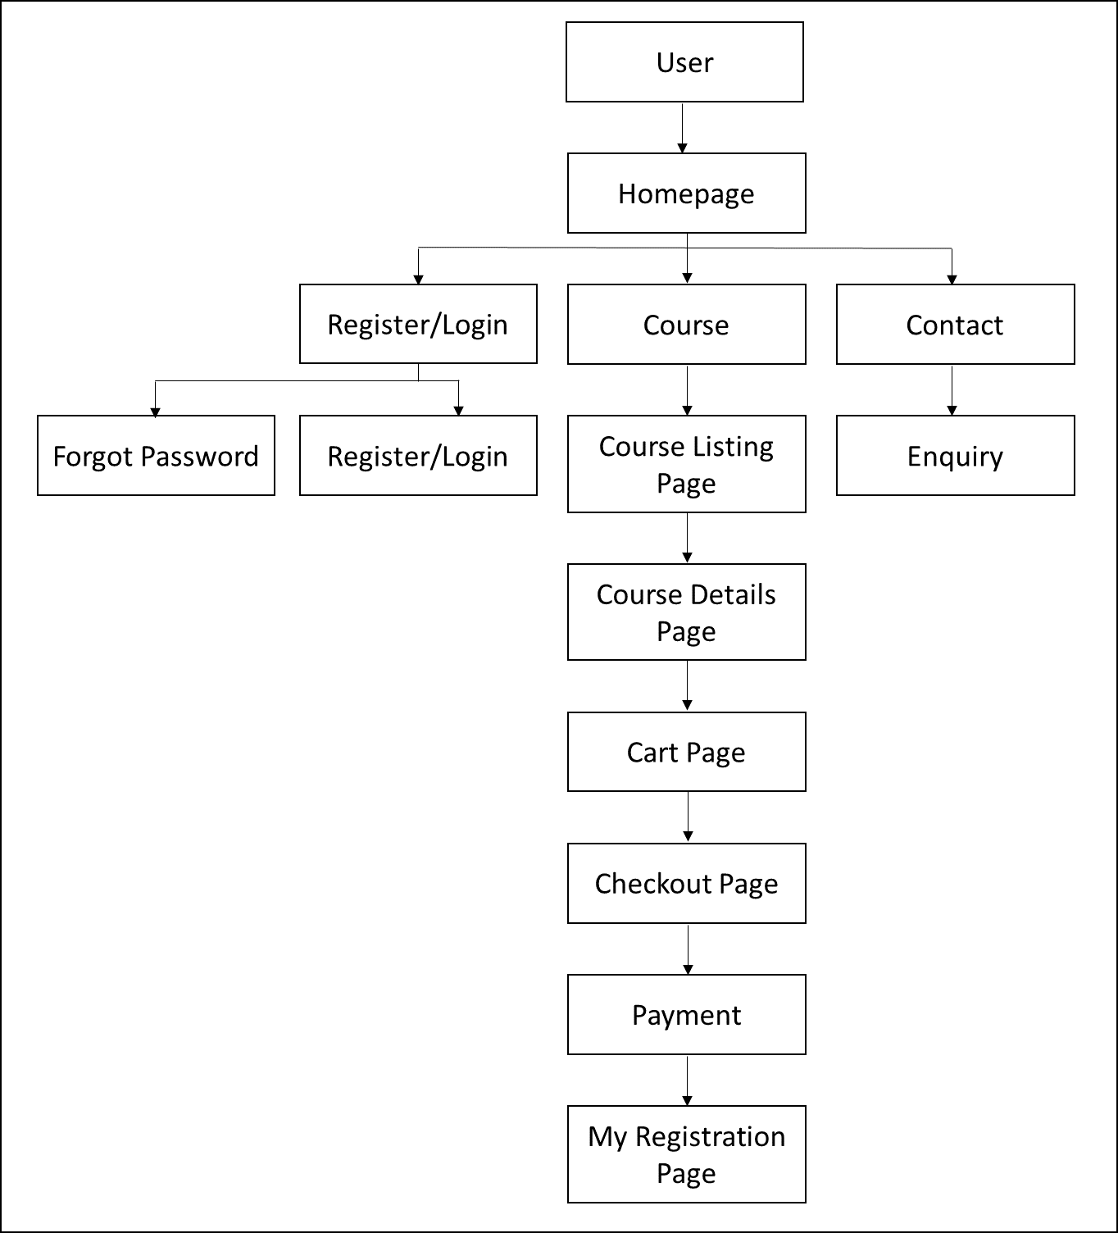

**Figure 3.5 Navigation Diagram of User**

**Figure 3.6** shows admin’s navigation diagram that begins with log in, dashboard and from there admin can choose the activity. The logout features is there on each of the web page.

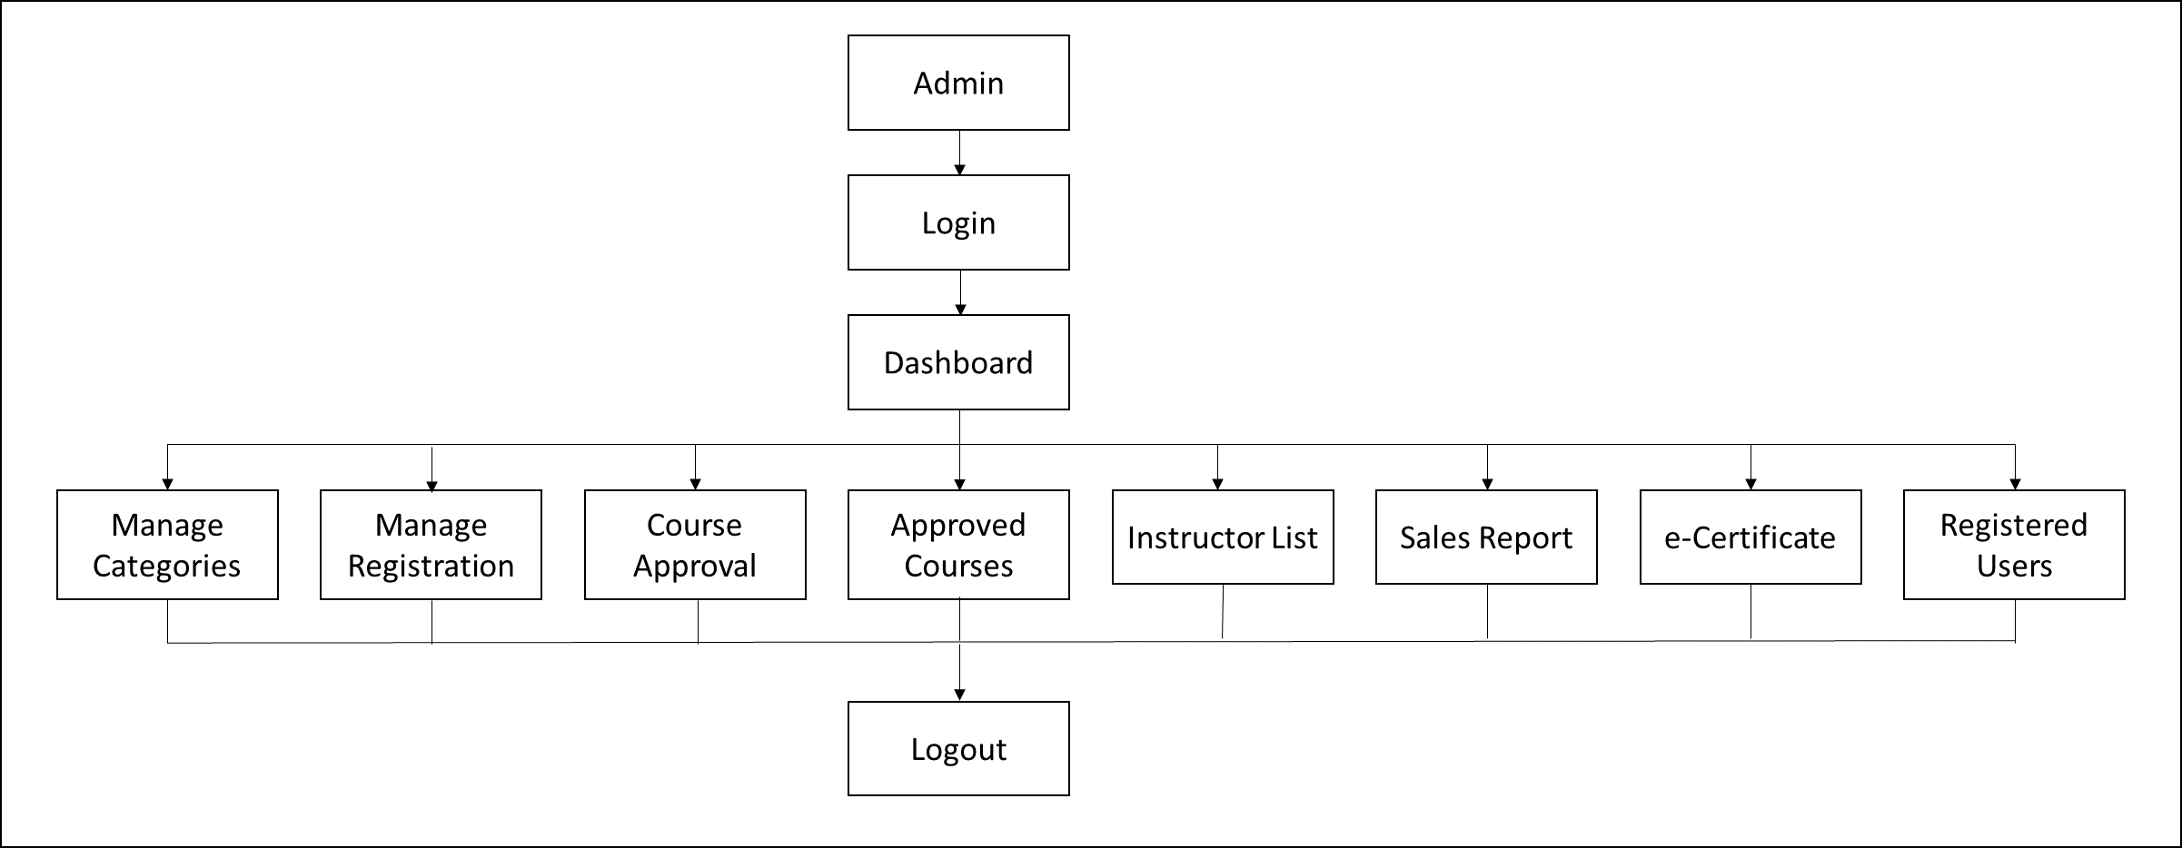

**Figure 3.6 Navigation Diagram of Admin**

**Figure 3.7** shows instructor’s navigation diagram which navigates from login page to dashboard and from there instructor can choose the activity. They are quite similar with the admin navigation diagram but with slightly different functions.

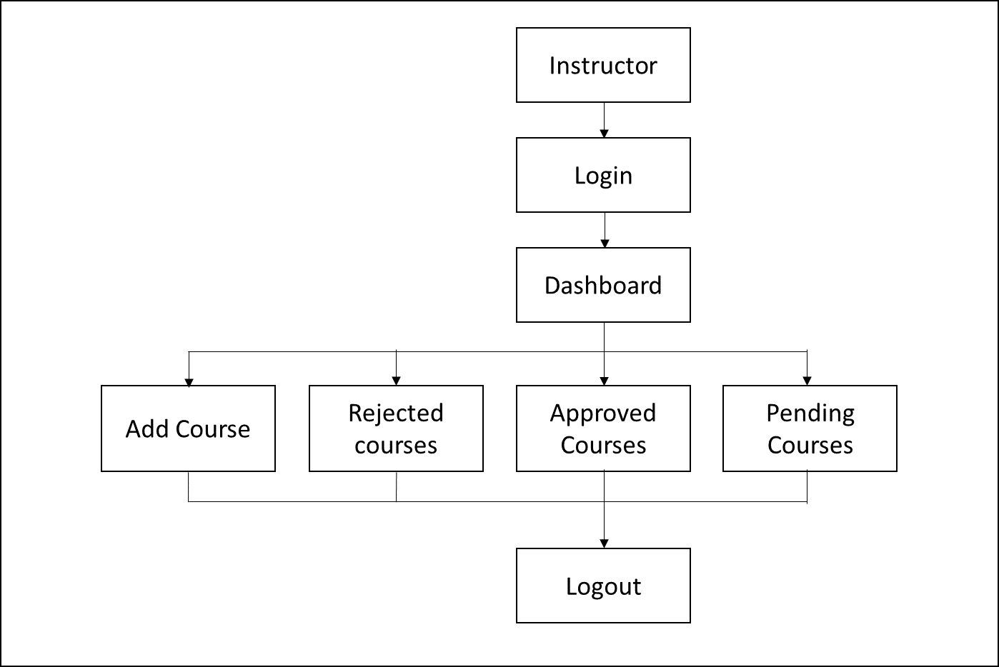

**Figure 3.7 Navigation Diagram of Instructor**

**3.7 SYSTEM INTERFACE LAYOUT**

**3.7.1 User’s Interface**

**Figure 3.8** shows the homepage of UNITEN Executive Education Programme Management System. The homepage contains information about the department and contact details for any kind of enquiry. It also provides subscription through email for any updates.



**Figure 3.8 Homepage**

**Figure 3.9** shows the enquiry form which can be found in the bottom of homepage.

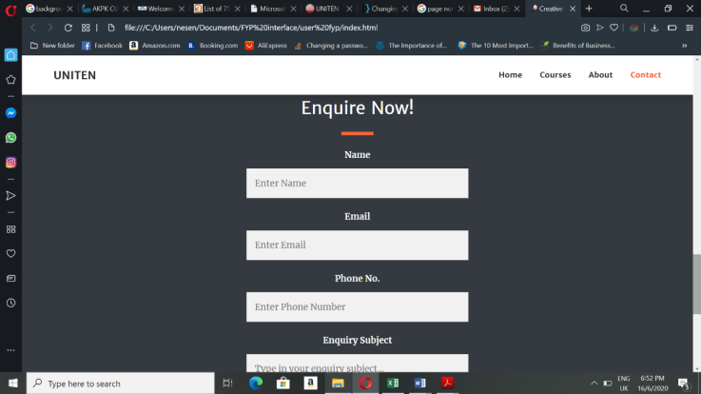

**Figure 3.9 Enquiry form**

**Figure 3.10** displays the list of courses provided by the department. Users can choose the categories they are interested in from the options given on the side or search for the courses with the search option. For further details of the programmes, details button should be clicked by the users.

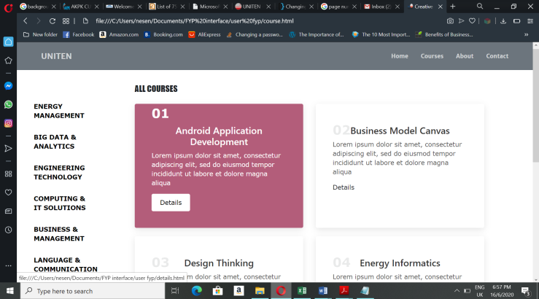

**Figure 3.10 Course List Page**

**Figure 3.11** shows the course descriptions after the details button clicked which is added by the admin. If users are interested in the course and want to purchase it they can click the “add to cart” button.



**Figure 3.11 Course Details Page**

After a course added to cart, the system will display the shopping cart page as in **Figure 3.12**. It has a table that contains course’s name users want to purchase with the quantity option and total amount of the course. If users want to confirm order, the “Proceed to Checkout” need to be clicked to continue the process.

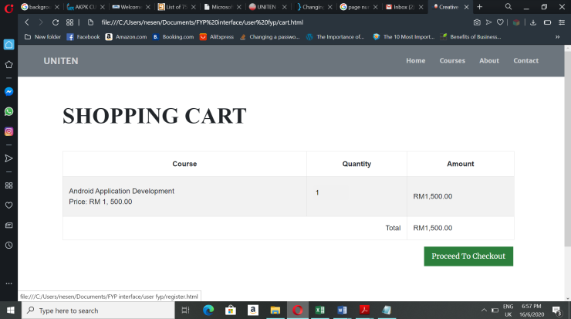

**Figure 3.12 Shopping Cart Page**

**Figure 3.13** shows a registration form where users have to fill up their name, email address, password, phone number, choose category whether they are a student or an employee to register. If users already registered before they have to sign in by clicking sign in.

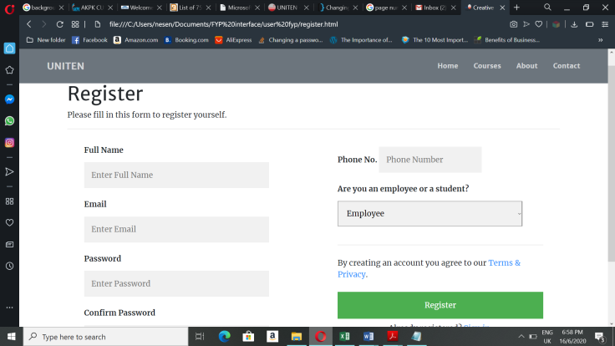

**Figure 3.13 User Register Page**

**Figure 3.14** shows the sign in page where users must enter their email address and password they used to register before to confirm order. This page is for users who have already registered before.

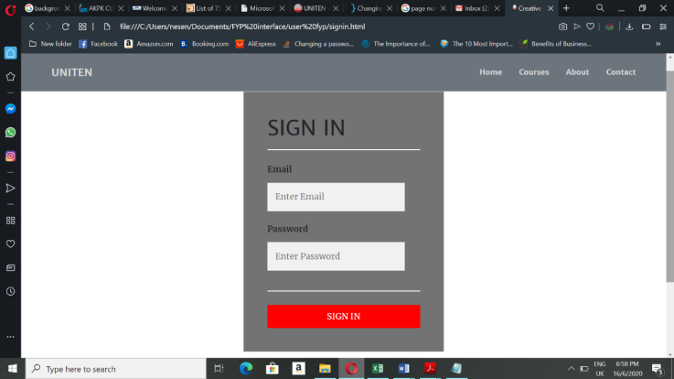

**Figure 3.14 User SignIn Page**

**Figure 3.15** shows the checkout page where payment details are entered by the users to pay for the order made. Users have to choose the payment method, full name, email address, billing address and click the done button to proceed with the payment. It will redirect users to online payment page according to the selection of payment method.

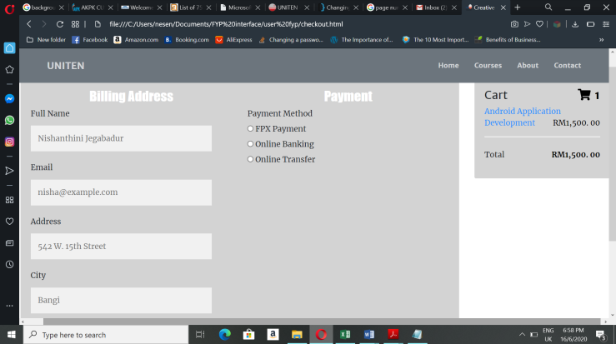

**Figure 3.15 Checkout Page**

**Figure 3.16** displays the payment successfully done and users will be notified with their invoice through email. This page will redirect to homepage upon clicking the ‘DONE’ button.

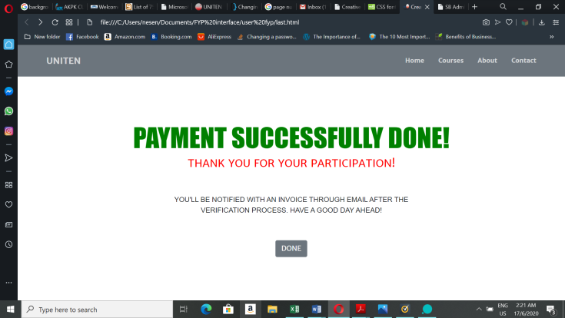

**Figure 3.16 Payment Successful Page**

**3.7.2 Admin’s Interface**

**Figure 3.17** shows the admin login page of UNITEN Executive Education Programme Management System. Admin can login into the system with Admin ID and password that specified for admins.

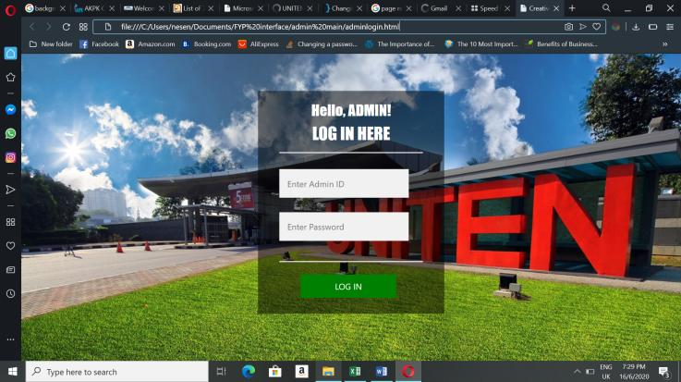

**Figure 3.17 Admin Login Page**

**Figure 3.18** shows the admin dashboard which displays all the key data in a webpage.

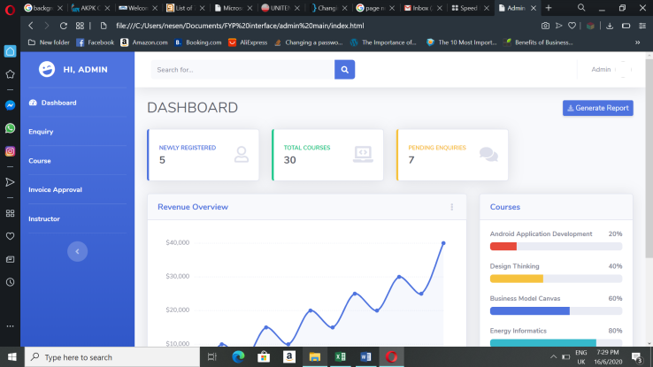

**Figure 3.18 Admin Dashboard**

**Figure 3.19** shows the enquiry management page where admins view the enquiries made by the users in table form and reply or decline each of the enquiry.

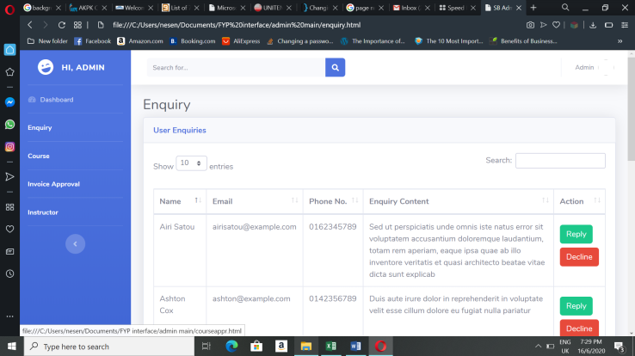

**Figure 3.19 Enquiry Management Page of Admin**

**Figure 3.20** shows course approval page where courses added by instructors shown in a table form. The admin will approve or decline the courses according to the requirements.

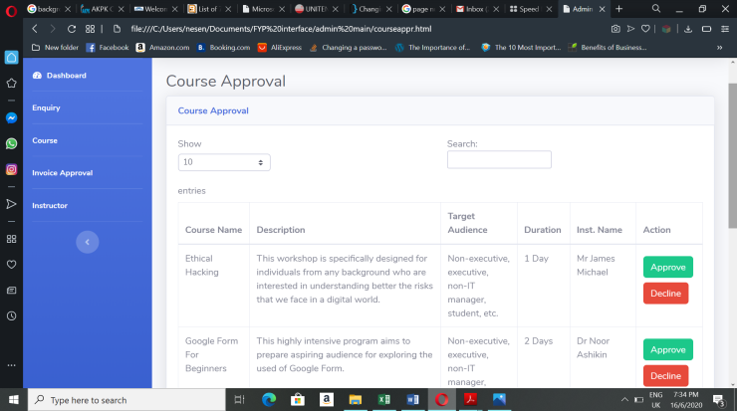

**Figure 3.20 Course Approval Page**

**Figure 3.21** shows invoice approval page where admin approves invoice for the payment made by the users. The invoice will be declined by the admin if they find any error in the payment made.

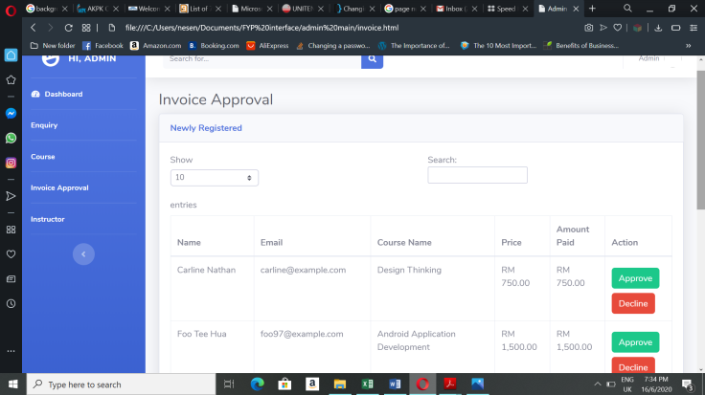

**Figure 3.21: Invoice Approval Page**

**Figure 3.22** displays instructors’ list who is involved in UNITEN Executive Education Programmes. Admin can add instructors by clicking the green button.

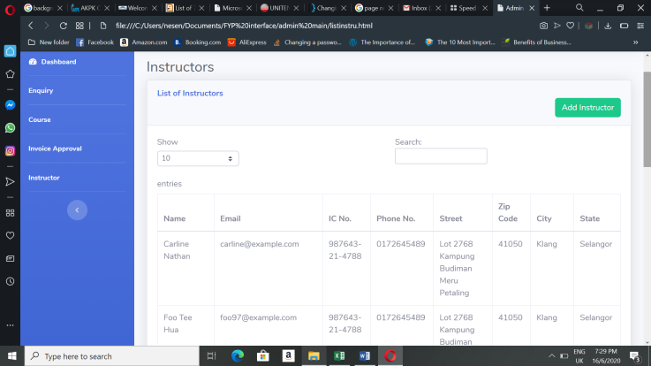

**Figure 3.22 Instructors’ List Page**

**Figure 3.23** shows the online form used by admin to create instructor account by adding their information such as their full name, email, phone number and others.

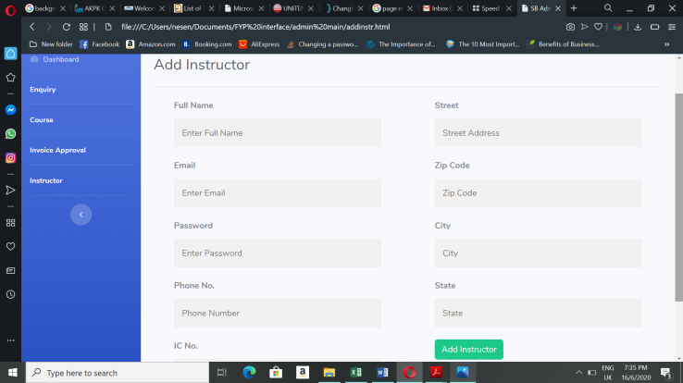

**Figure 3.23 Form to add instructors**

**Figure 3.24** shows a prompt where admin given a choice logout to end the current session. Logout option can be found at the top right of the page. Upon logging out, the page will be redirected to the admin login page.

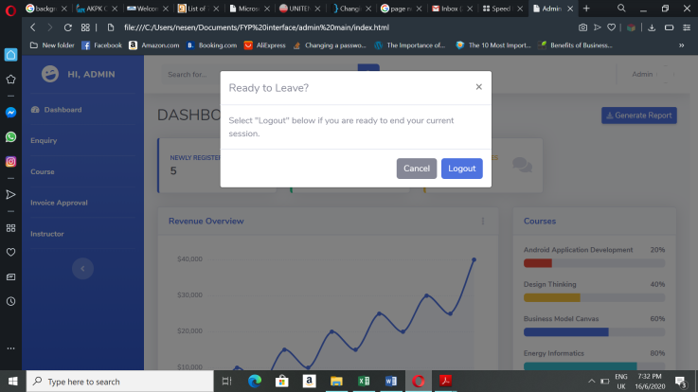

**Figure 3.24 Logout Prompt of Admin Page**

**3.7.3 Instructor’s Interface**

**Figure 3.25** shows the instructor login page where instructors can login into UNITEN Executive Education Programme Management System with their email address and password.

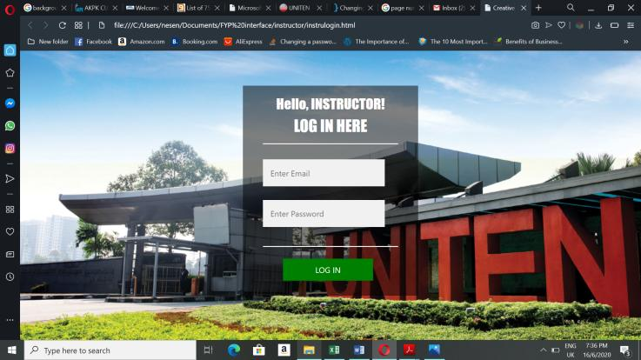

**Figure 3.25 Instructor Login Page**

**Figure 3.26** shows instructor dashboard which displays key data such newly registered, course current capacity and number of total courses in the system.

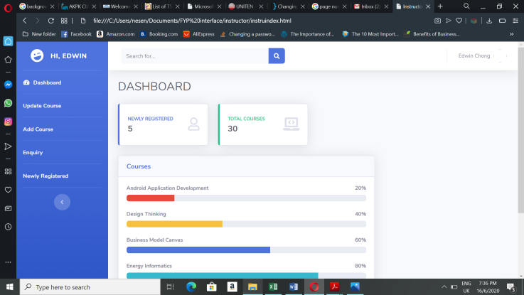

**Figure 3.26 Instructor Dashboard**

**Figure 3.27** shows the course list that are approved by the admin and instructor can view and edit the course contents.

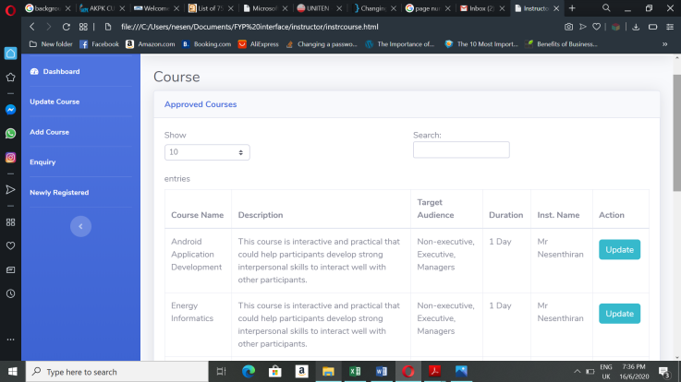

**Figure 3.27 Approved Course List Page**

**Figure 3.28** shows a form where instructors can edit the content of the course and update it.

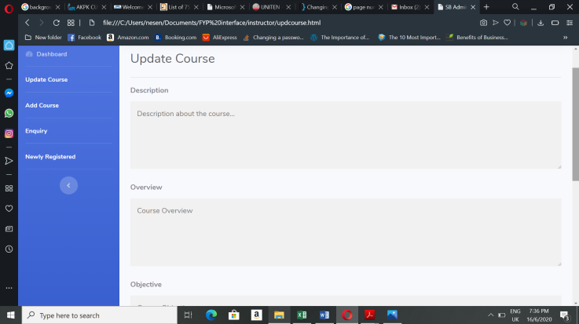

**Figure 3.28 Update Course Form**

**Figure 3.29** shows a form that used by instructors to add course which will approved by the admin later. This form requires the course name, description and more course details.

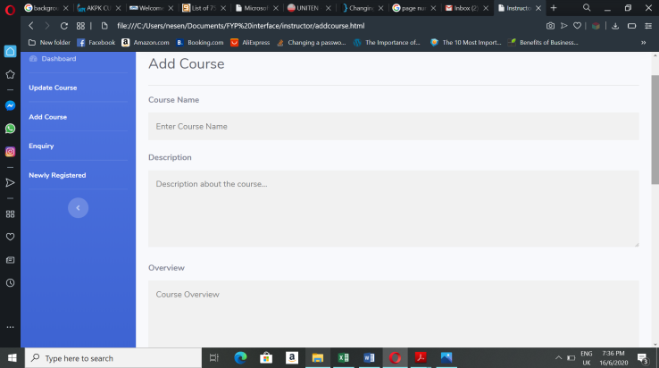

**Figure 3.29 Add Course Form**

**Figure 3.30** shows the enquiry management page where instructors can view the enquiries made by the users in table form and reply or decline each of the enquiry.

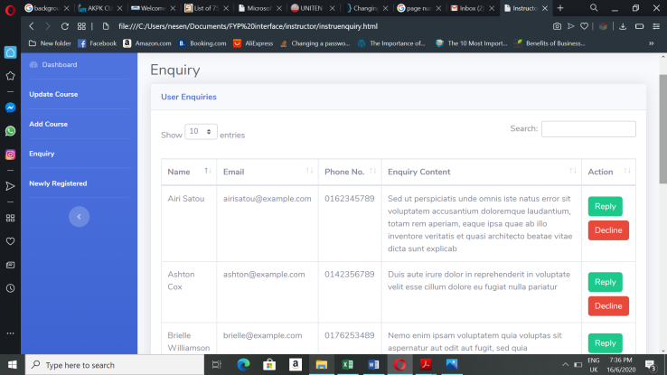

**Figure 3.30 Enquiry Management Page of Instructor**

**Figure 3.31** shows the information of users who recently registered courses and instructors have access to view it.

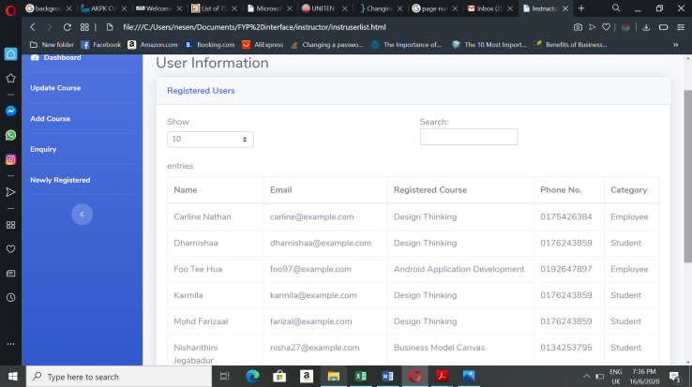

**Figure 3.31 Users’ Information Page**

**Figure 3.32** shows a prompt where instructors given a choice logout to end the current session. Logout option can be found at the top right of the page. Upon logging out, the page will be redirected to the instructor login page.

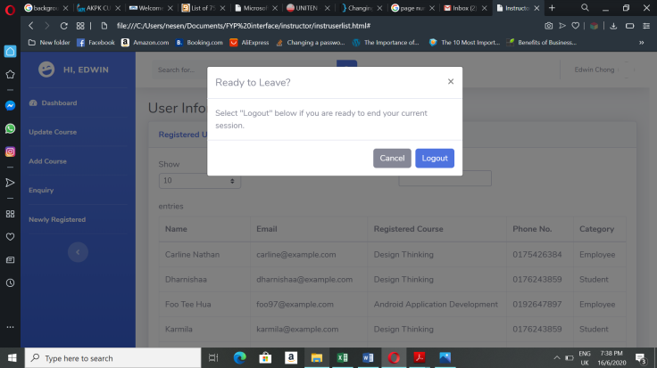

**Figure 3.32 Logout Prompt of Instructor Page**

**3.8 CONCLUSION**

This chapter mostly discussed about the design part of the project which can be used as a guideline to develop the complete system that includes coding and testing. This will make the construction phase easier later in the Project 2. This chapter also includes the diagrams and data dictionary which can be helpful in organizing the database structure.

**CHAPTER 4**

**IMPLEMENTATION**

**4.0 OVERVIEW**

Chapter 4 focuses on developing the proposed system and implementing the designs shown in the last chapter. Hardware and software used to develop the system also listed in this chapter. Tables for phpMyAdmin that used to give connectivity to the interfaces can be seen in this.

**4.1 DEVELOPMENT ENVIRONMENT**

Development environment is essential for developing any software or application because it provides suitable hardware and software that a system developer needed to build systems. This environment helps to speed up the development process and also reduce the number errors made by the developers from time to time by giving a clear picture to them. Without development environment, developers would not be able to complete projects on time.

**4.1.1 Hardware Requirements**

The main component used to develop the ‘UNITEN Executive Education Programme Management System’ is a laptop. **Table 4.1** shows the hardware specifications of the laptop that has been used for system implementation.

**Table 4.1:** Hardware Requirements

|  |  |
| --- | --- |
| **Hardware** | **Description** |
| Processor | Intel CoreTM i5 |
| RAM | 4GB |
| Storage available | 42.1GB |

**4.1.2 Software Requirements**

**Table 4.2** shows the list of software and tools required to develop the UNITEN Executive Education Programme Management System (EEProMS).

**Table 4.2:** Software Requirements

|  |  |
| --- | --- |
| **Software** | **Description** |
| Opera & Microsoft Edge | These web browsers used to run the code |
| XAMPP Server | Server used to host the developed system |
| Notepad++ | To write and edit source code |
| PhpMyAdmin | Database that gives connection to the system created in phpMyAdmin |

**4.2 IMPLEMENTATION OF UNITEN EEProMS**

UNITEN Executive Education Programme Management System used ‘Waterfall Model’ approach where implementation phase of the system began only after design phase is completed. For this system, the interface design in Chapter 3 re-used for the implementation phase after making some changes as it was developed using HTML and CSS code. After that, several tables are created in phpMyAdmin which are listed in the previous chapter as data dictionary. Later, to establish the connection between the system interface and database, PHP language code used by the developer to make the system functional.

**4.2.1 Description of Developed System**

This system is mainly developed for UNITEN Business Development Department to manage the courses or programs they provide. This system helps the admin, instructor and users to connect with each other in maintaining and managing the educational programs.

**4.3 TECHNICAL DETAIL OF IMPLEMENTATION**

Different types of tools and software such as Notepad++, phpMyAdmin and GitHub has been used in order to complete the implementation phase of the proposed system.

**4.3.1 Notepad++**

Notepad++ is easy to get as it can be installed from browser for free. And it is also easy to use as the code organized well and the error made by developers can be identified quickly. Figure 4.1 shows the code written in Notepad++.

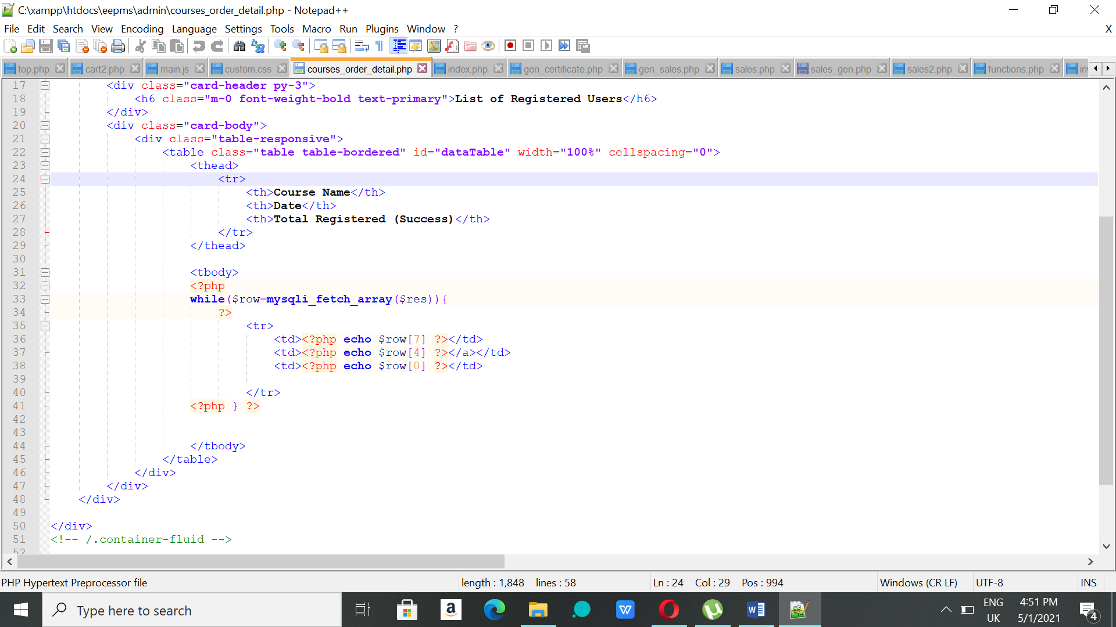

**Figure 4.1:** Code in Notepad++

**4.3.2 PhpMyAdmin**

PhpMyAdmin is used to create database where data can be stored, retrieved, updated, deleted and more. It holds data inserted throughout the use of system. **Figure 4.2** shows the list of tables created for this system.

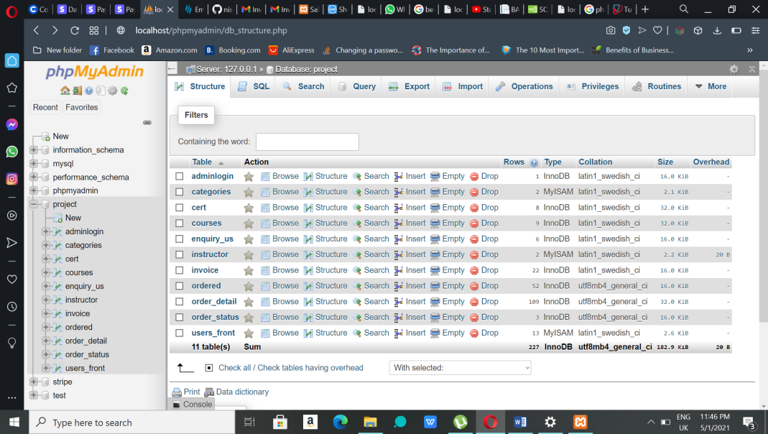

**Figure 4.2:** phpMyAdmin

**4.3.3 GitHub**

GitHub was used to store the project folder safely and acts as a backup where the folder can inserted and updated easily. It is also used by the developer to get reference code that can referred to write the code. Figure 4.3 shows the project folder stored in the GitHub.

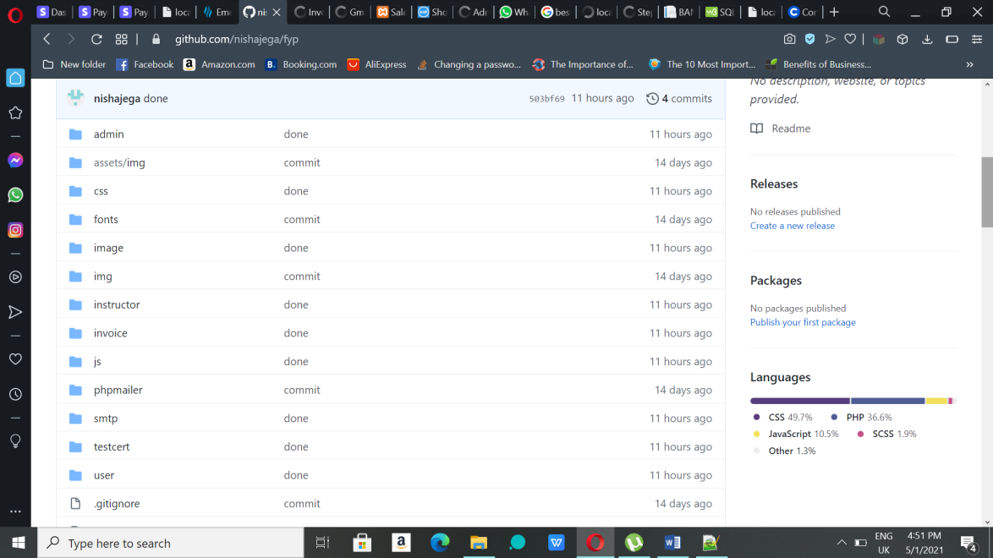

**Figure 4.3:** GitHub

**4.4 DATABASE IMPLEMENTATION**

There are 10 tables under the ‘project’ database that has been used by the developer. Below are the list of tables with their structure.

**Figure 4.4** shows the admin login table that has two attributes named username and password and this table has administrator’s login details.

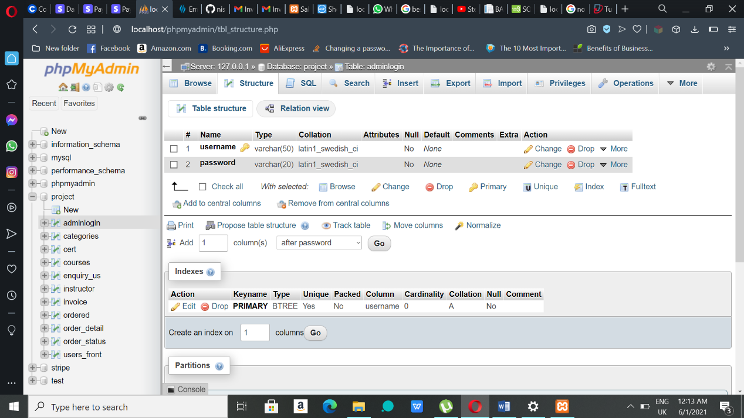

**Figure 4.4:** Admin login table

**Figure 4.5** shows the categories table that has three attributes names id (unique), categories and status and this table stores course’s category details.

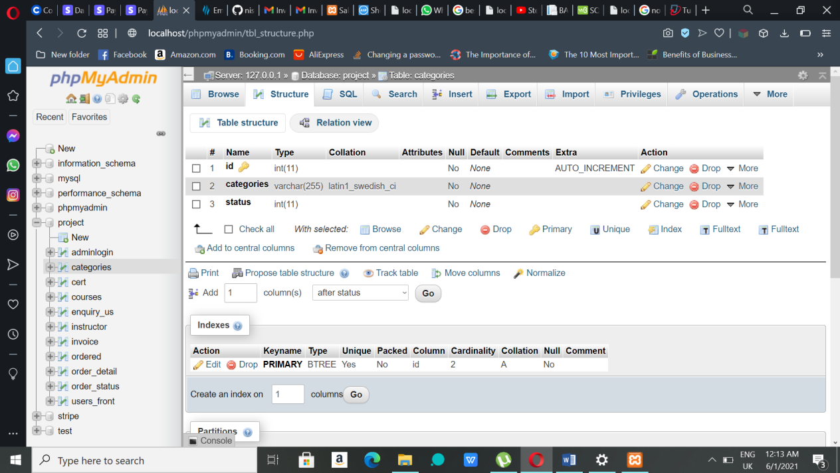

**Figure 4.5:** Categories table

**Figure 4.6** shows certificate table that contains attributes such as id, order detail id, name, email, course, date, instructor and status. This table stores data that will be used for e-certification.

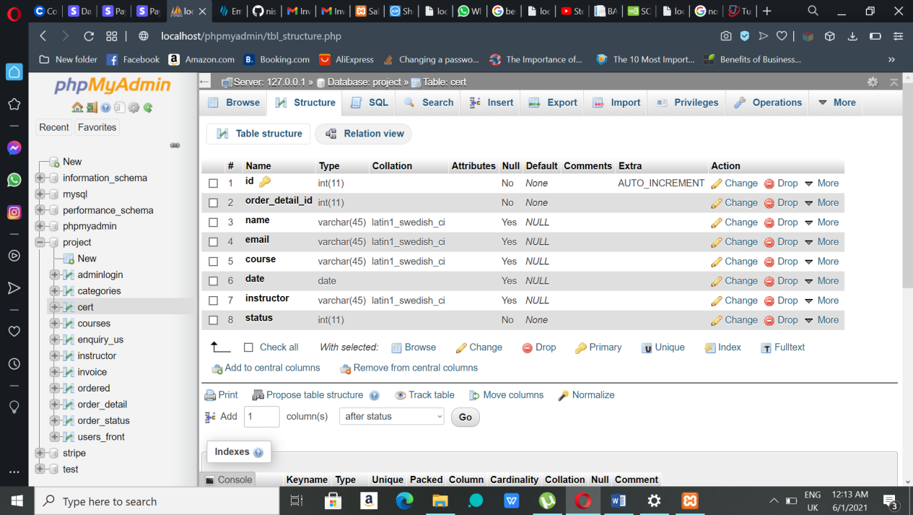

**Figure 4.6:** Certificate table

**Figure 4.7** shows the courses tables which contains many attributes such as id, categories id, name, description, overview, audience target, duration, price, date, date2, date3, date4, instructor name, active and filename. This table is used to store course or program details.

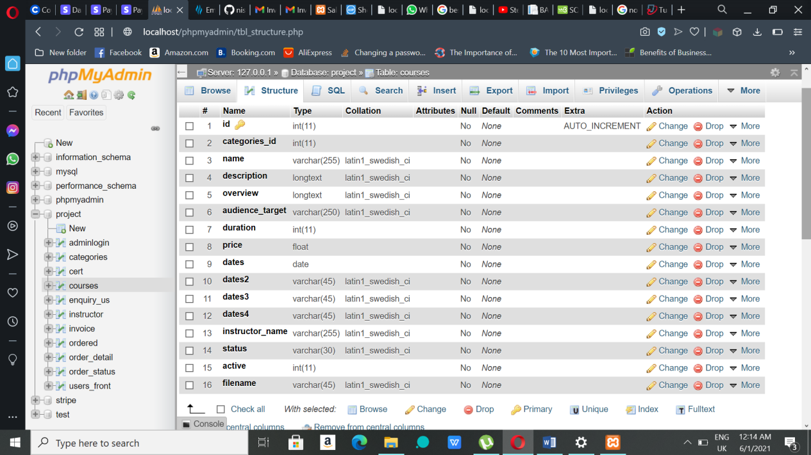

**Figure 4.7:** Courses table

**Figure 4.8** shows the enquiry table which contains attributes such as id, name, email, phone and enquiry. This table has details of enquiry made by the users.

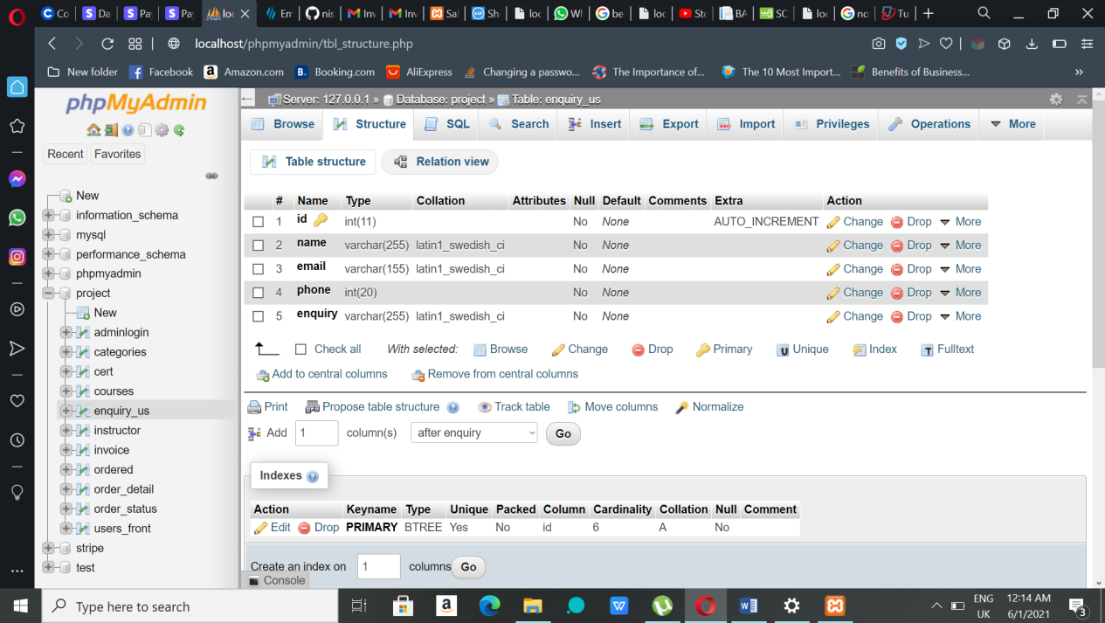

**Figure 4.8:** Enquiry table

**Figure 4.9** shows instructor table that contain id, name, email, password, staff number, verification id, verification status and status as attributes. This table has data of registered instructors.

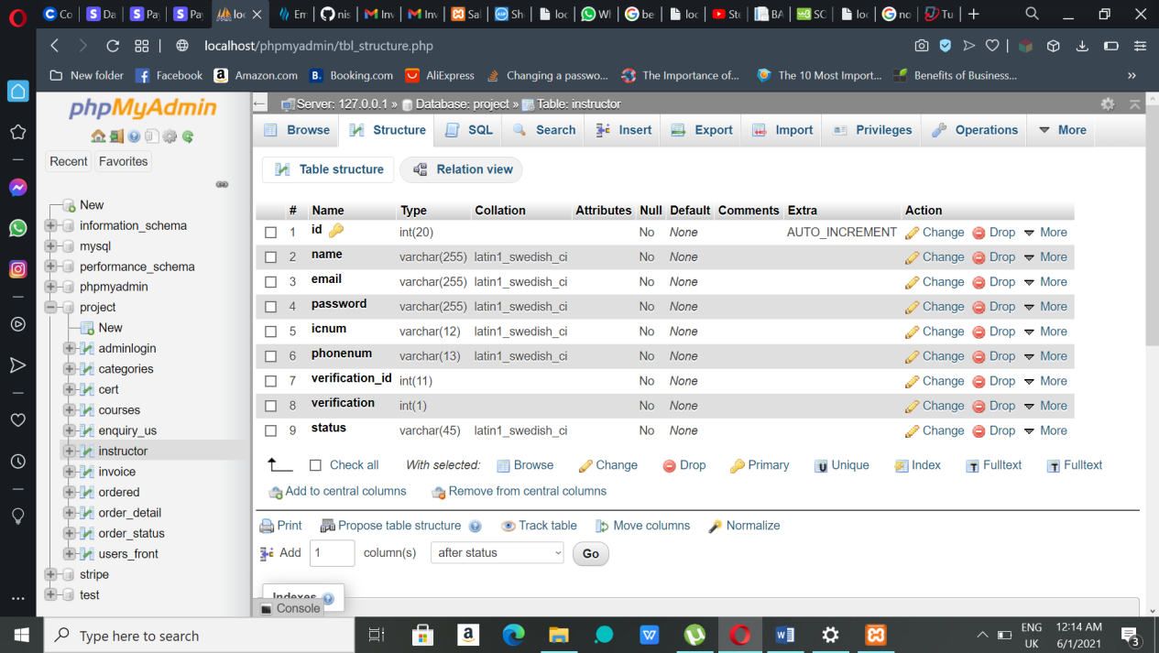

**Figure 4.9:** Instructor table

**Figure 4.10** shows the order table which contains attributes such as id, user name, address, state, postcode, total price, payment status, token, order status and added on. The data after making purchases will be inserted in this table.

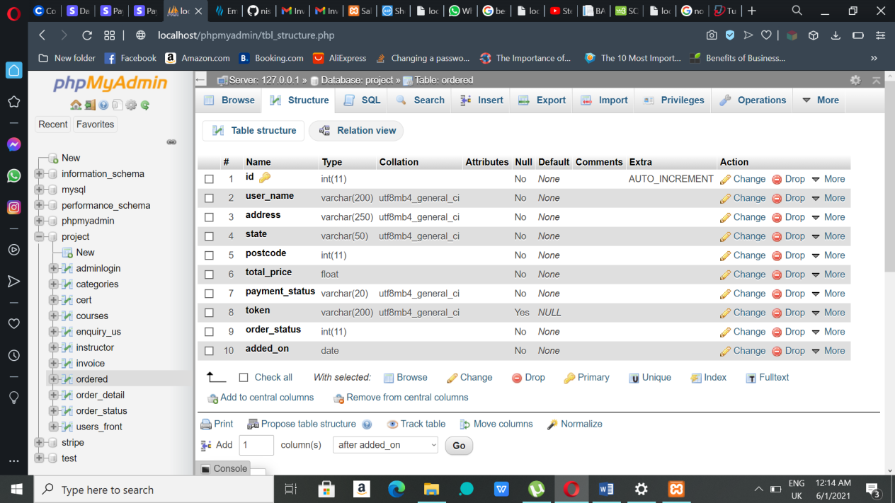

**Figure 4.10:** Order table

**Figure 4.11** shows order detail table that has id, ordered, product id, date, quantity and price as attributes. This table contains order details of every order.

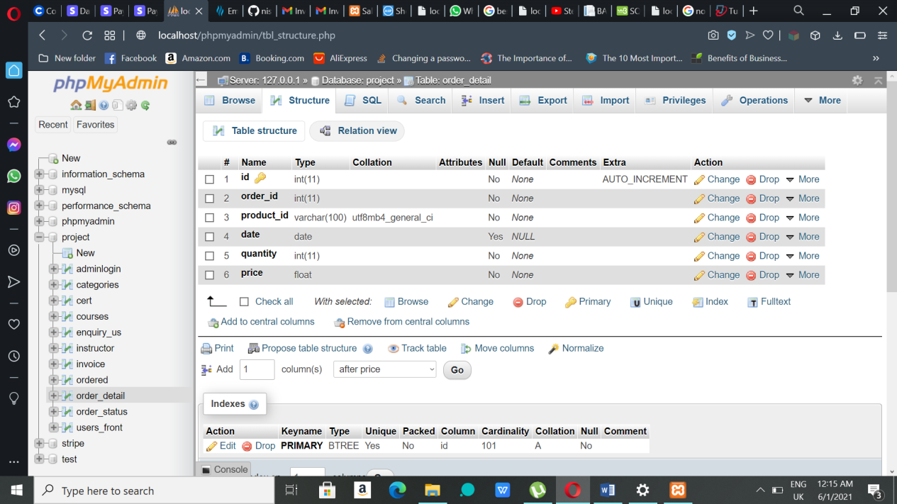

**Figure 4.11:** Order detail table

**Figure 4.12** shows order status table that has only two attributes named as id and name. This table contains data of order status.

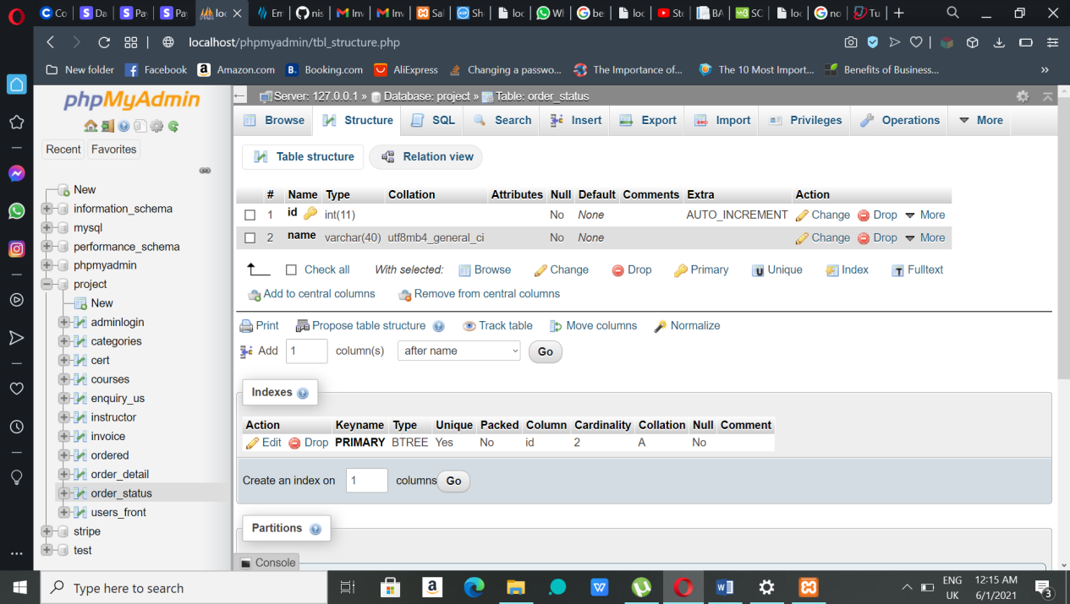

**Figure 4.12:** Order status table

**Figure 4.13** shows users table that contains id, name, email, password and phone number as attributes. This table has the users’ information who registers in the system.

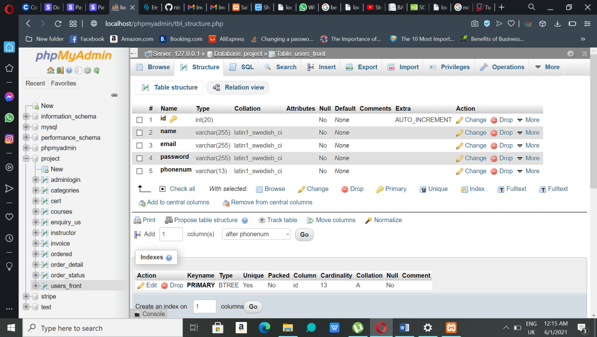

**Figure 4.13:** User table

**4.5 USER MANUAL**

As the system is new to users, the user manual will guide them throughout the system. This user manual is for three main user of the system that are admin, instructors and users.

**4.5.1 Instructor Interface and Functionalities**

**Instructor Registration and Login**

1. Instructor will be given the link by administrator to register themselves in the system and the link is http://localhost/eepms/instructor/register.php.
2. The link will get them to register page as shown in **Figure 4.14**.
3. Instructor then registers by filling in all the required details and a valid email to receive a link that is shown in the **Figure 4.15**.

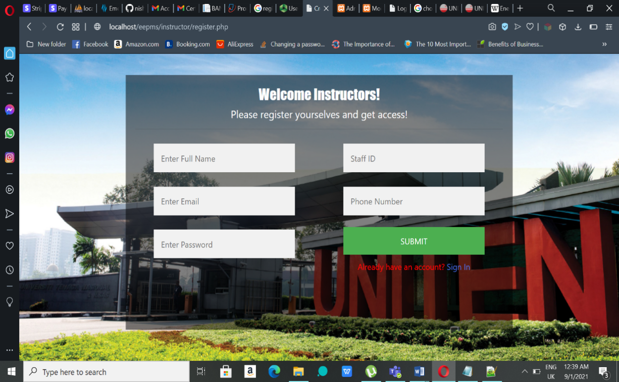

**Figure 4.14**: Instructor Register Page

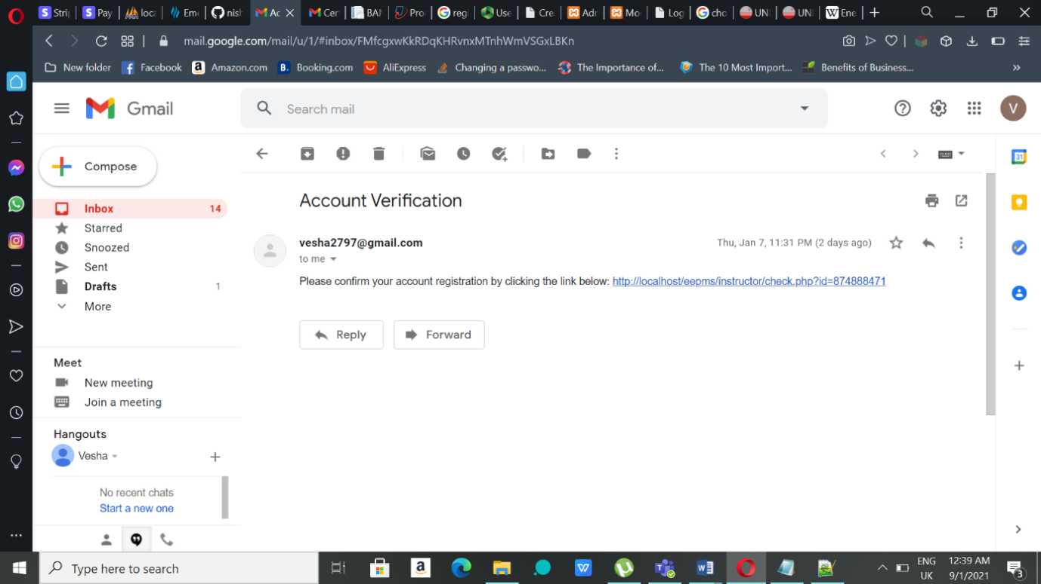

**Figure 4.15:** Account verification link

1. After clicking the link they will be redirected to the login page as shown in **Figure 4.16** where instructor must enter the valid and correct login details to get into the system.
2. After successful login, the page will be redirected to instructor’s dashboard page.

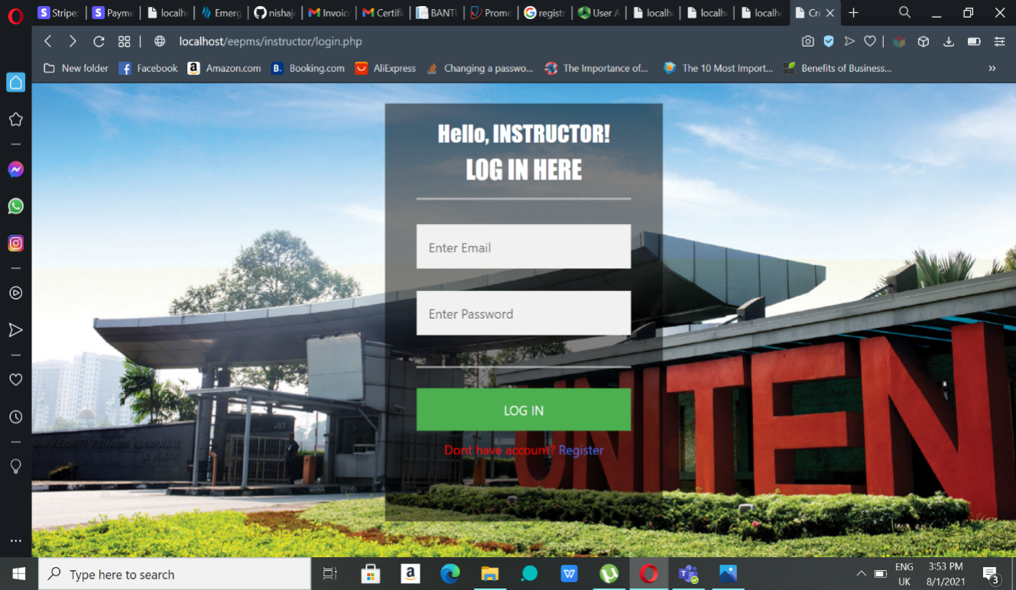

**Figure 4.16:** Instructor Login Page

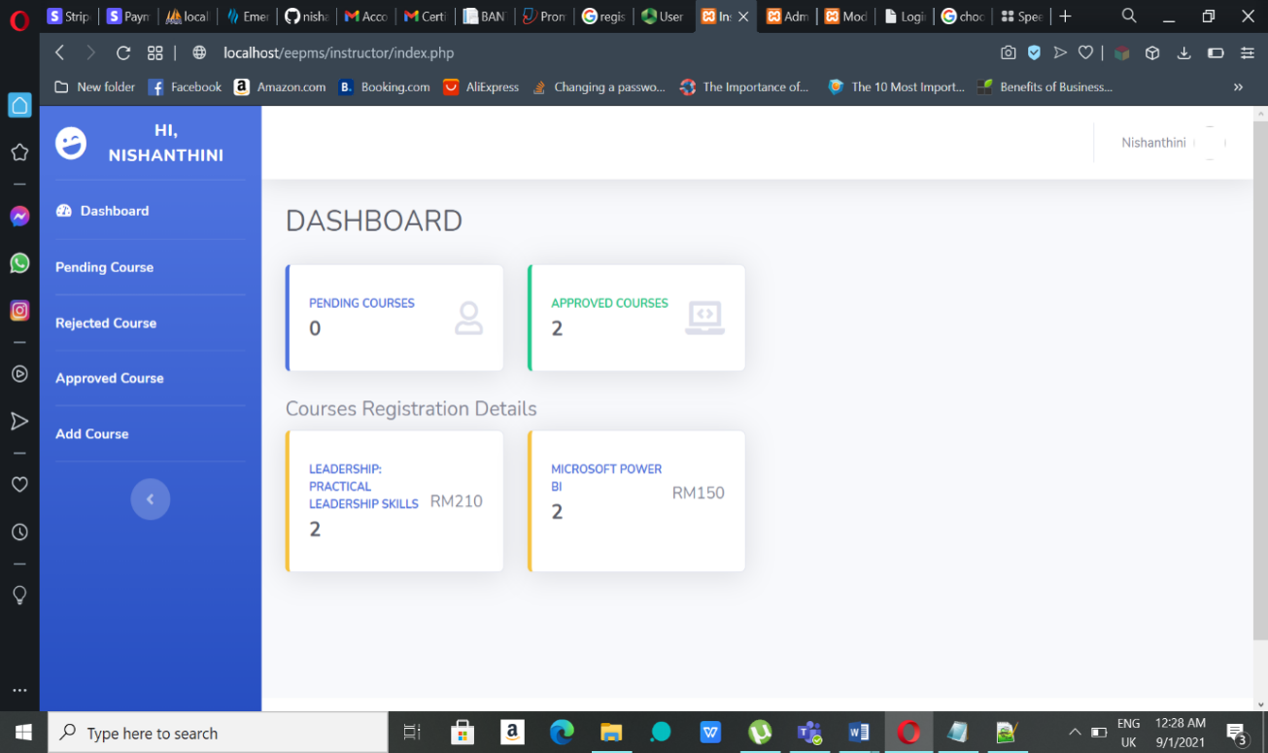

**Figure 4.17:** Instructor dashboard

**Adding Course**

1. To add a course, instructor should click ‘Add Course’ in the left-side menu, where a form will appear to be filled up as shown in the **Figure 4.18**.
2. After filling in all the required fields, click on the ‘Submit’ button given below the form to add the course. The added course can be seen in the Pending Course page.

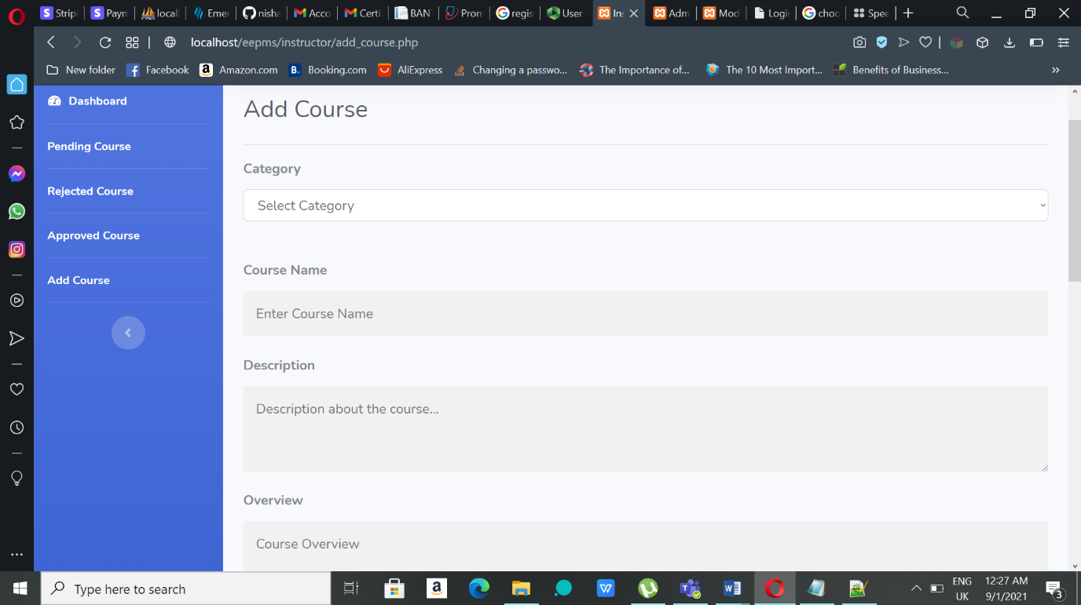**Figure 4.18:** Add Course Page

**Editing and Updating Courses**

1. Courses can edited and updated in two pages that are Pending Course and Approved Course page and it only can be edited while its status is in Pending or Approve. In order the edit the courses that are already added instructor should click the ‘Edit’ button which can be seen in the Figure 4.19 and 4.20. The pending courses will move to the Approved Courses page once the admin approve the course.

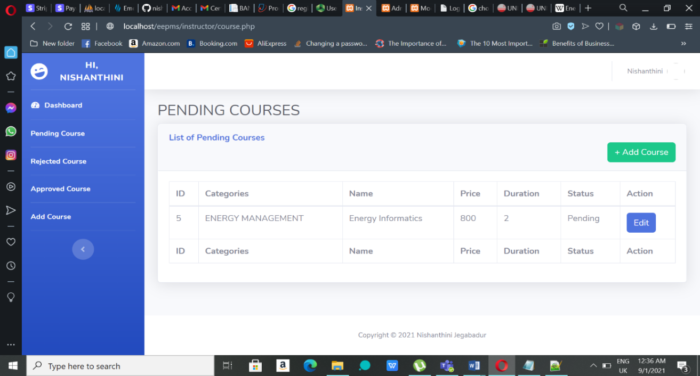**Figure 4.19:** Pending Courses Page

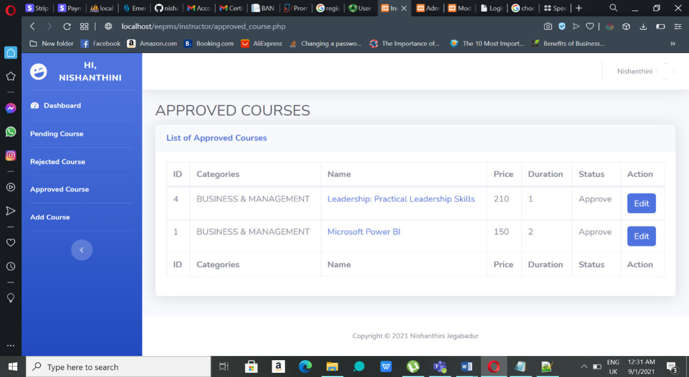

**Figure 4.20:** Approved Courses Page

1. After clicking the edit button, a form with existing course details will appear like in the **Figure 4.21**. Click the ‘Submit’ button to update the edited details.

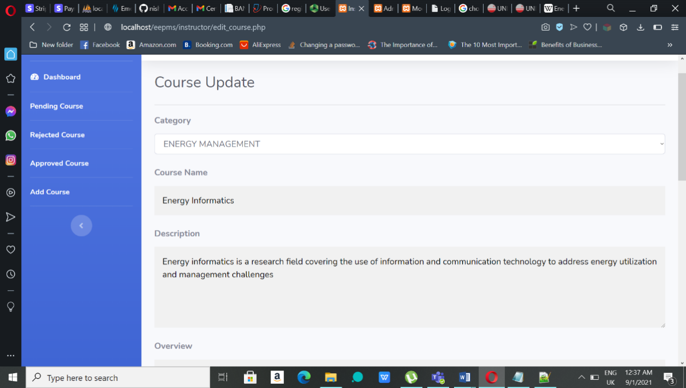

**Figure 4.21:** Edit and Update Course Page

**Deleting Courses**

1. Instructors can only remove or delete courses in Rejected Courses page after it gets rejected by the admin. To delete the course, click the ‘Clear’ button and confirm the alert by clicking ‘OK’ to proceed with the deletion. The course will be deleted after confirmation.

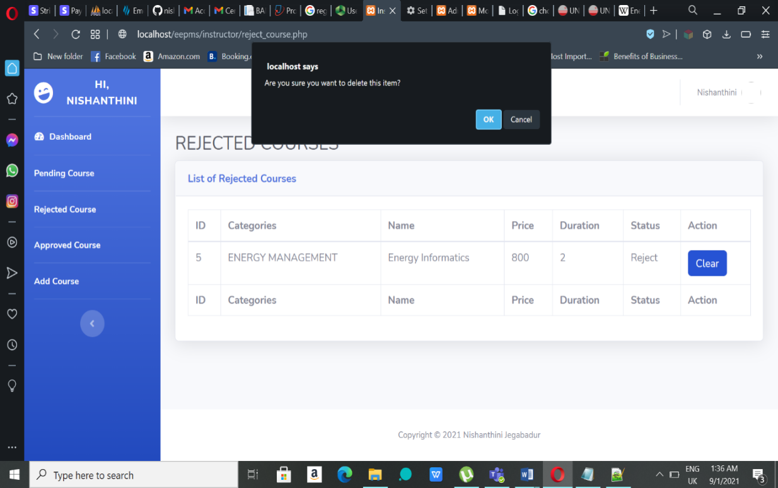

**Figure 4.22:** Rejected Course Page

**Logout**

1. In order the logout the system, click on the name on top right and click ‘Logout’ to get out of the system as shown in the **Figure 4.23**.

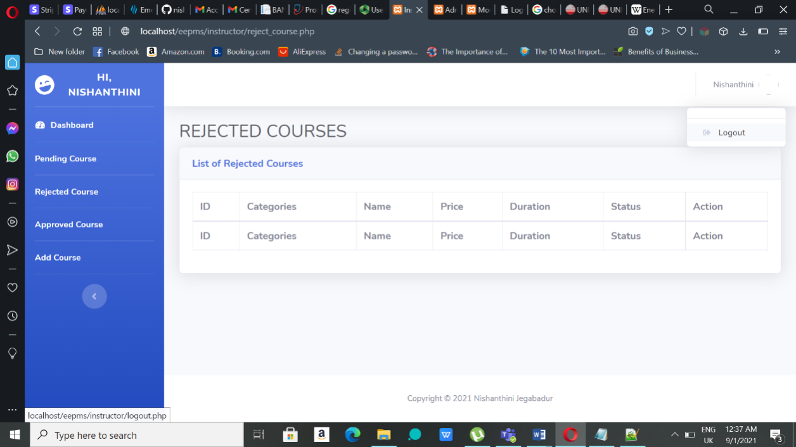

**Figure 4.23:** Logout

**4.5.2 Admin Interface and Functionalities**

**Admin Login**

1. Run xampp server and enter the link <http://localhost/eepms/admin/login.php>.
2. After clicking the link, admin will be redirected to the login page as shown in **Figure 4.24**. Then, the admin enters the username and password given by the developers and click the ‘Log In’ button to enter the system.

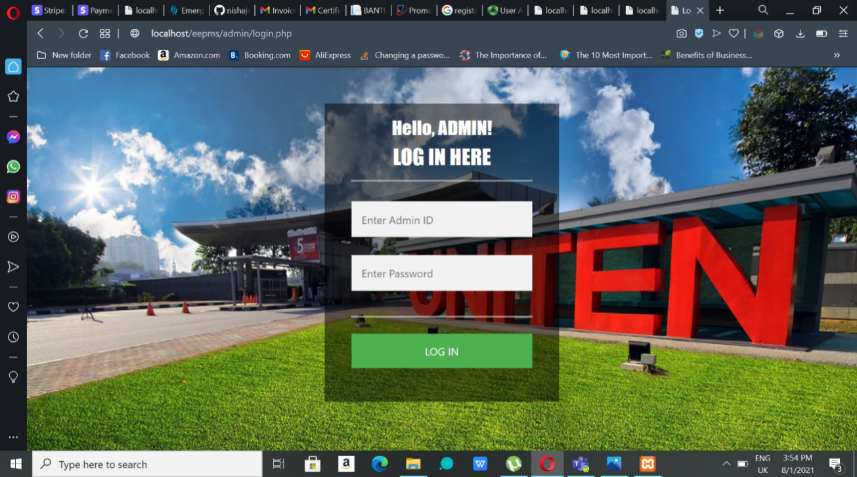

**Figure 4.24:** Admin Login Page

**Dashboard**

Once the login successful, the page will be redirected to Admin’s dashboard where it gives a brief glance of current flow of the system. 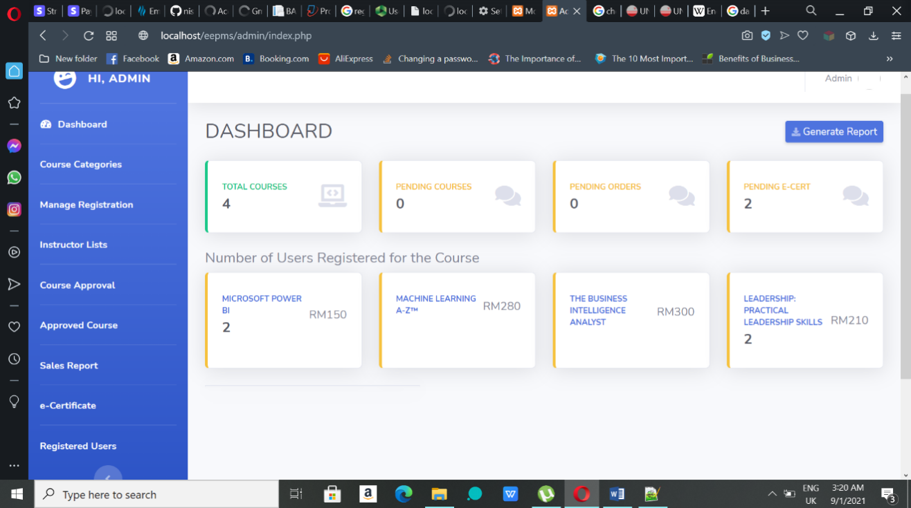

**Figure 4.25:** Dashboard Page

**Managing Categories**

1. Courses usually belong to a category so, these categories are managed by the admin. Admin can add, edit, delete and make it active or deactivate the categories. The ‘Active’ button shows that the category is active in the front-end and clicking it will change it to ‘Deactivate’ button so it cannot be seen in the front-end. Clicking the ‘Add Categories’ button will redirect the user to a form.

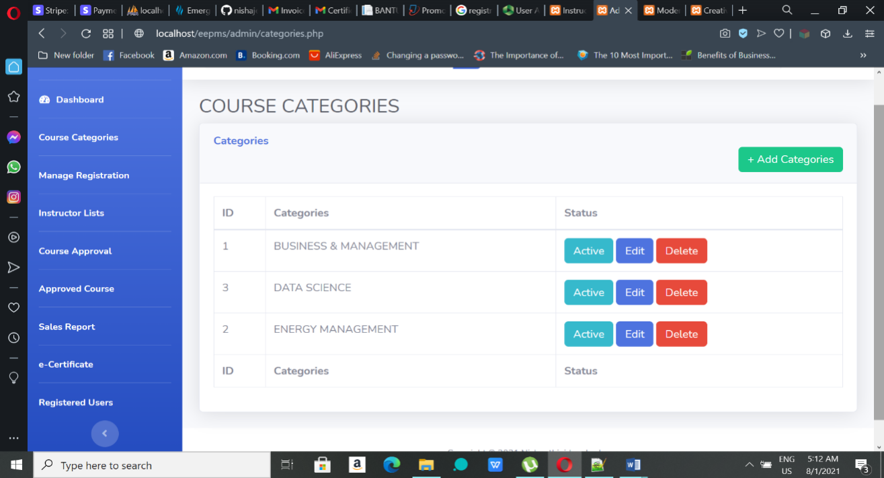

**Figure 4.26:** Categories Page

1. After entering a category in the form shown in **Figure 4.27**, the user should click the ‘Submit’ button to successfully add the category to the system and database.

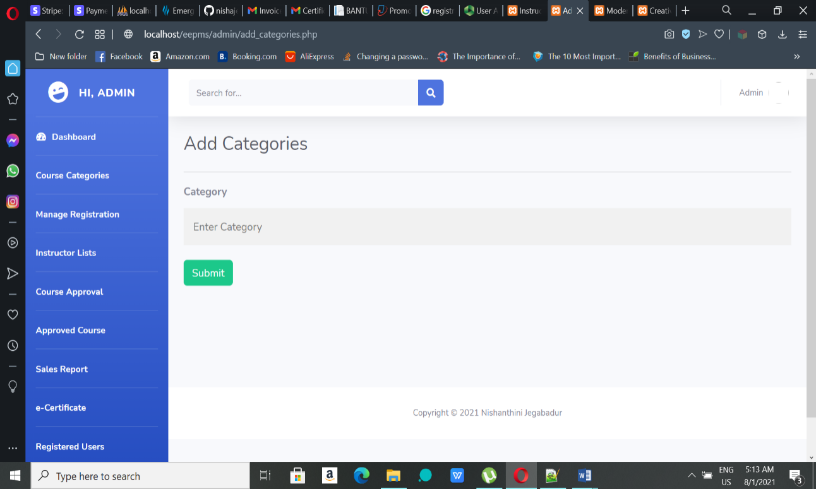

**Figure 4.27:** Add Categories Page

1. After clicking the ‘Edit’ button in Categories Page, a form with existing category will be shown. The user can edit and click ‘Submit’ button to update the particular category.

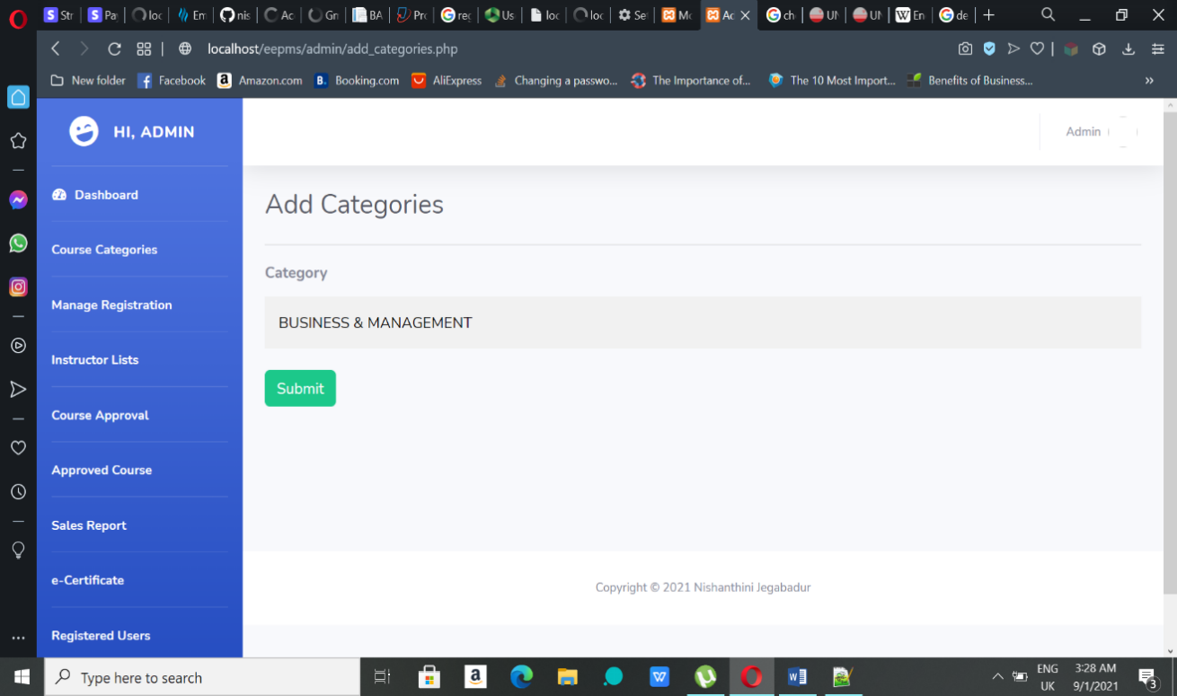

**Figure 4.28:** Edit and Update Categories Page

1. To delete a category, click the ‘Delete’ button and confirm the alert by clicking ‘OK’ to proceed with the deletion. The particular will be deleted after confirmation.

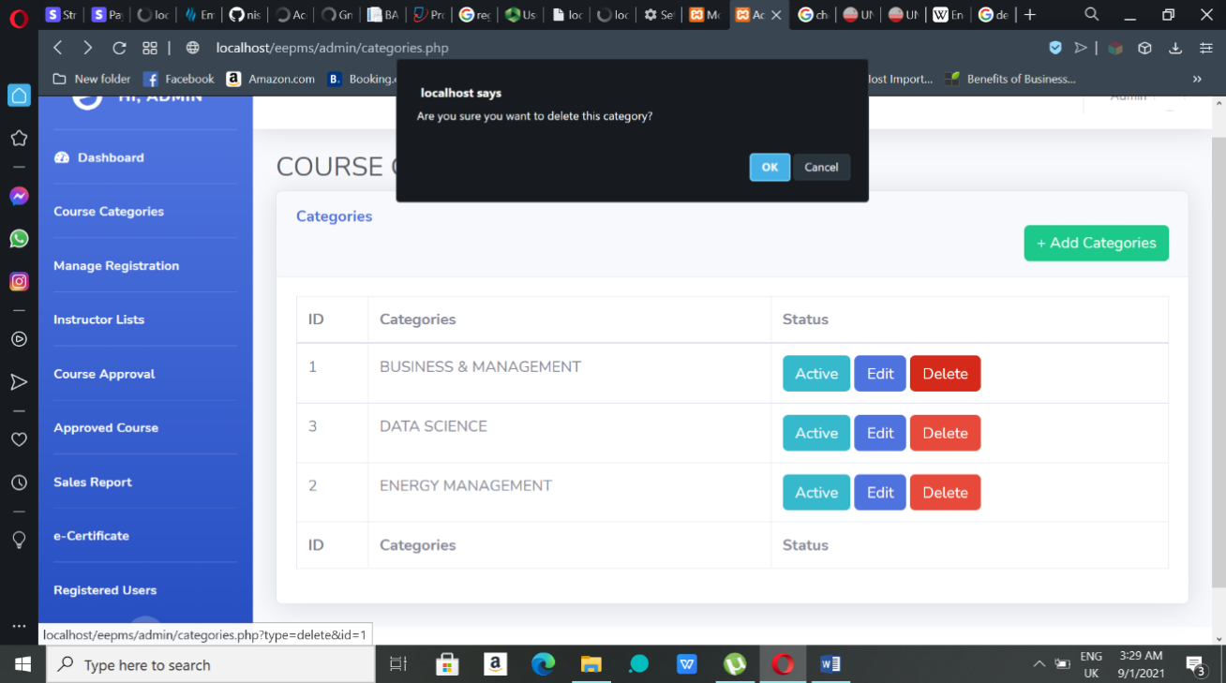

**Figure 4.29:** Delete Categories

**Approval of Course**

1. The course added by instructors will be approved by the admin to be displayed in the front-end. In Course Approval page, clicking the ‘Reject’ or ‘Approve’ button will redirect them to a form with the course details.

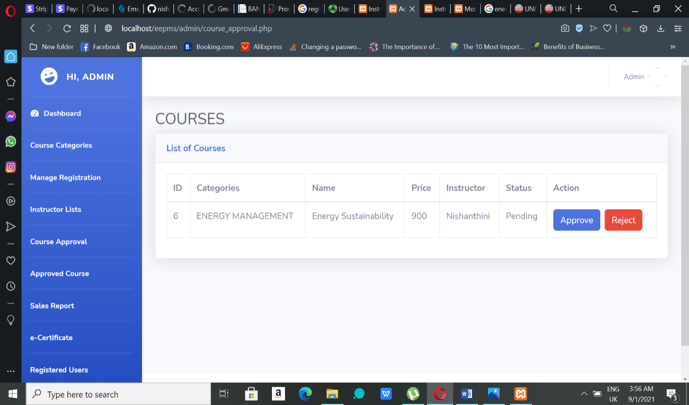

**Figure 4.30:** Course Approval Page

1. To approve the course chosen, admin should the ‘Approve’ button in the end of the form.

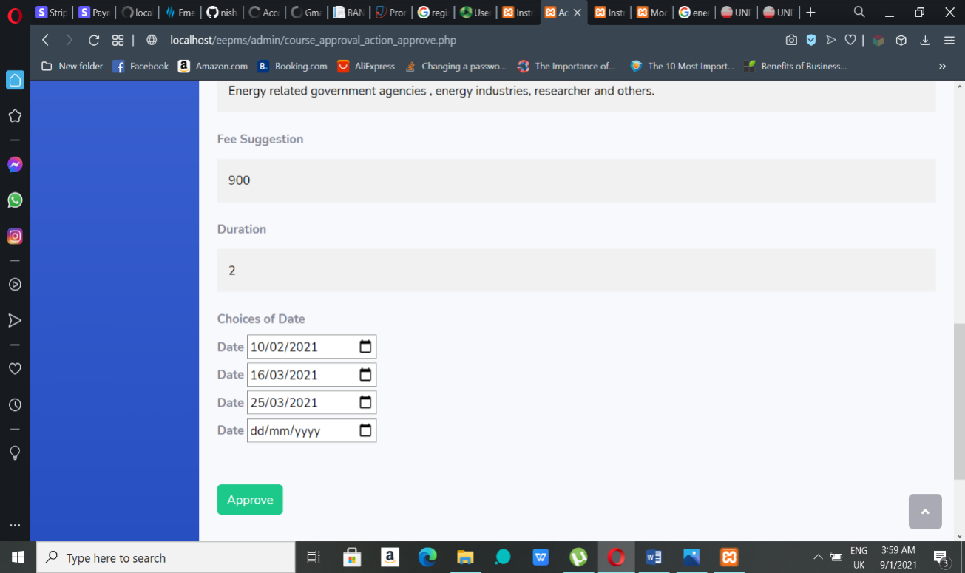

**Figure 4.31:** Course Approve Page

1. To reject the course chosen, click the ‘Reject’ button in the end of the form. User can always go back without approving or rejecting the course.

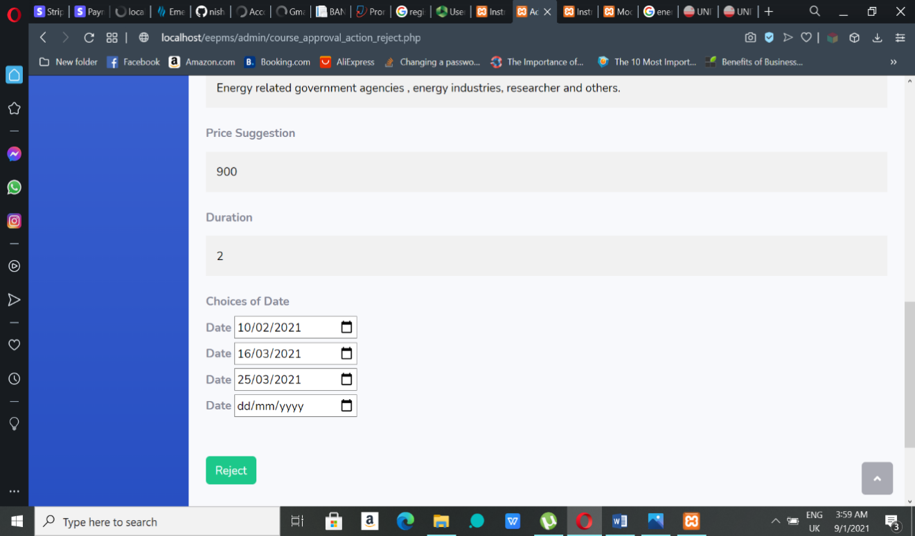

**Figure 4.32:** Course Reject Page

**Able/Disable Instructors**

As the admin has full power on the system, they can able or disable the instructors if they find it necessary. To disable the instructor, click ‘Disable’ button so the instructors cannot get into the system. Admin can also activate the instructor’s account by clicking the ‘Able’ button.

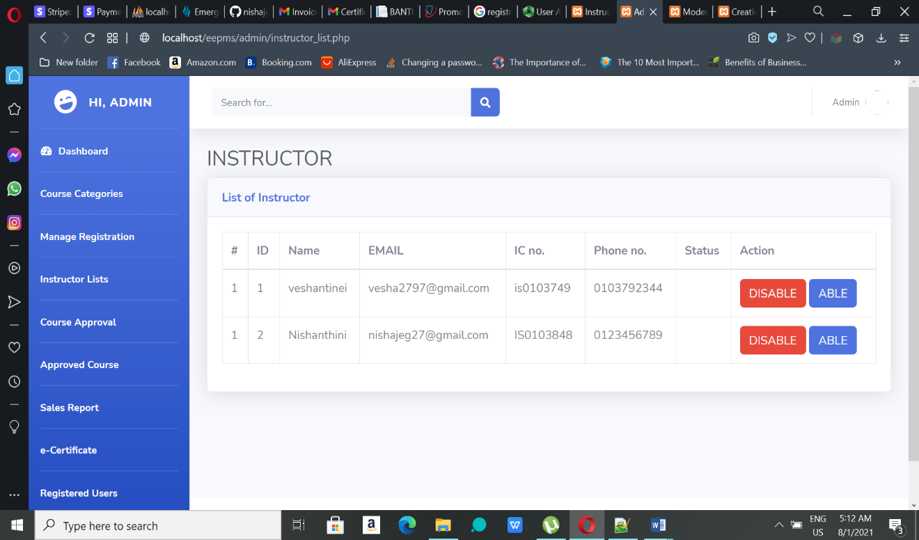

**Figure 4.33:** Able/Disable Instructor Page

**Managing Approved Courses**

1. Admin can add, edit, delete and make it active or deactivate the courses. The ‘Active’ button shows that the course is active in the front-end and clicking it will change it to ‘Deactivate’ button so it cannot be seen in the front-end. And clicking the delete button will delete the course after alerting confirmation box.

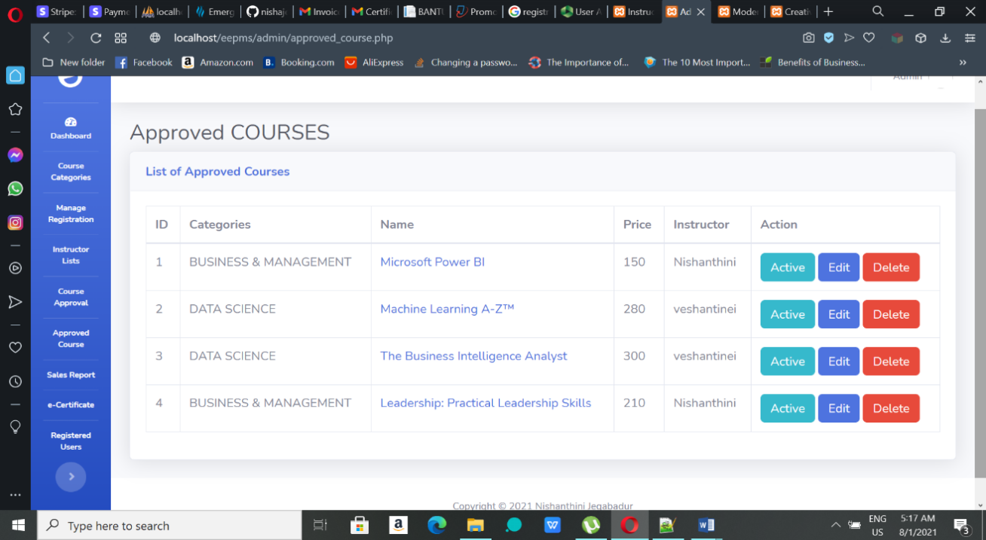

**Figure 4.34:** Approved Courses Page

1. After clicking the ‘Edit’ button in Approve Courses Page, a form with existing course details will be shown. The user can edit and click ‘Submit’ button in the bottom of the form to update the particular course.

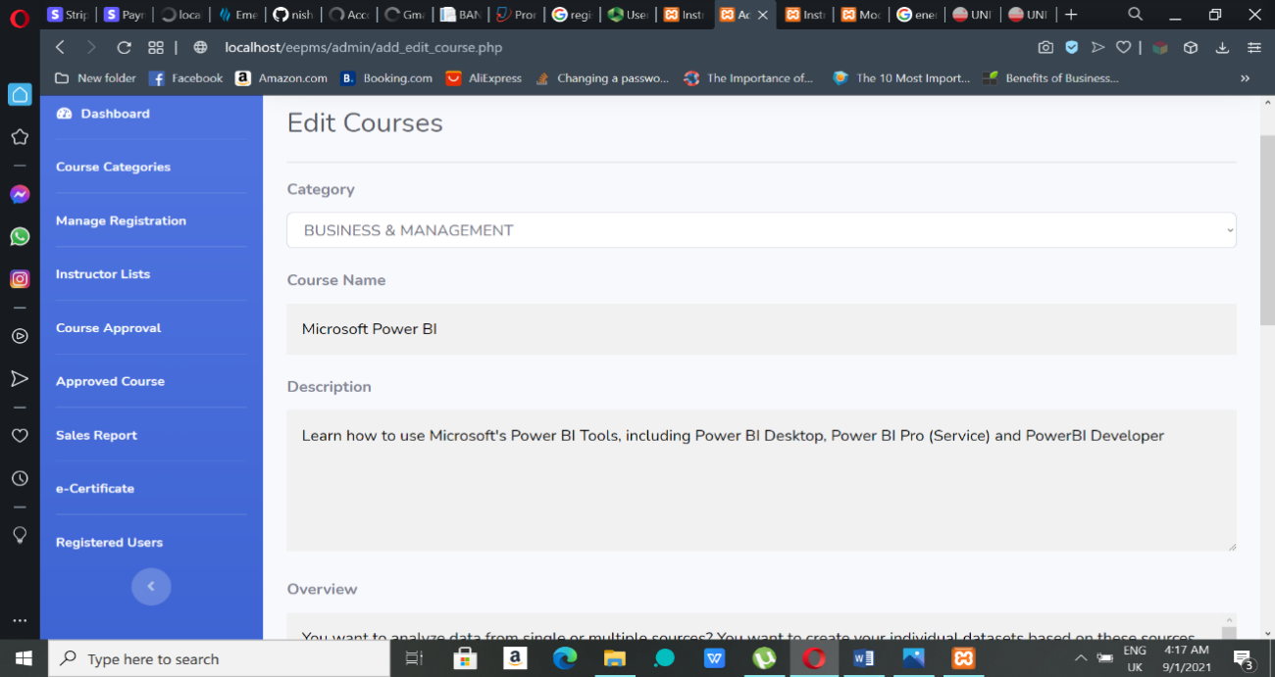

**Figure 4.35:** Edit and Update Course Page

**View Registered Users**

Clicking the ‘Registered User’ menu in the side-menu bar will show a table of users who have registered to the system like in the **Figure 4.36**.

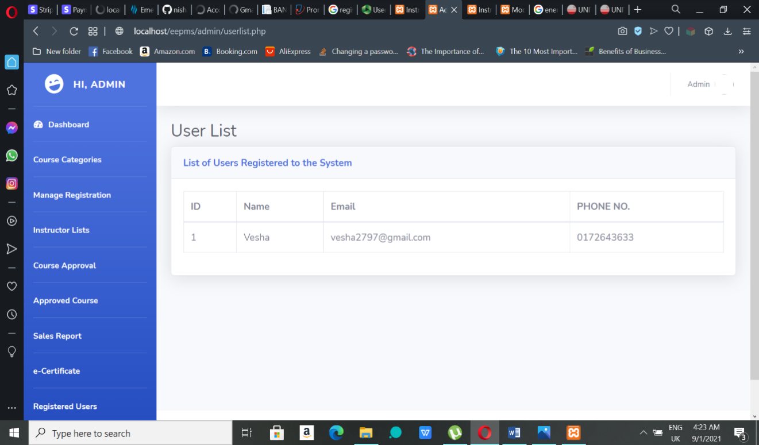

**Figure 4.36:** Registered User List Page

**Managing Course Registrations**

1. The Managing Registration menu will show the list of registrations made by the users. Clicking the ‘Detail’ button will be redirected to Registered Courses page shown in the Figure 4.38 where the admin can get more detail of the registration.

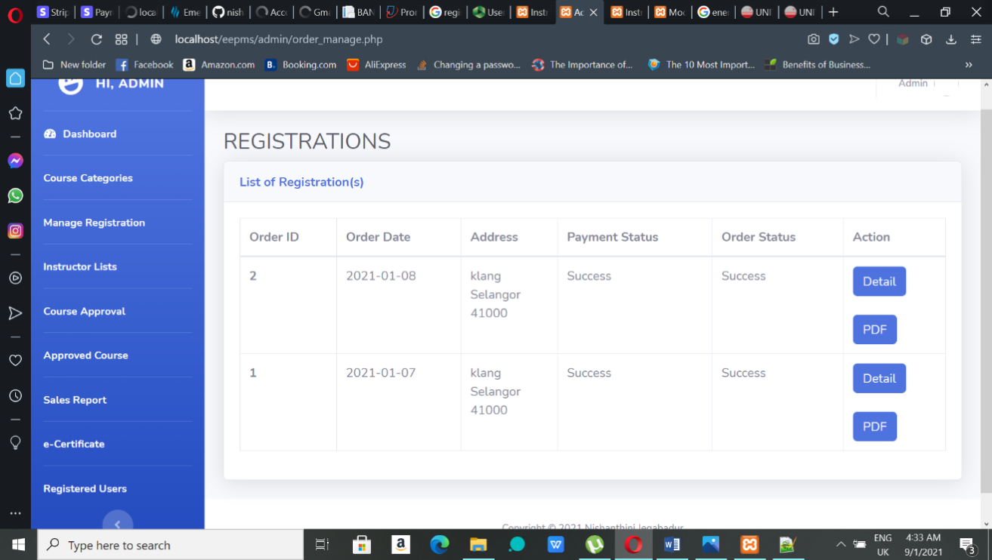

**Figure 4.37:** Registration Page

1. In the registration detail page, admin can change the order status from pending to success or cancelled. Click the dropdown and choose an option to state that the registration is success or cancelled. Once the option selected, click the ‘Submit’ button change the status. Email will be sent to the user who made the registration after change in the status.

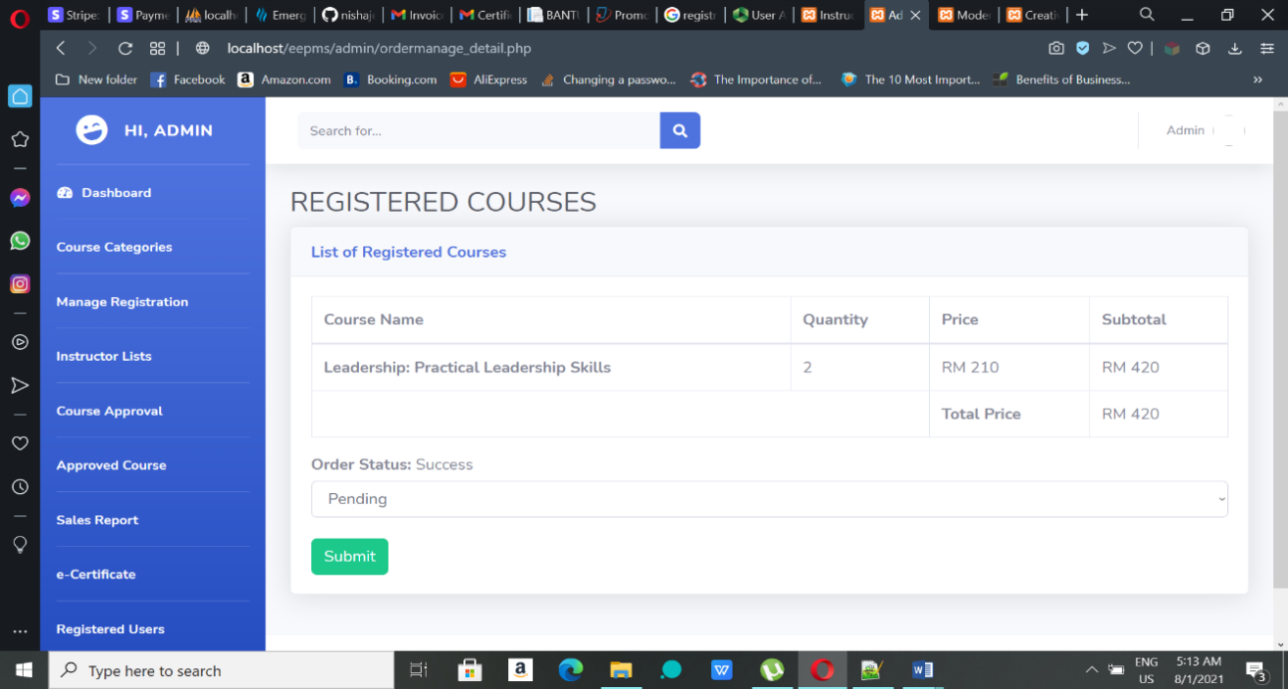

**Figure 4.38:** Registration Detail Page

**Sending e-Certificate**

To send e-certificate to registered user, click the ‘Send e-Cert’ button so that the system will send an auto-generated e-certificate to the particular user. The certificate can be sent only once.

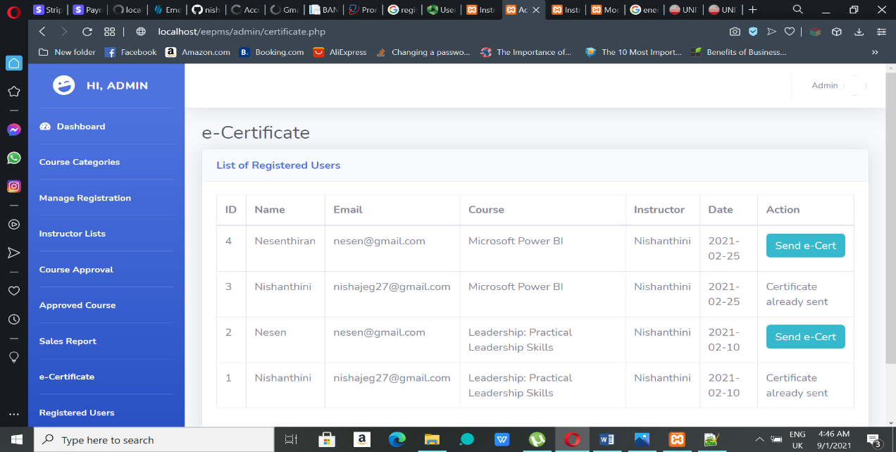

**Figure 4.39:** e-Certification Page

**Generating Sales Report**

Generating sales report can be done in two ways. First one, generating pdf format report and next one is showing it in the page itself. According to user preference, admin can choose either method. For pdf format report, admin must choose the month and year and click the ‘Generate PDF Report’ button. User can click ‘Submit’ button after choosing the month and year to show the report in the page itself.

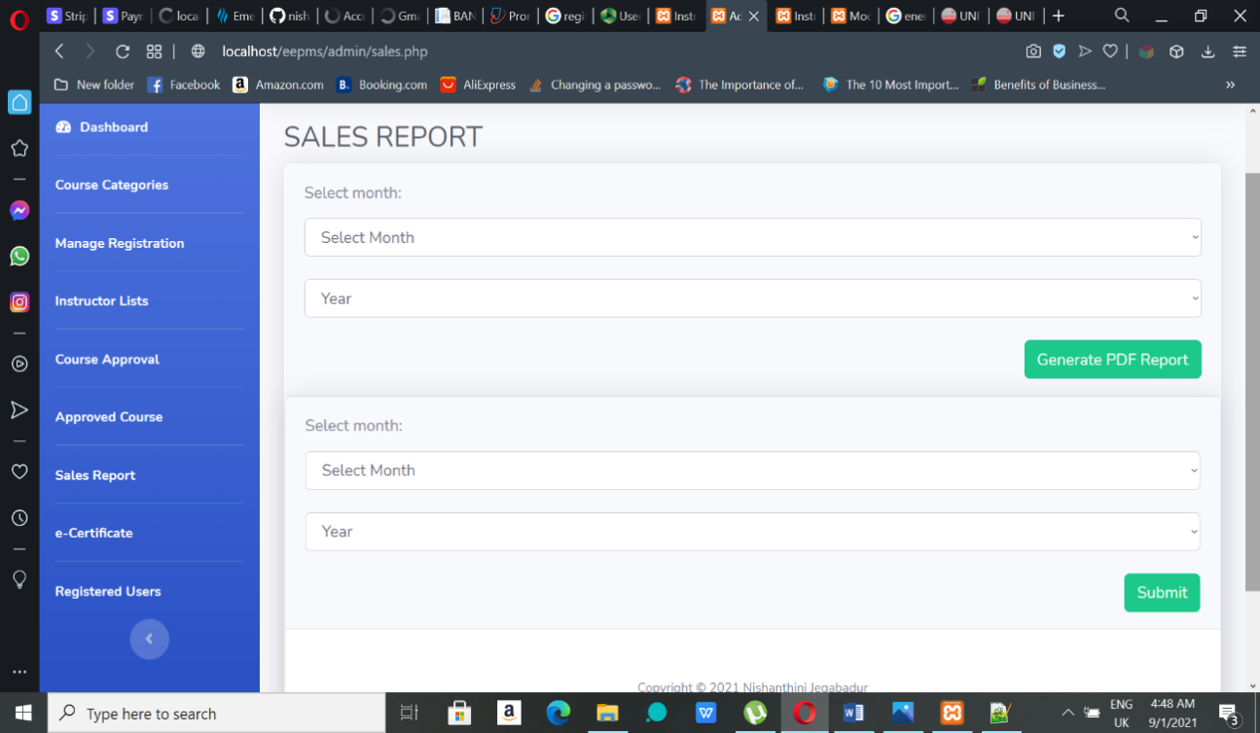

**Figure 4.40:** Sales Report Page

**Logout**

To logout, click on the admin on top-right and click ‘Logout’ to get out of the system.

**4.5.3 User Interface and Functionalities**

**User Homepage**

Figure 4.41 shows the homepage of the system where can choose any option from the menu-bar.



**Figure 4.41:** Homepage

**Enquiry form**

After clicking the ‘Contact’ from the menu, it will slide to the bottom of the page to enquiry form. Users can make any enquiry the courses or system with that form. By clicking the ‘Submit’ button in the bottom, the form will be submitted.

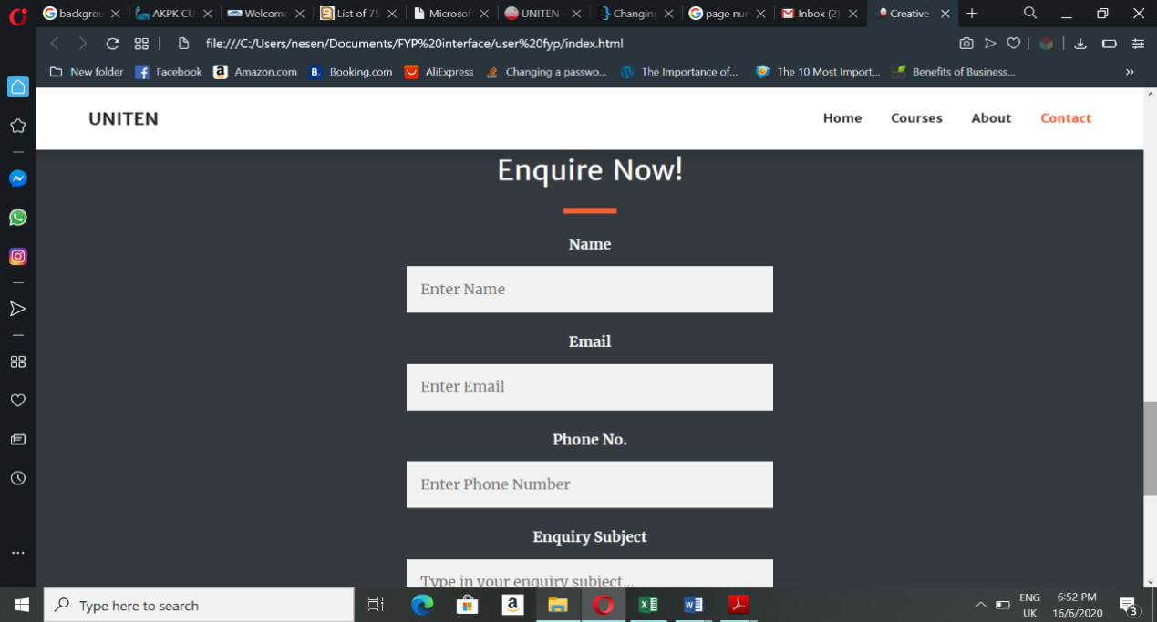

**Figure 4.42:** Enquiry Form

**User Login/Register**

User can register or login to the system by clicking the ‘Register/Login’ option in the menu-bar of page. They will be redirected to Register/Login page to get themselves registered or logged in. User have to register themselves with by entering their details and click ‘Register’ button if they are new to the system. but if they have already registered in the system, they can enter the login credentials and click ‘Login’ button to proceed.

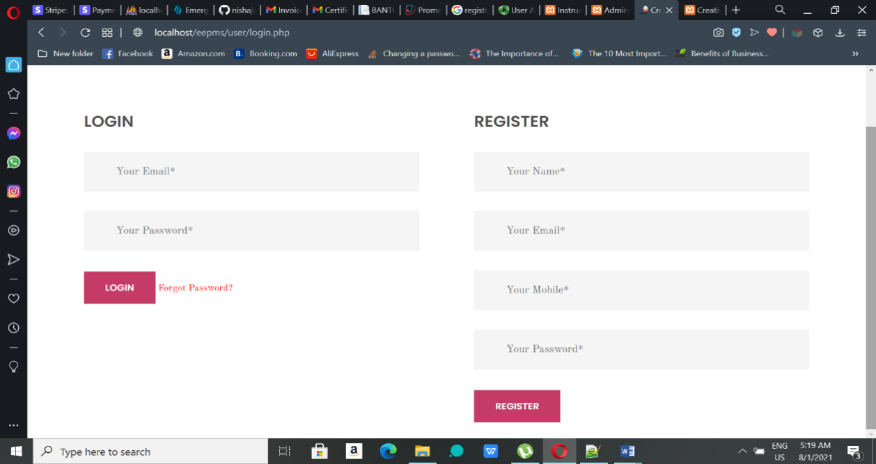

**Figure 4.43:** Register/Login Page

**Forgot Password**

If user forgot their password while logging in, they can click the ‘Forgot Password?’ link to get their old password. A form asking for user’s email used for this system will appear. User must fill in the form with the correct email to get the password.

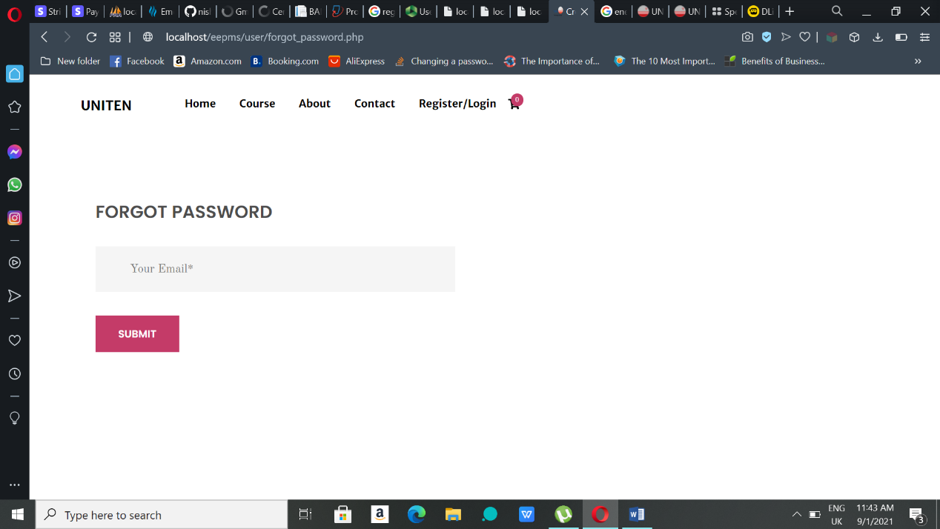

**Figure 4.44:** Forgot Password Page

**Course Page**

Course added by the instructors listed here. On the left side of the page the categories are listed where users can choose any of their interested field of category to filter the courses. Users can also search for their interested courses in search bar above the category list. By clicking the ‘Details’ button in the course box, users can view course details.

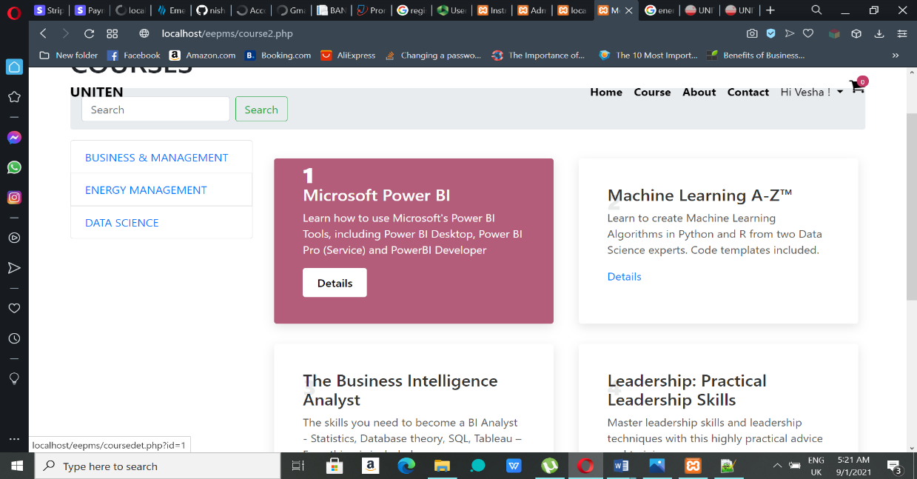

**Figure 4.45:** Course Page

**Course Details Page**

After choosing a particular course, its details will be shown in this page like in the **Figure 4.46**. If user interested in this course, they can add that course to cart for registration. Before clicking ‘Add To Cart’ user must choose the number of participants wants participate in course and their convenient date.

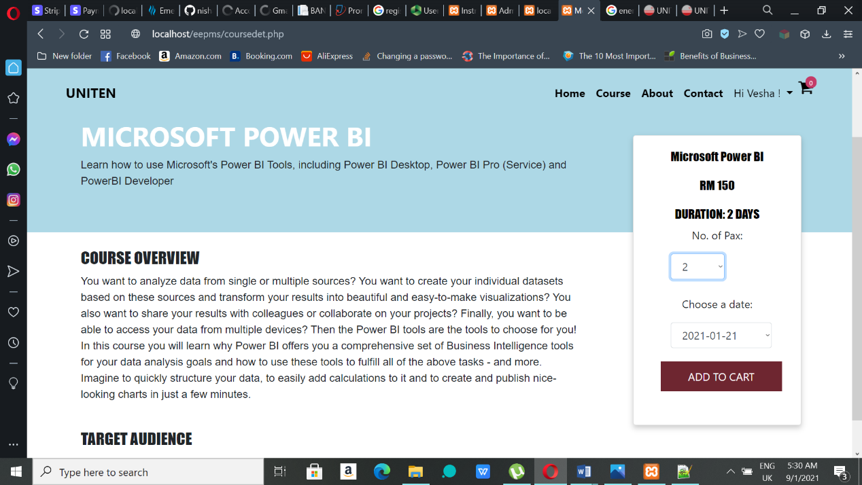

**Figure 4.46:** Course Details Page

**Cart Page**

After adding to cart, user must click on the cart icon in the top-right of the page to view the cart page. The cart page will have the registration details added by the user. To continue looking or the courses, click the button in bottom-left to go back to Course Page. If the user want to proceed with the checkout, click the bottom-right ‘Checkout’ button to visit the checkout page.

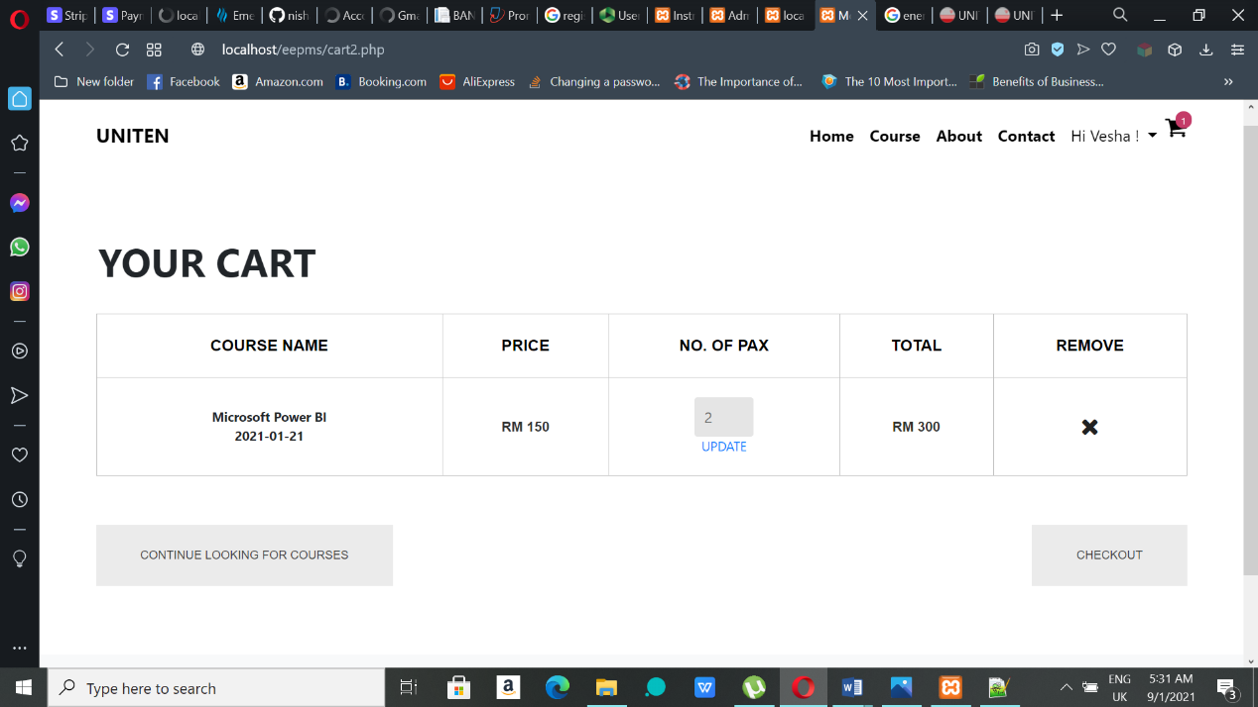

**Figure 4.47:** Cart Page

**Checkout Page**

1. In Checkout page, if the user have not registered or logged in to the system, it will ask for registration or login details from the user to proceed with checkout. User have to register themselves with by entering their details and click ‘Register’ button if they are new to the system. but if they have already registered in the system, they can enter the login credentials and click ‘Login’ button to proceed.

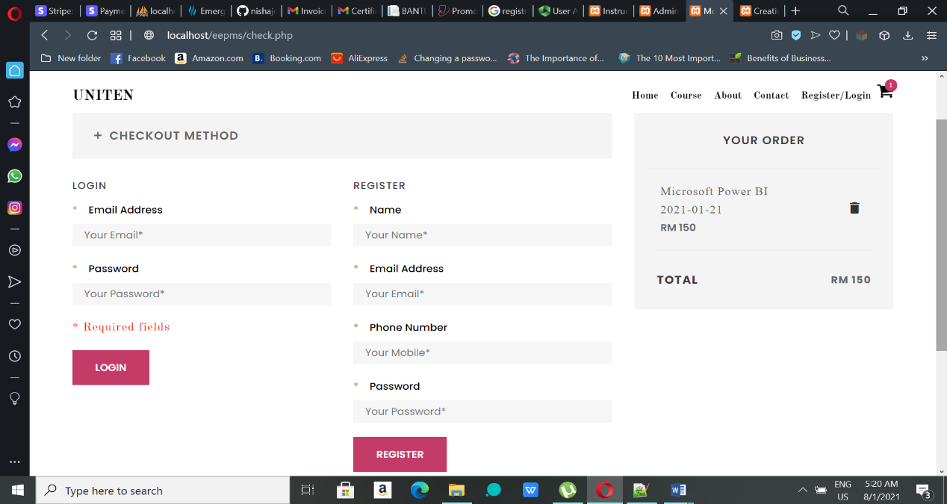

**Figure 4.48:** Registration/Login (Checkout Page)

1. To proceed with checkout, users must enter their billing address detail and click ‘Submit’ to submit the registration details.

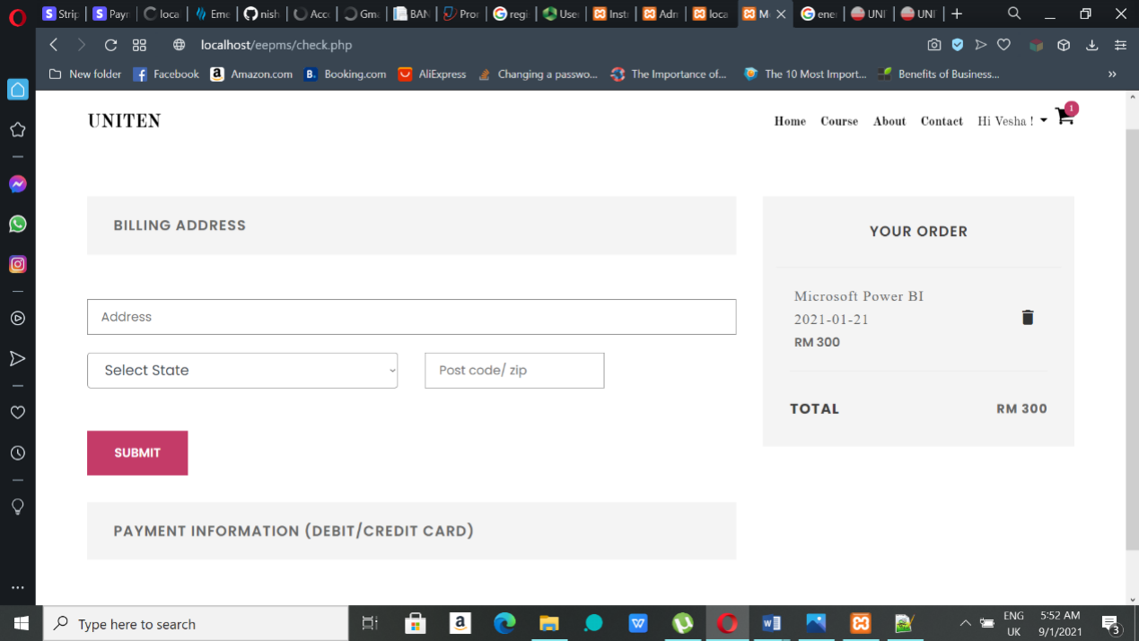

**Figure 4.49:** Billing Address (Checkout Page)

1. After submitting the address, ‘Pay With Card’ will appear to proceed with payment. Click the button to make payment. If user skip this step their registration will not complete. Their payment status will be in pending.

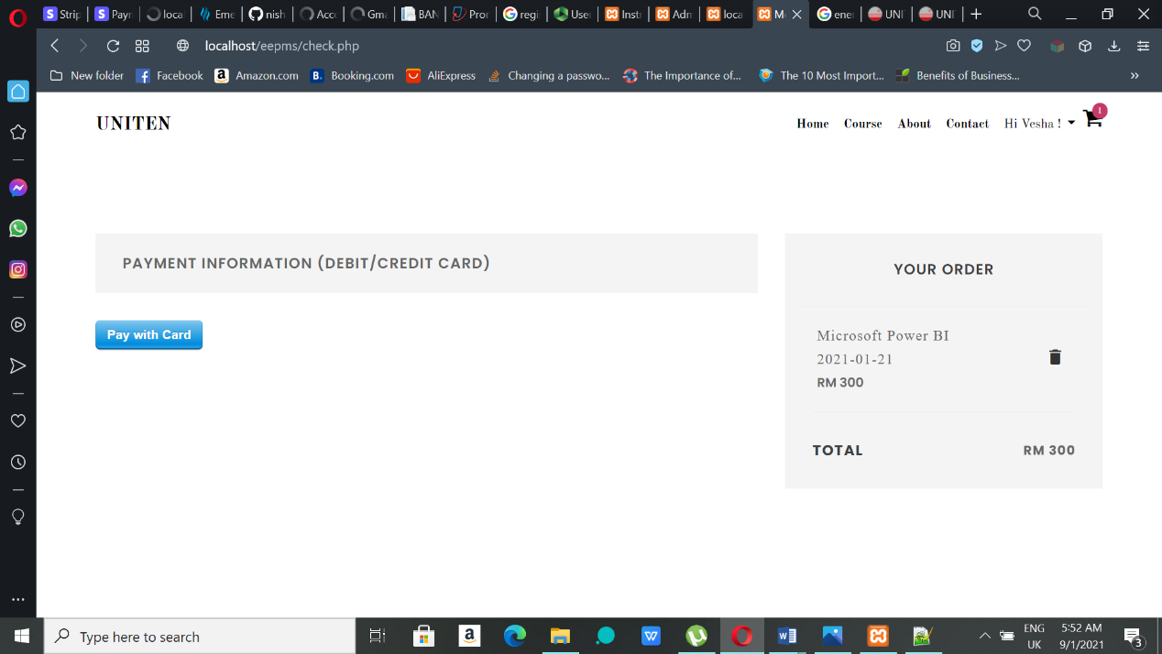

**Figure 4.50:** Pay With Card

1. After clicking the button, a modal form will pop up to get the user’s payment card details. Enter the right credentials to pay successfully.

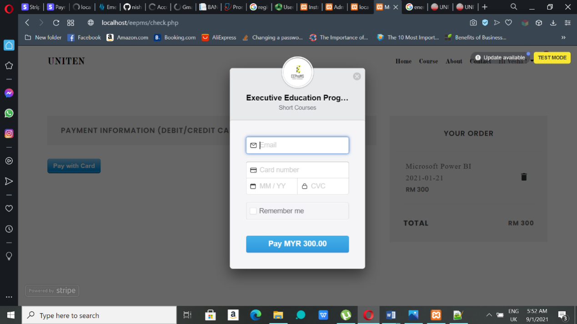

**Figure 4.51:** Stripe Payment Gateway

1. After payment successful, the page will be redirected to Thank You page. User can click the ‘Contact us’ link to communicate with department through email. If the user want to check their registration detail, then click ‘Continue to My Registration’ button.

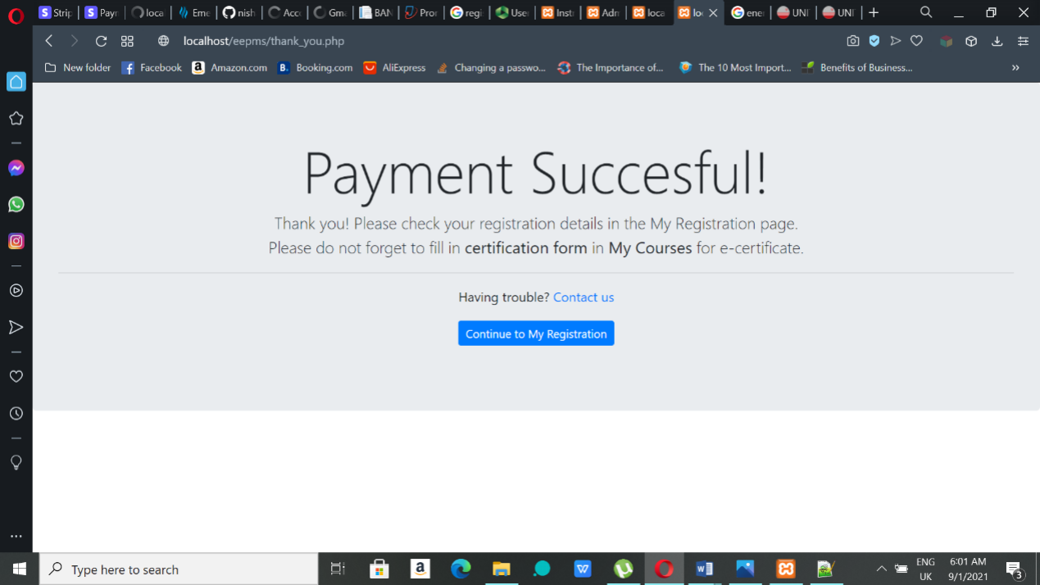

**Figure 4.52:** Thank You page

**Checking My Registration**

User can check their current and previous registrations in this page. They can get their registration details by clicking ‘Invoice’ through pdf format. User can click ‘e-Cert’ button to view their registration detail in the system itself. User can get to this page by clicking their name in the top-right of any page after login and choosing the My Registration option.

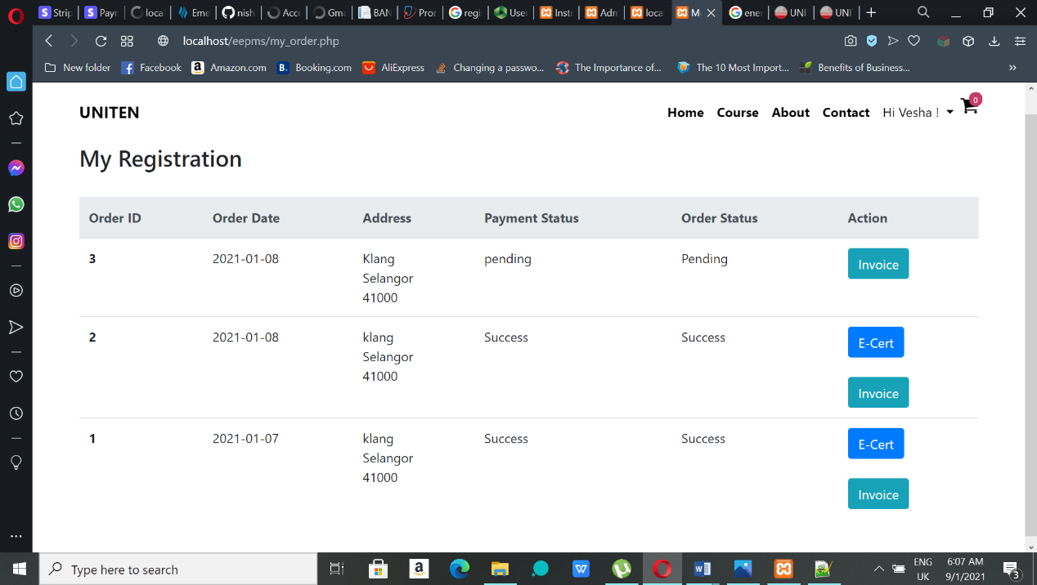

**Figure 4.53:** My Registration Page

**Registration Detail Page**

User can see their registration details in this page and also can give their name and email details for e-certification by clicking the ‘e-Cert’ button.

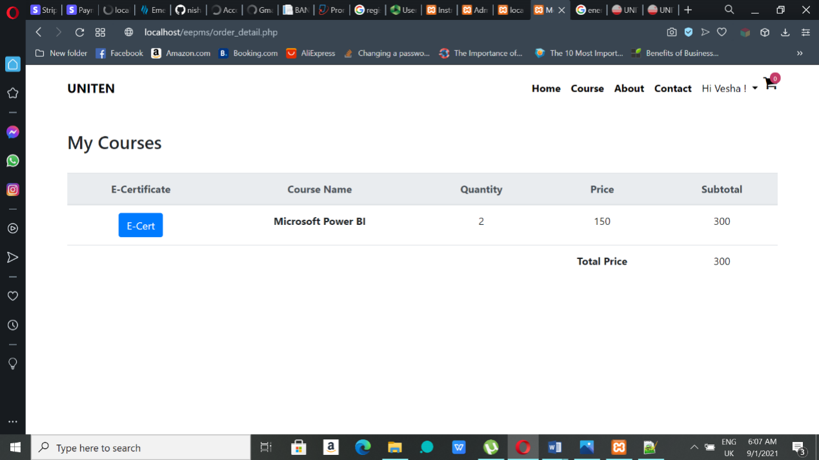

**Figure 4.54:** My Courses page

**e-Certification Form**

User have fill in this Certificate form to get their certificate through email. They can the name and email of the participants in this form. After submitting this button by providing details, their registration process will be completed.

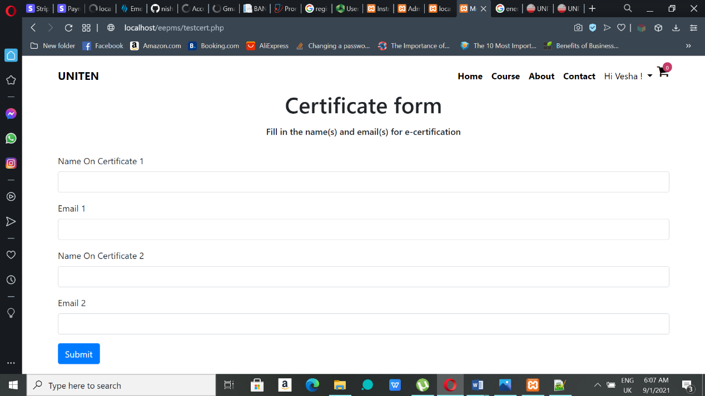

**Figure 4.55:** -e-Certificate Form

**My Profile Page**

When users click their name in the top-right of any page after login, there will a dropdown with My Profile option. Clicking that option will get user to this page. This page contains user’s current name under Profile form. User can change name by editing their current name and click ‘Update’ button. User can change password by entering current and new password in the fields and click ‘Update’ button.

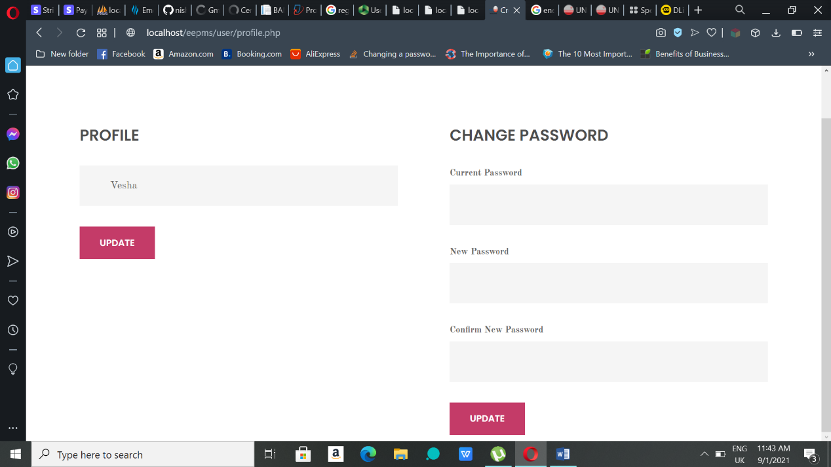

**Figure 4.56:** My Profile Page

**4.6 CONCLUSION**

This chapter came up the implementation of the proposed system where the system executed with coding by using the suitable software and hardware tools. This system also shows the interfaces of the system which is taken from the design of Chapter 3 and made some enhancement to make the system look better. Not just this, it also provides user manual which will be helpful for the users because it will help them go through this system.

**CHAPTER 5**

**TESTING**

**5.0 OVERVIEW**

According to the SDLC chosen for this system, testing come after the implementation part. Testing is important for all kind of automated system as it helps to make it better. System testing is all about the standard set by the developer and ensure that the system has fulfilled and is running according the standard set. This chapter mainly focuses on the testing that has been done to the developed system.

**5.1 USER ACCEPTANCE TESTING**

The developed ‘Execution Education Programme Management System’ (EEProMS) has underwent user acceptance testing where the end user test the system using the requirements set by the developers. This testing ensures that the system can be used by the users correctly without errors and bugs before going into the user world. All the functions and features of the system are tested thoroughly by the testers to make sure each of them working well and up to the client’s expectation. Testing has been for all types of users of the system that are instructors, administrators and front-end users. Test case is also development as a proof of the testing took place.

**5.1.1 Testing for Registration and Login function**

**Table 5.1:** User Acceptance for Admin Login

|  |  |  |  |  |  |  |  |
| --- | --- | --- | --- | --- | --- | --- | --- |
| System | | EEProMS – Admin login function | | | | | |
| Purpose | | To test the user acceptance of the login function | | | | | |
| Test Case Details: Testing on the login function validating username and password | | | | | | | |
| Step | Description | | | Expected result | | Actual result | Comment/Remark |
| 1. | Clicking the ‘Log In’ button without filling up any field | | | Display error message | | Display error message |  |
| 2. | Entering invalid username and password | | | Display error message | | Display error message |  |
| 3. | Entering valid username and password | | | Admin dashboard shows up | | As expected | Admin login function working well |
| **Tester Name** | | | Ms Dharnishaa | | | | |
| **Date** | | | 24 December 2020 | | | | |
| **Pass/Fail** | | | Pass | | | | |
| Verified By:  Name: Sarrmine Armugam  Date: 25 December 2020 | | | | | Accepted by:  Name: Carline  Date: 25 December 2020 | | |

**Table 5.2:** User Acceptance for Instructor and User Registration

|  |  |  |  |  |  |  |  |
| --- | --- | --- | --- | --- | --- | --- | --- |
| System | | EEProMS – Instructor and user registration function | | | | | |
| Purpose | | To test the user acceptance of the registration function | | | | | |
| Test Case Details: Testing on the registration function validating process on all fields | | | | | | | |
| Step | Description | | | Expected result | | Actual result | Comment/Remark |
| 1. | Clicking the ‘Register’ button without filling up any field | | | Display error message | | Display error message in all the field |  |
| 2. | Entering existing email | | | Display error message | | Display error message |  |
| 3. | Entering invalid email | | | Display error message | | Display error message | Email with @ and . is accepted |
| 4. | Enter short password (<6) | | | Display error message | | Display error message |  |
| 5. | Enter invalid mobile number | | | Display error message | | Display error message | Only 10-11 numbers are accepted |
| 6. | Fill in all the required field with valid data | | | Registration success | | Registration success | Registration function working well |
| **Tester Name** | | | Ms Dharnishaa | | | | |
| **Date** | | | 24 December 2020 | | | | |
| **Pass/Fail** | | | Pass | | | | |
| Verified By:  Name: Sarrmine Armugam  Date: 25 December 2020 | | | | | Accepted by:  Name: Carline  Date: 25 December 2020 | | |

**Table 5.3:** User Acceptance for Instructor and User Login

|  |  |  |  |  |  |  |  |
| --- | --- | --- | --- | --- | --- | --- | --- |
| System | | EEProMS – Instructor and user login function | | | | | |
| Purpose | | To test the user acceptance of the login feature | | | | | |
| Test Case Details: Testing on the login function validating email and password | | | | | | | |
| Step | Description | | | Expected result | | Actual result | Comment/Remark |
| 1. | Clicking the ‘Log In’ button without filling up any field | | | Display error message | | Display error message in both fields |  |
| 2. | Entering invalid email and password | | | Display error message | | Display error message |  |
| 3. | Entering valid email and password without email confirmation | | | Display error message | | Display error message | Validation for instructor only |
| 4. | Entering valid username and password | | | Redirecting to the right page | | As expected | Instructor and user login function working well |
| **Tester Name** | | | Ms Dharnishaa | | | | |
| **Date** | | | 24 December 2020 | | | | |
| **Pass/Fail** | | | Pass | | | | |
| Verified By:  Name: Sarrmine Armugam  Date: 25 December 2020 | | | | | Accepted by:  Name: Carline  Date: 25 December 2020 | | |

**5.1.2 Testing for Functions in Admin side**

**Table 5.4:** User Acceptance for Functions in Admin pages

|  |  |  |  |  |  |  |  |
| --- | --- | --- | --- | --- | --- | --- | --- |
| System | | EEProMS – Admin Functions | | | | | |
| Purpose | | To test the user acceptance of all the Admin functions and features | | | | | |
| Test Case Details: Testing on all the other functions and features involved in Admin side | | | | | | | |
| Step | Description | | | Expected result | | Actual result | Comment/Remark |
| 1. | Clicking the ‘Approve’ button in Course Approval page | | | Course details can be reviewed and click ‘Approve’ button again for confirmation | | As expected |  |
| 2. | Clicking the ‘Reject’ button in Course Approval page | | | Course details can be reviewed and click ‘Reject’ button again for confirmation | | As expected |  |
| 3. | Clicking the ‘Able’ button in Instructor List page | | | The status changed to ‘active’ and the instructors are activated | | As expected |  |
| 4. | Clicking the ‘Disable’ button in Instructor List page | | | The status changed to ‘disabled’ and the instructors are deactivated | | As expected |  |
| 5. | Clicking ‘Generate PDF Report’ button without choosing a month and year in Sales Report page | | | Display error message to choose a month from the list | | As expected |  |
| 6. | Clicking ‘Submit’ button without choosing a month and year in Sales Report page | | | Display error message to choose a month from the list | | As expected |  |
| 7. | Clicking ‘Generate PDF Report’ button after choosing month and year in Sales Report page | | | A PDF format sales report will appear | | As expected |  |
| 8. | Clicking ‘Submit’ button after choosing month and year in Sales Report page | | | Display the report details in the page itself | | As expected |  |
| 9. | Clicking ‘Active’ button in Approved Courses and Course Categories page | | | The button colour changed and the button name changed to ‘Deactive’ | | As expected |  |
| 10. | Clicking ‘Edit’ button in any admin page | | | An editing form with current details will come out | | As expected |  |
| 11. | Clicking ‘Delete’ button in any admin page | | | Alert will pop up for confirmation and the details will be deleted from the page and also database | | As expected |  |
| 12. | Clicking ‘Order Detail’ button in Order Manage | | | Order detail page will appear | | As expected |  |
| 13. | Clicking ‘PDF’ button in Order Manage page | | | A PDF format invoice for that particular order will appear | | As expected |  |
| 14. | Clicking ‘Submit’ button after choosing an order status option in Registered Courses page | | | An email will be sent to the registered user regarding their order status | | As expected |  |
| 15. | Clicking ‘Send e-Cert’ button in e-Certificate page | | | An email will be sent with e-certificate to the user who registered | | As expected |  |
| **Tester Name** | | | Ms Dharnishaa | | | | |
| **Date** | | | 24 December 2020 | | | | |
| **Pass/Fail** | | | Pass | | | | |
| Verified By:  Name: Sarrmine Armugam  Date: 25 December 2020 | | | | | Accepted by:  Name: Carline  Date: 25 December 2020 | | |

**5.1.3 Testing for Functions in Instructor side**

**Table 5.5:** User Acceptance for Course Insertion Function

|  |  |  |  |  |  |  |  |
| --- | --- | --- | --- | --- | --- | --- | --- |
| System | | EEProMS – Course details insertion | | | | | |
| Purpose | | To test the user acceptance of the inserting function | | | | | |
| Test Case Details: Testing on the inserting function validating process on all fields | | | | | | | |
| Step | Description | | | Expected result | | Actual result | Comment/Remark |
| 1. | Clicking the ‘Submit’ button without filling up any field | | | Display error message | | Display error message in important fields |  |
| 2. | Entering alphabet in price field | | | Display error message | | Display error message | Price must be in numbers |
| 3. | Entering invalid value in duration field | | | Display error message | | Display error message | Duration must be within 1 to 10 integer |
| 4. | Entering valid values in all field | | | Course details inserted successfully | | As expected | Course details insertion works well |
| **Tester Name** | | | Ms Dharnishaa | | | | |
| **Date** | | | 24 December 2020 | | | | |
| **Pass/Fail** | | | Pass | | | | |
| Verified By:  Name: Sarrmine Armugam  Date: 25 December 2020 | | | | | Accepted by:  Name: Carline  Date: 25 December 2020 | | |

**Table 5.6:** User Acceptance for Functions in Instructor pages

|  |  |  |  |  |  |  |  |
| --- | --- | --- | --- | --- | --- | --- | --- |
| System | | EEProMS – Instructor Functions | | | | | |
| Purpose | | To test the user acceptance of all the other Instructor functions and features | | | | | |
| Test Case Details: Testing on all the other functions and features involved in Admin side | | | | | | | |
| Step | Description | | | Expected result | | Actual result | Comment/Remark |
| 1. | Clicking the ‘Edit’ button in Pending Course and Approved Course page | | | An editing form with current details of the courses will come out | | As expected |  |
| 2. | Clicking the ‘Clear’ button in Rejected Course page | | | Alert will pop up for confirmation and the rejected course will be deleted from the page and also database | | As expected |  |
| **Tester Name** | | | Ms Dharnishaa | | | | |
| **Date** | | | 24 December 2020 | | | | |
| **Pass/Fail** | | | Pass | | | | |
| Verified By:  Name: Sarrmine Armugam  Date: 25 December 2020 | | | | | Accepted by:  Name: Carline  Date: 25 December 2020 | | |

**5.1.4 Testing for Functions in Front-end User side**

**Table 5.7:** User Acceptance for Front-End User

|  |  |  |  |  |  |  |  |
| --- | --- | --- | --- | --- | --- | --- | --- |
| System | | EEProMS – User Functions (Front-end) | | | | | |
| Purpose | | To test the user acceptance of all the other User’s functions and features | | | | | |
| Test Case Details: Testing on all the other functions and features involved in User side | | | | | | | |
| Step | Description | | | Expected result | | Actual result | Comment/Remark |
| 1. | Clicking ‘Add To Cart’ button in course details page without adding quantity | | | Alert box will pop up | | As expected | Quantity must be chosen from the given option |
| 2. | Choose a quantity value and click the ‘Add To Cart’ button | | | The course will be added to cart | | As expected |  |
| 3. | Clicking the ‘X’ button in Your Cart page | | | The particular course will be removed from the cart | | As expected |  |
| 4. | Increase the quantity value and click update | | | The price for that particular course will be updated according to the quantity value | | As expected |  |
| 5. | Entering alphabet value in the quantity field | | | Shows error in the price field of cart | | As expected |  |
| 6. | Clicking ‘Checkout’ button without adding any course in the cart | | | The page be redirected to the index.php | | As expected | At least one course is needed to proceed with the checkout |
| 7. | Clicking ‘Checkout’ button after adding course in the cart | | | Successfully move on the checkout page | | As expected |  |
| 8. | Clicking the trash icon beside course added to the cart in the Checkout page | | | The particular course will be removed from the checkout | | As expected |  |
| 9. | Removing all the course added the cart by clicking the trash icon in the Checkout page | | | The page will be redirected to the index.php | | As expected | At least one course is needed for checkout |
| 10. | Clicking ‘Submit’ button without filling in the billing address at the Checkout page | | | Display required message for all the field | | As expected |  |
| 11. | Entering alphabet values in the postcode field | | | Alphabets cannot be entered in this field | | As expected |  |
| 12. | Entering valid data in billing address and submit it | | | Data inserted and payment method appears | | As expected |  |
| 13. | Clicking ‘Invoice’ button in the My Registration(s) page | | | A PDF format invoice for that particular order will appear | | As expected |  |
| 14. | Clicking ‘In Detail’ button in the My Registration(s) page | | | Courses registered for that particular page will appear | | As expected |  |
| 15. | Clicking ‘e-Cert’ button in My Courses page | | | A form to fill up for e-certification will appear | | As expected |  |
| 16. | Clicking ‘Submit’ button without filling in e-Cert form | | | Display required message for all the field | | As expected |  |
| 17. | Entering invalid email (without @ and .) in the e-Cert form | | | Display error message | | As expected |  |
| 18. | Entering valid data in all the field of e-Cert form | | | Alert success box | | Alert success box |  |
| **Tester Name** | | | Ms Dharnishaa | | | | |
| **Date** | | | 24 December 2020 | | | | |
| **Pass/Fail** | | | Pass | | | | |
| Verified By:  Name: Sarrmine Armugam  Date: 25 December 2020 | | | | | Accepted by:  Name: Carline  Date: 25 December 2020 | | |

**Table 5.8:** User Acceptance for Enquiry feature

|  |  |  |  |  |  |  |  |
| --- | --- | --- | --- | --- | --- | --- | --- |
| System | | EEProMS – Enquiry feature | | | | | |
| Purpose | | To test the user acceptance of the enquiry feature | | | | | |
| Test Case Details: Testing on the enquiry feature validating process on all fields | | | | | | | |
| Step | Description | | | Expected result | | Actual result | Comment/Remark |
| 1. | Clicking the ‘Submit’ button without filling up any field | | | Alert box will pop up | | Alert box pops up for every field |  |
| 2. | Entering invalid email | | | Alert box will appear | | As expected | Email with @ and . is accepted |
| 3. | Entering invalid phone number | | | Alert box will appear | | As expected | Only 10-11 numbers are accepted |
| 4. | Fill in all the required field with valid data | | | Enquiry success. Email sent to a particular email | | As expected | Enquiry feature working well |
| **Tester Name** | | | Ms Dharnishaa Mohana Dass | | | | |
| **Date** | | | 24 December 2020 | | | | |
| **Pass/Fail** | | | Pass | | | | |
| Verified By:  Name: Sarrmine Armugam  Date: 25 December 2020 | | | | | Accepted by:  Name: Carline  Date: 25 December 2020 | | |

**5.2 CONCLUSION**

This chapter main focuses about the testing of the system. This testing has helped in developing the system with more awareness on building a defect-free system. All the functions and features are tested, verified and accepted by three different testers to make sure the testing has been done in a proper manner.

**CHAPTER 6**

**CONCLUSION**

On the whole, Executive Education Programme Management System (EEProMS) is a system developed for UNITEN Business Development Department (BDD) to manage the short courses or programmes offered by them. As yet, EEProMS has carry through the objectives stated in Chapter 1. The system is completed to be reviewed and it is recommended to be implemented in the department as it will help them avoid the hassle in managing the course registration process. Their current manual system is time consuming as almost all the activities included in the process is done manually such as the paper works, registration and managing the courses. Therefore using this system will solve their problems and also will lessen their workload.

**6.1 PROJECT OUTCOME**

As a project outcome, the system able to achieve the objectives and will give expected results in future. The project has gone through many phases to that considered as the outcome of the project. In the first phase, after meeting the Head of BDD, the problems are identified and EEProMS was proposed to in an attempt to solve their problems. After finding out the problems and background of the department, the objectives and scope of the system were also identified in this phase. Requirement analysis takes place in the second phase where existing similar system are listed out and analysed to come up with the suitable functionalities for the proposed system. Waterfall Model was chosen as the most suitable software development methodology which helps in developing the system by order. Not just that, interview was also conducted to gather

the requirements of the proposed system. Then comes the design phase where user interfaces and tables required in the database connection are designed. Those interfaces give us an image on how the proposed system will look like. And the interfaces were re-used during the implementation phase but some changes were made to enhance the look of the system. The system executed with code in this implementation phase. The functionalities came to real in this phase and it is usable by the users. This phase also provides user manual to guide the users on how the system works. But the system has to undergo the testing phase to be fully utilized. In this testing phase, user acceptance test was done to check the integrity of the system. These phases helps to get through the Final Year Project because it helps in providing a complete and error-free system.

**6.2 EXPERIENCE GAINED**

This is a new and challenging experience because everything was done virtually and students couldn’t connect with their supervisors much. Even though, students find it hard to learn everything virtually, eventually, students get used to it and started learning new things on their own which is very good. The students learned how to cope up with this situation and successfully developed the system.

**6.3 PROBLEMS ENCOUNTERED**

There are some problems encountered during this development of Final Year Project. One of the main problem is time constraints. Finishing up and showing progress for each milestone to the supervisors was very hard due to the not enough time. The workload was very high for this semester because other subjects’ tasks were also need to be done on time which causes insufficient time to complete the tasks or project on time. Other than this, deciding on the function requirements for this project also considered to be a problem. Over-promised and under-deliver does not represent a good project. Hence, deciding on the functionalities took time because the developer has to be aware what they are capable of.

**6.4 LIMITATION/ EXCLUDED FEATURES**

Though the EEProMS manage to achieve all the objectives stated in chapter 1, there are still few limitations can be found in the system. That are:

* The number of users can register for one particular course is not limited. A limitation has to be set for every course on how many users can register to the course but the programme or course is taking place on several days so, setting limitation of each day was cannot be done. So, this could add work for the staffs of BDD as they have to check the number of registered users for all the courses. Hence, the system dashboard has a function where it calculates the total number of registered users for every course or programme.
* Secondly, in terms of security, even though the input validation has been done, the password is not encrypted when it is stored in the database tables.

**6.5 FUTURE RECOMMENDATIONS**

Despite achieving the objectives, EEProMS can come up with new features in future because this developed system is triggering point for them where they can add more functionalities to the system. The password encryption can be easily done while deploying the system. The functions like limiting the number of registering users and providing discounts can be added to make the system more effective. And also the system scope can expanded by expanding their business ideas to target more users in future. Notification feature can be added to this so when user register for a system, admin or instructor can get notification through email showing that someone registered for their courses.

**REFERENCES**

[1] *Waterfall Model*. Retrieved from: <https://www.coursehero.com/file/53252184/Waterfall-modeldocx/>

[2] *UNITEN Professional Services*. Retrieved from: <https://www.uniten.edu.my/business-plus-service/professional-services/>

[3] Wikipedia. *Introduction to Software Engineering/Process/Methodology.* Retrieved from: [https://en.wikibooks.org/wiki/Introduction_to_Software_Engineering/Process/Methodology#](https://en.wikibooks.org/wiki/Introduction_to_Software_Engineering/Process/Methodology)

[4] Wikipedia. *Waterfall Model*. Retrieved from: <https://en.wikipedia.org/wiki/Waterfall_model>

**APPENDIX A:** Interview Questions

Person A

1. Can Puan brief about the whole of this short course registration process?
2. Which type of clients mostly participates in the programmes? Internal or external clients?
3. How these executive education programmes or short courses are being promoted?
4. How are the receipts and sales report produced?
5. What are difficulties faced by the staffs and management during this courses registration process?
6. Do you think the current method for registration is satisfying and efficient enough?
7. How the certificates are given out to the participants?
8. If there is system developed for this, how it can solve the problem.

Person B

1. Have you ever participated in any the executive education programmes?
2. How do you get to know about the course?
3. Then why did not you get yourself registered in the programme you were interested in?
4. What can be done by the management to make the process more efficient?

TURNITIN REPORT

